**APPENDIX B** (Pockalny)

**SITE REPORTS**

**ENDEAVOR-EN651**

**Concentrations and source assessment of black carbon across tropical Atlantic air and sediment**

**(Amazon Fan, Ceara Rise, Abyssal Plain, Mid-Atlantic Ridge, Sierra Leone Rise/Basin)**

R/V Endeavor, 27 February, 2020 – 17 March, 2020

Chief Scientist: Rainer Lohmann, Professor of Oceanography, GSO/URI

Shipboard Science Party Members:

Benjamin Geyman, Graduate Student, Harvard University

Samuel Katz, Graduate Student, GSO/URI

Gabriel Matthias, *R/V Endeavor*, Marine Technician

Nuria Penalva Arias, Graduate Student, Universitat Autònoma de Barcelona

Robert Pockalny, Research Scientist, GSO/URI

Antoni Rosell-Mele, Research Professor, Universitat Autònoma de Barcelona

Lydia Sgouros, *R/V Endeavor*, Marine Technician Intern

**Site EN651-01 (Amazon Submarine Fan)**

**Site Objectives**

The principal objectives of this site are to,

* Test multi-coring system.
* Obtain sediment and core material to characterize sediment type and measure black carbon content in upper 20 cm.

**General Description**

Coring site is located in on a submarine fan near the northern limit of the Amazon Fan in a region characterized by mixture of terrigenous and biogenic ooze. The site is located on CHIRP Line 1 (01 March 2020, JD 061) @ 12:01 GMT).

Location: 7˚ 25.38’ N 48˚ 8.67’ W

Water depth: 4244 m (12 kHz Knudsen), 4265 m (GMRT)

Crustal age: 83 Ma (based upon Müller et al., 2008)

Estimated total sediment thickness: 3077 m (Divins, 2009).

A minimum of 10 m of sediment was imaged by CHIRP 3.5 kHz seismic system.

Thickness cored: core MC02 – 42 cm (four tubes)

**Operations**

* Site survey with CHIRP 3.5 kHz (3/1/20 11:25z to 3/1/20 12:39z)
* CTD to 1000 m (CTD01 with 12 water samples taken)
* Multicore deployment with 8 tubes (MC01 - 3/1/20 15:02z to 3/1/20 19:18z)

- no mud recovered, except small bits in 2 cores and on leg stands

* Multicore deployment with 4 tubes (MC02 - 3/1/20 19:50z to 3/2/20 00:15z)

- mud recovered in all tubes

- added 6 weight bars

**EN65-01 Survey**

The EN65-01site was surveyed on March 01, 2020 with Knudsen 3260 seismic system. The survey began at 11:25z on March 1 and was completed at 12:39z on March 1.

The survey results indicate the coring site is located on a submarine fan at the base of the Amazon River with numerous channel levee systems meandering through the region with a general N-S trend. The channels are located more than 1 km to the east and more than 2 km to the west of the coring site. Most of the channels are less than 5 m deep and 100 m wide, but one large channel to the west is about 20 m deep and 1 km wide. The cored shallow sediment section thickens to the west of the coring site.

**Lithologic Description**

Foraminiferal marls, yellowish red (7.5 YR 7/4) from 0 -30 cm.

Darker, diffuse bands from 30-36 cm.

Foraminiferal marls, yellowish red (7.5 YR 7/4) greater than 36.

All four tubes collected sediment with core lengths ranging from 30 to 40 cm. The two shorter cores did not have the core stopper in place and the lower 10 cm or so of sediment were missing. Sediment sections were sampled for the top 20 cm with 1 cm sampling for the 0-10 cm section and then 2 cm samples for the 10-20 cm. Sediment at this site varied from yellowish brown in the upper 30 cm then a series of three darker, diffuse bands from about 30 to 36 cm depth.

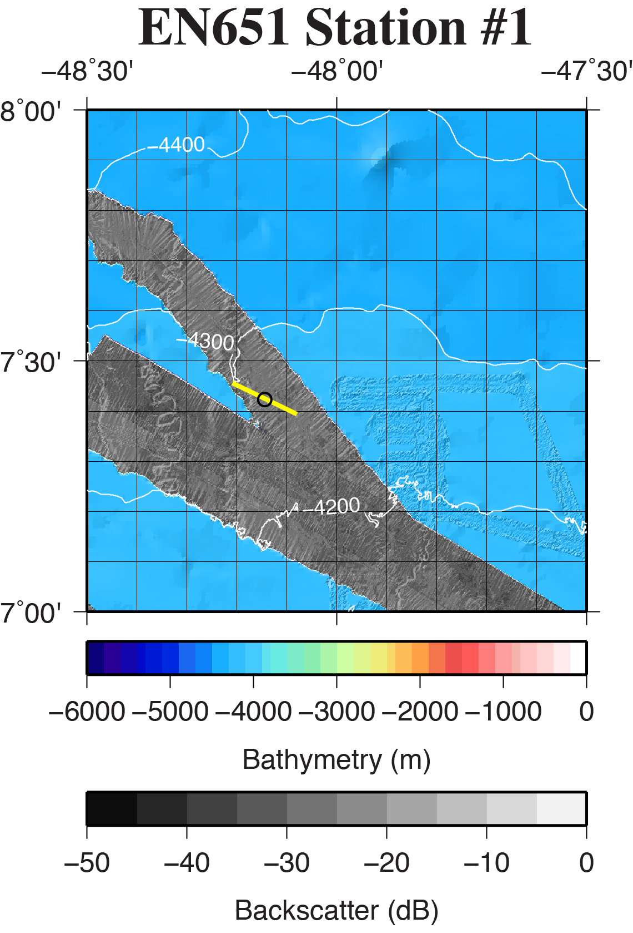

**Figure SR01-1.** Regional location of coring site EN651-01 (black circle) overlain on the GMRT database (Ryan et al., 2009) and available multibeam data. Bathymetry color-change interval is 100 meters with contours labeled every 100 meters. Backscatter intensity grayscale is darker for more reflective regions. Yellow line is the location of CHIRP survey shown in Fig. SR01-2.

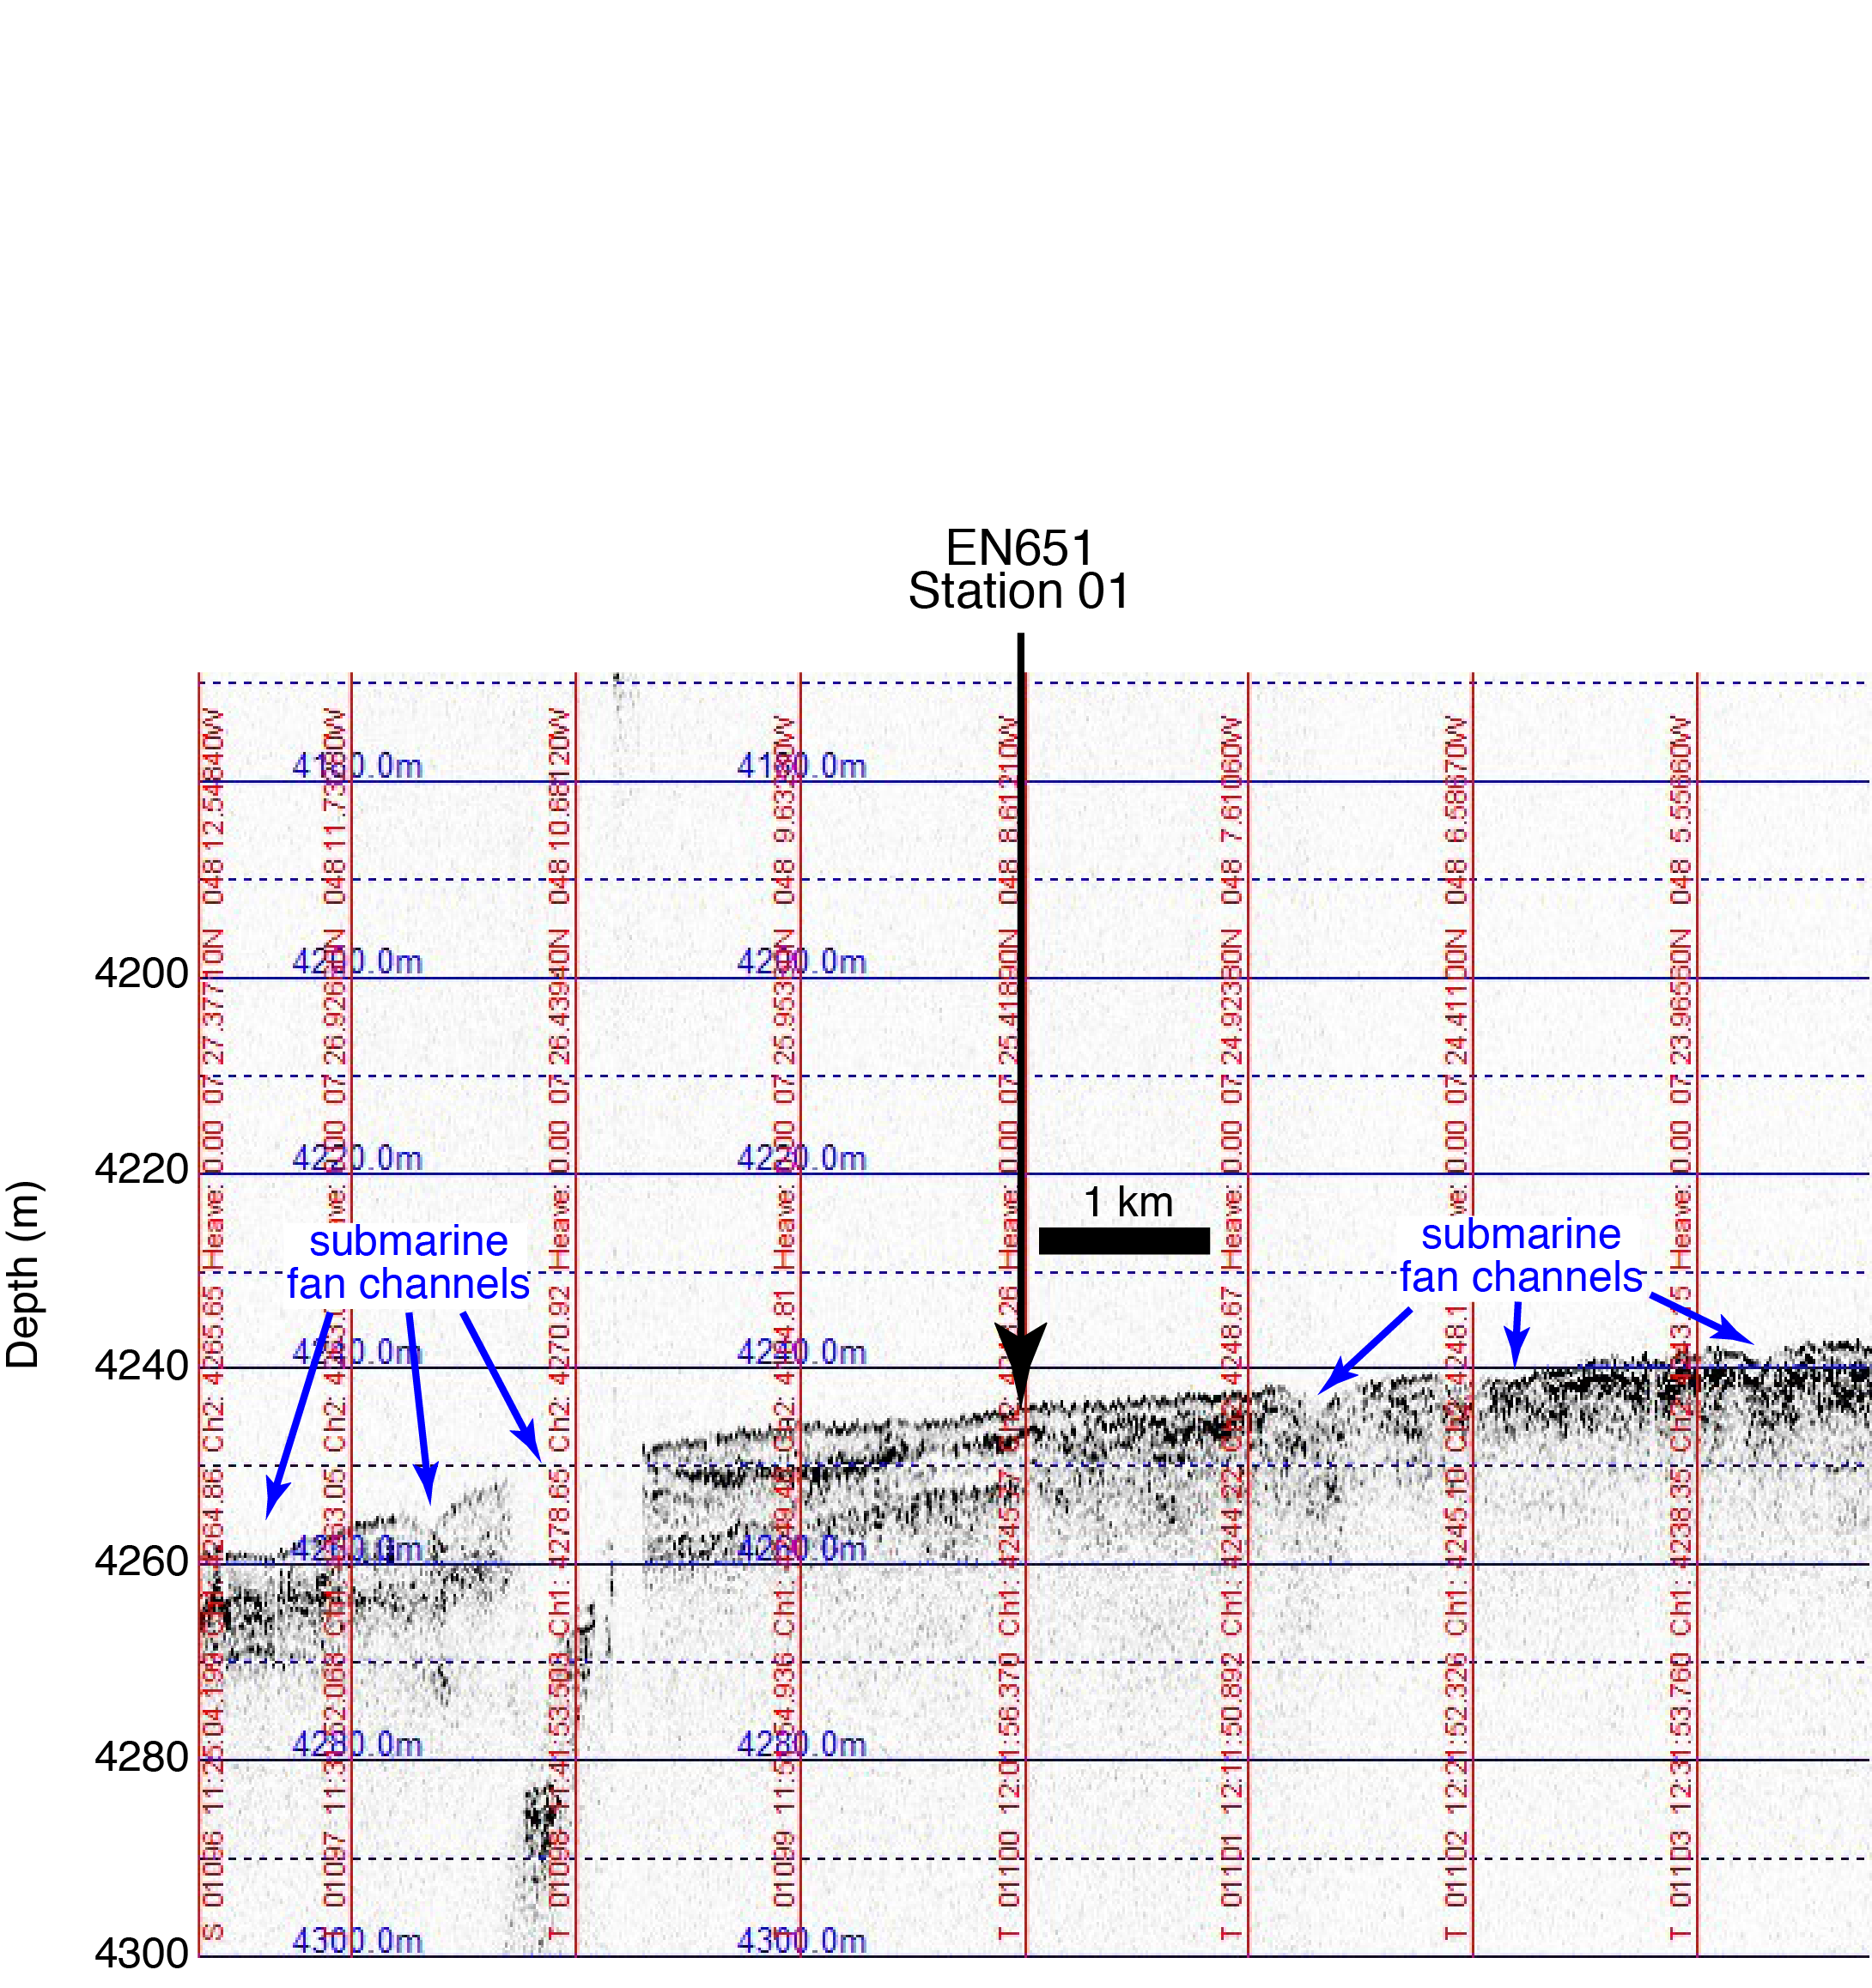

Figure SR01-2: A portion of CHIRP seismic data surveyed at 7 kts across core site EN651-01. Oceanic crust is not imaged but at least 10m of sediment are visible in the record. Blue arrows identify the location of channels and levees on the submarine fan.

**Site EN651-02 (Ceara Rise)**

**Site Objectives**

The principal objectives of this site are to,

* Obtain sediment and core material to characterize sediment type and measure black carbon content in upper 20 cm.

**General Description**

Coring site is located on the Ceara Rise about 2 km to the SSW of a sedimented volcanic relict.

Location: 5˚ 29.00’ N 44˚ 27.00’ W

Water depth: 3310 m (12 kHz Knudsen), 3318 m (GMRT)

Crustal age: 72 Ma (based upon Müller et al., 2008)

Estimated total sediment thickness: 820 m (Divins, 2009).

A minimum of 10 m of sediment was imaged by CHIRP 3.5 kHz seismic system.

Thickness cored: no core recovery, small mud samples available from feet and various other parts of corer.

**Operations**

* Site survey with CHIRP 3.5 kHz

- Line #1 - 3/3/20 01:53z to 3/3/20 02:25z

- Line #2 - 3/3/20 15:42z to 3/3/20 16:03z (not shown)

* CTD to 1000 m (CTD01 with 12 water samples taken)
* Multicore deployment with 8 tubes (MC01 - 3/3/20 03:50z to 3/3/20 07:12z)

- no mud recovered, except small bits in 2 cores, likely pre-trip

* Multicore deployment with 4 tubes (MC02 - 3/3/20 08:14z to 3/3/20 11:24z)

- added 2 weight bars

- no mud recovered, likely pre-trip

* Box corer deployment (BC01 - 3/3/20 12:17z to 3/3/20 15:30z)

- pre-trip

**Lithologic Description**

Foraminiferal marls dark yellowish red (7.5 YR 7/4)

**EN651-02 Survey**

The EN651-02 site was surveyed on March 03, 2020 with Knudsen 3260 seismic system. Survey Line #1 began at 01:53z on March 3 and was completed at 02:25z on March 3. Survey Line #2 began at 15:42z on March 3 and was completed at 16:03z on March 3.

The survey results indicate the coring site is located on the Ceara Rise in a broad 30-km-wide valley about 10 km to the southwest of a 200-m-high remnant volcanic peak.

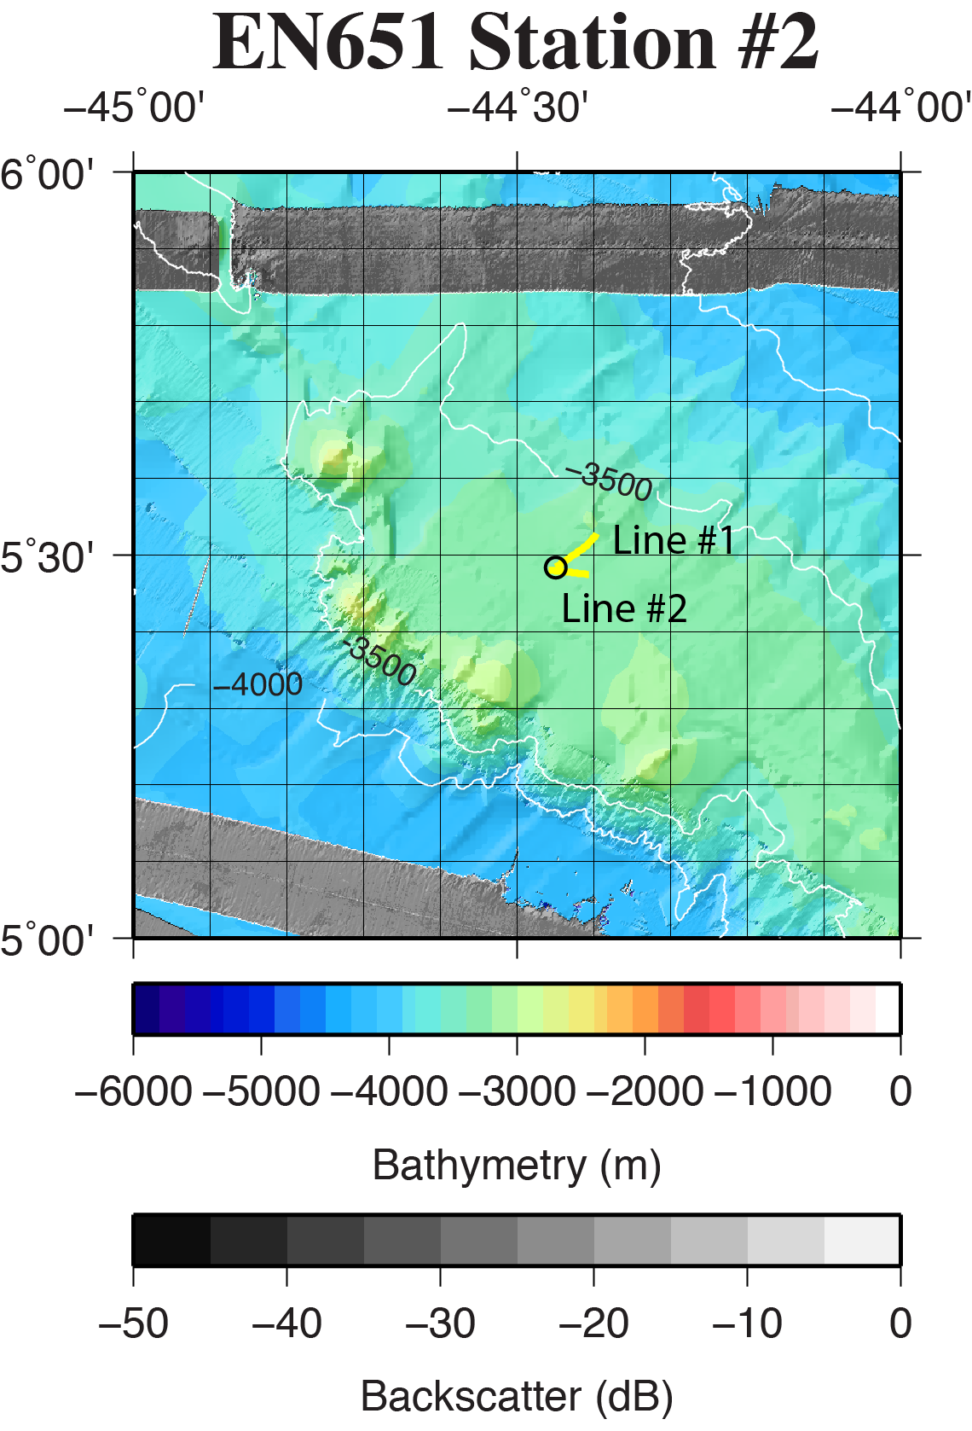

**Figure SR02-1.** Regional location of coring site EN651-02 (black circle) overlain on the GMRT database (Ryan et al., 2009) and available multibeam data. Bathymetry color-change interval is 100 meters with contours labeled every 500 meters. Backscatter intensity grayscale is darker for more reflective regions. Yellow line is the location of CHIRP surveys shown in Fig. SR02-2.

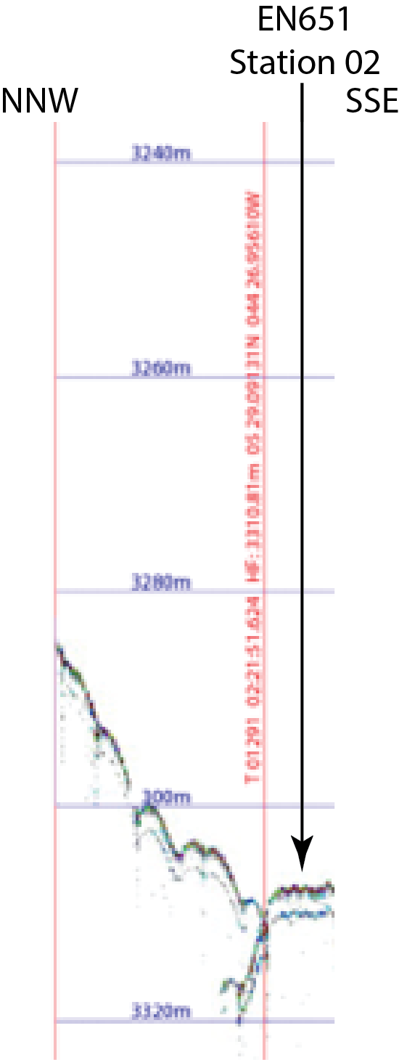

Figure SR02-2: A portion of CHIRP seismic data Line #1surveyed at 10 kts across core site EN651-02. Oceanic crust is not imaged but at least 10m of sediment are visible in the record. The bright subsurface reflector is at ~3 mbsf.

**Site EN651-03 (Abyssal Plain, South American Plate)**

**Site Objectives**

The principal objectives of this site are to,

* Obtain sediment and core material to characterize sediment type and measure black carbon content in upper 20 cm.

**General Description**

Coring site is located on a heavily sedimented abyssal plain with very low relief (< 100 m) vestiges of abyssal hills.

Location: 5˚ 02.38’ N 40˚ 21.77’ W

Water depth: 4650 m (12 kHz Knudsen), 4666 m (GMRT)

Crustal age: 47 Ma (based upon Müller et al., 2008)

Estimated total sediment thickness: 670 m (Divins, 2009).

A minimum of 30 m of sediment was imaged by CHIRP 3.5 kHz seismic system.

Thickness cored: no core recovery, small mud samples available from core parts.

**Operations**

* Site survey with CHIRP 3.5 kHz

- Line #1 - 3/4/20 16:01z to 3/4/20 17:40z

- Line #2 - 3/5/20 00:30z to 3/5/20 00:50z

* CTD to 1000 m (CTD01 with 12 Niskin Bottle water samples taken)
* Multicore deployment with 4 tubes (MC01 - 3/4/20 19:09z to 3/4/20 23:05z)

- added trip-testing pinger and camera

- no mud recovered, except small bits in 2 cores, likely pre-trip

* Multicore deployment with 8 tubes (MC02 - 3/5/20 00:23z to 3/5/20 04:52z)

- no mud recovered, nothing tripped. Just samples from legs

**Lithologic Description**

Foraminiferal marls dark yellowish red (7.5 YR 6/4)

**EN651-03 Survey**

The EN651-03 site was surveyed on March 04, 2020 with Knudsen 320B seismic system. Survey Line #1 began at 16:01z on March 4 and was completed at 17:40z on March 4. Survey Line #2 began at 00:30z on March 5 and was completed at 00:50z on March 5.

The survey results indicate the coring site is located on a heavily sedimented abyssal plain with relatively low relief.

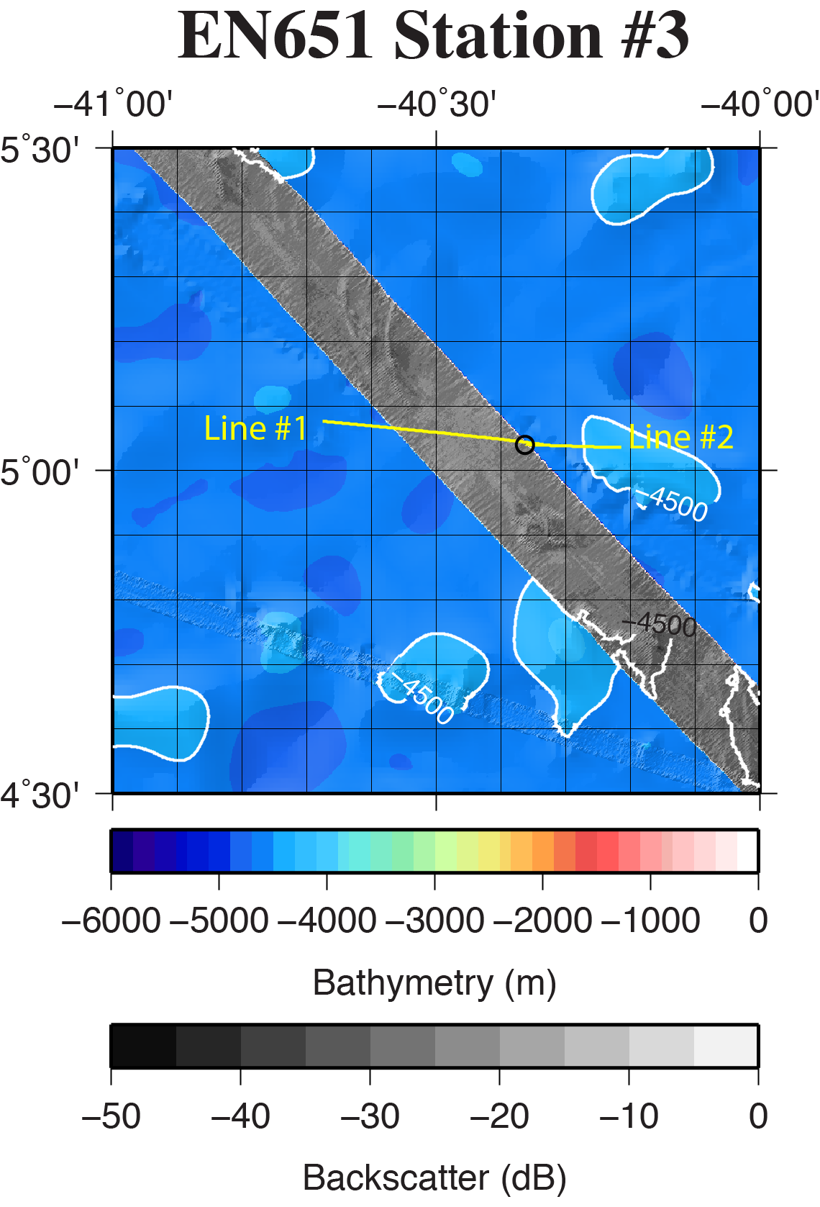

**Figure SR03-1.** Regional location of coring site EN651-03 (black circle) overlain on the GMRT database (Ryan et al., 2009) and available multibeam data. Bathymetry color-change interval is 100 meters with contours labeled every 500 meters. Backscatter intensity grayscale is darker for more reflective regions. Yellow line is the location of CHIRP surveys shown in Fig. SR03-2.

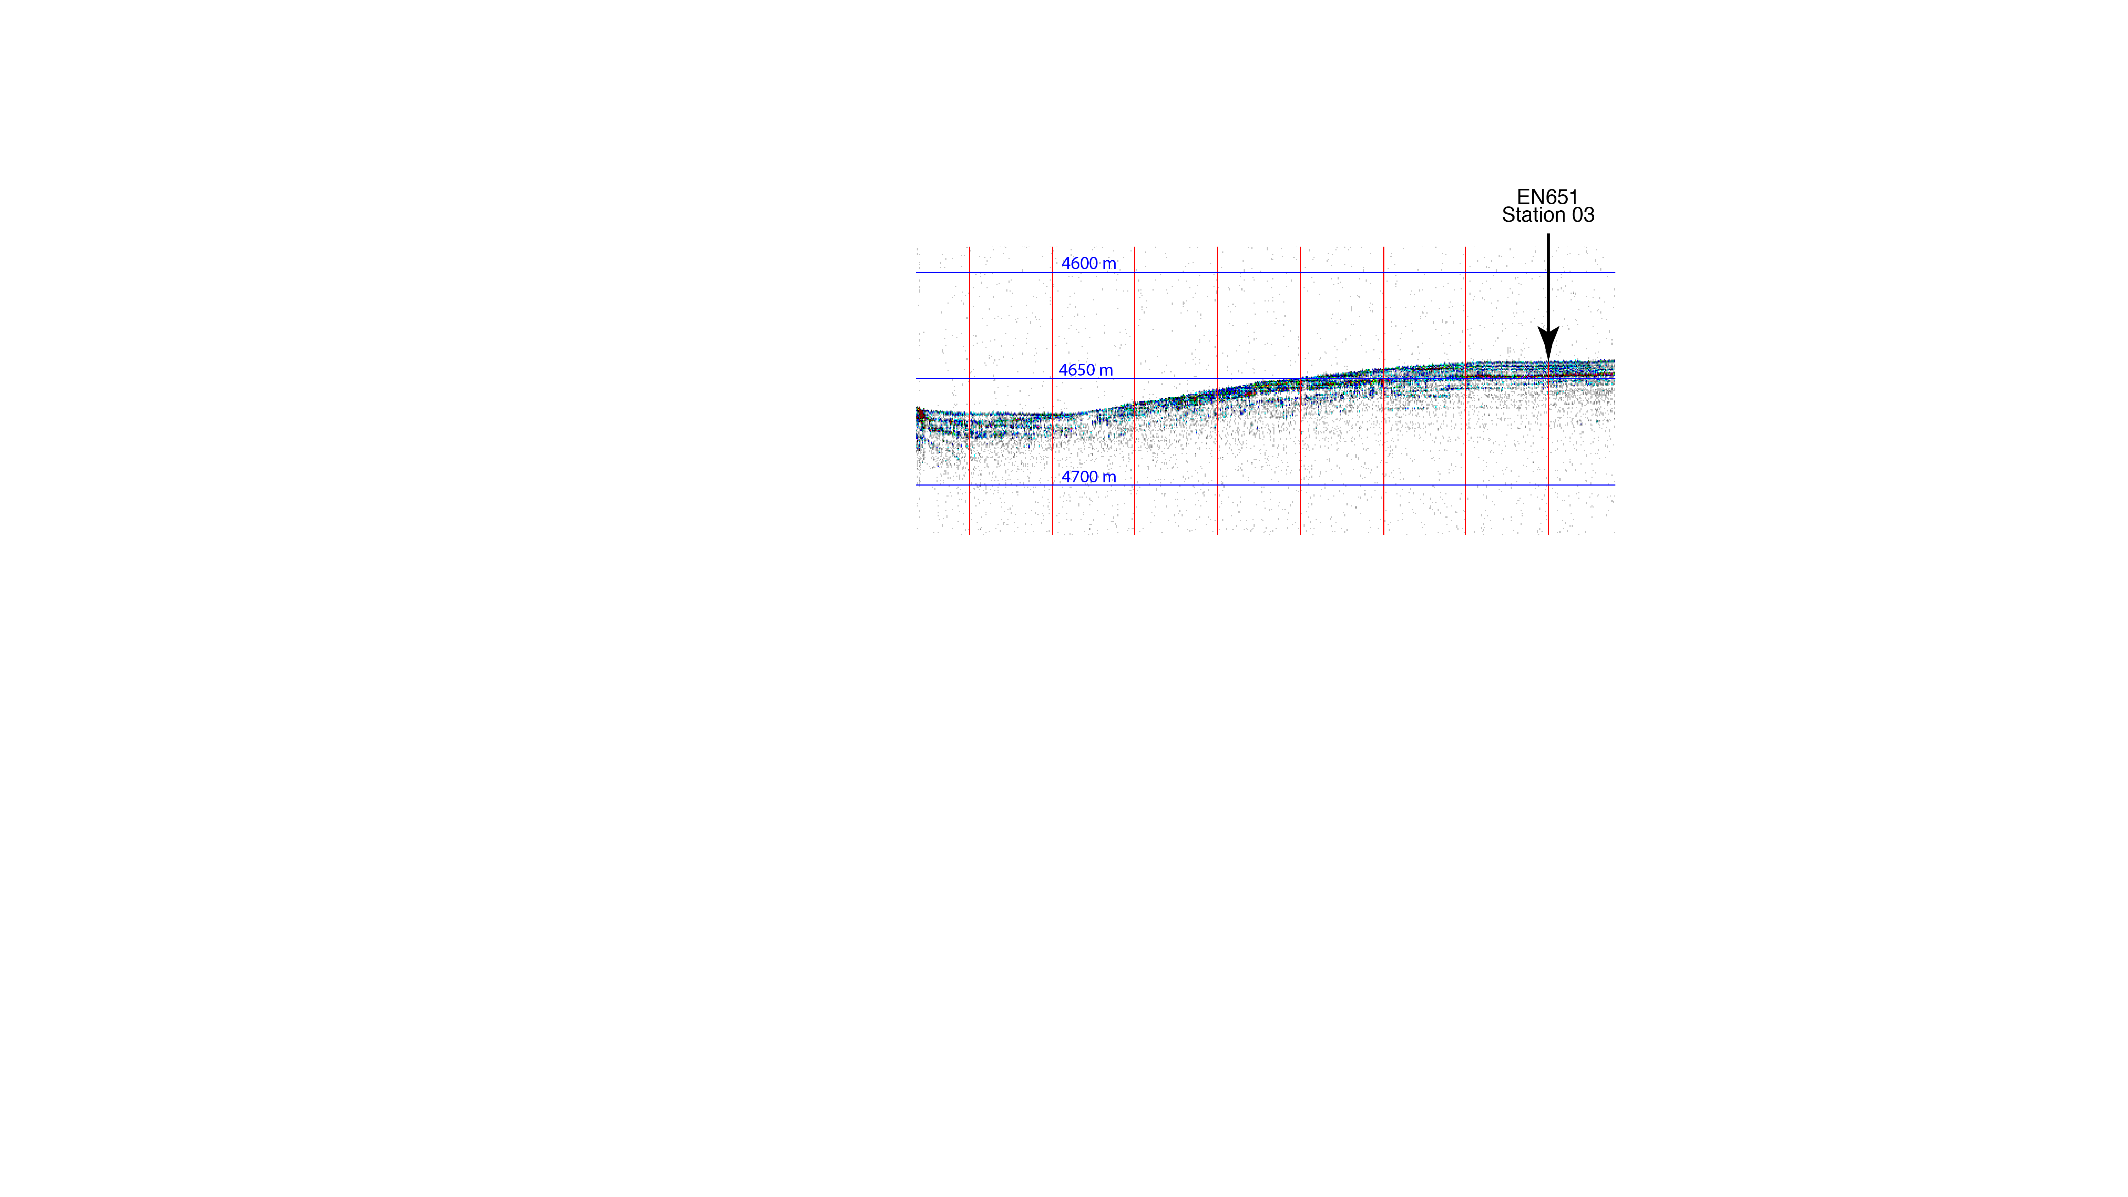

Figure SR03-2: A portion of CHIRP seismic data surveyed at 10 kts across core site EN651-03. Oceanic crust is not imaged but at least 30 m of sediment are visible in the record.

**Site EN651-03b (Abyssal Plain, South American Plate)**

**Site Objectives**

The principal objectives of this site are to,

* Obtain sediment and core material to characterize sediment type and measure black carbon content in upper 20 cm.

**General Description**

Coring site is located on a flat sedimented region between two 150 m to 200 m abyssal hills.

Location: 4˚ 59.81’ N 38˚ 58.80’ W

Water depth: 4660 m (12 kHz Knudsen), 4673 m (GMRT)

Crustal age: 38 Ma (based upon Müller et al., 2008)

Estimated total sediment thickness:540 m (Divins, 2009).

A minimum of 20 m of sediment was imaged by CHIRP 3.5 kHz seismic system.

Thickness cored: ~40 cm cored in all 8 tubes.

**Operations**

* Site survey with CHIRP 3.5 kHz

- Line #1 - 3/5/20 12:43z to 3/5/20 13:00z

- Line #2 - 3/5/20 18:07z to 3/6/20 13:05z

* Multicore deployment with 8 tubes (MC01 - 3/5/20 13:07z to 3/5/20 17:38z)

- added hose clamp to column and reduced width of strings

- all 8 tubes with mud, even open-bottom tubes

**Lithologic Description**

Foraminiferal marls dark yellowish red

Total Core – 44 cm

- 0-20 cm 7.5YR 6/4

- 20-44 cm 7.5 YR 5/4

**EN651-03b Survey**

The EN651-03b site was surveyed on March 05, 2020 with Knudsen 320B seismic system. Survey Line #1 began at 12:43z on March 3 and was completed at 13:00z on March 5. Survey Line #2 began at 18:07z on March 5 and was completed at 13:05z on March 6.

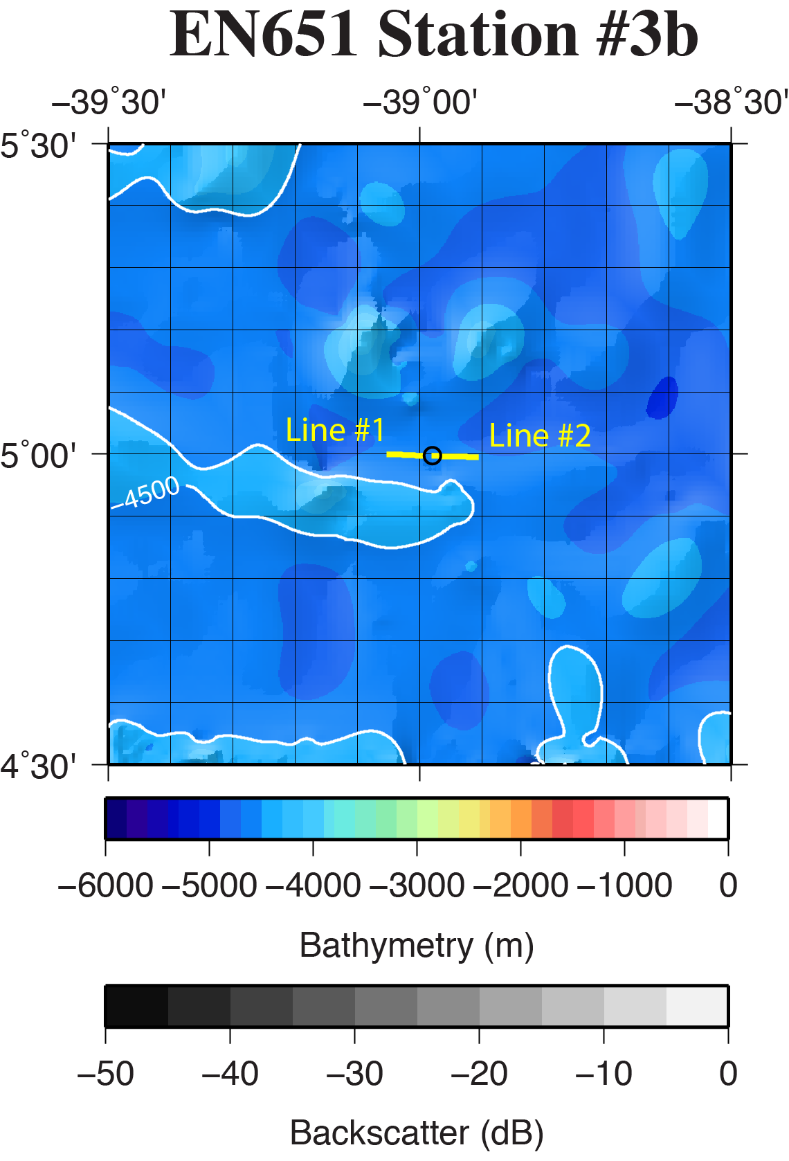

**Figure SR03b-1.** Regional location of coring site EN651-03b (black circle) overlain on the GMRT database (Ryan et al., 2009) and available multibeam data. Bathymetry color-change interval is 100 meters with contours labeled every 500 meters. Backscatter intensity grayscale is darker for more reflective regions. Yellow line is the location of CHIRP surveys shown in Fig. SR03b-2.

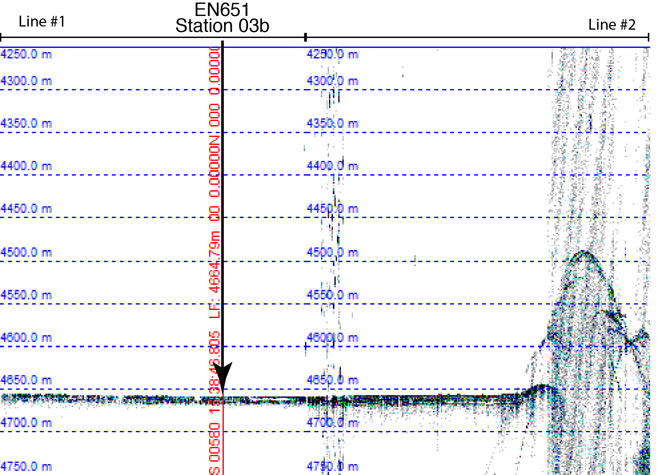

**Figure SR03b-2:** A portion of CHIRP seismic data surveyed at 10 kts across core site EN651-03b. Oceanic crust is not imaged but at least 20 m of sediment are visible in the record.

**Site EN651-04 (Abyssal Hills, South American Plate)**

**Site Objectives**

The principal objectives of this site are to,

* Obtain sediment and core material to characterize sediment type and measure black carbon content in upper 20 cm.
* Deep water CTD and water samples (e.g., > 1000 m)

**General Description**

Coring site is located on a narrow sedimented depression/valley between two 100 m to 400 m abyssal hills.

Location: 4˚ 59.93’ N 35˚ 47.46’ W

Water depth: 3993 m (12 kHz Knudsen), 3644 m (GMRT)

Crustal age: 20 Ma (based upon Müller et al., 2008)

Estimated total sediment thickness:382 m (Divins, 2009).

A minimum of 20 m of sediment was imaged by CHIRP 3.5 kHz seismic system.

Thickness cored: ~30 cm cored in all 8 tubes.

**Operations**

* Site survey with CHIRP 3.5 kHz

- Line #1 - 3/6/20 12:31z to 3/6/20 12:56z

* Deep-water CTD to 3970 m, 12 Niskin Bottle water samples

- CTD01 - 3/6/20 13:27z to 3/6/20 16:10z

* Multicore deployment with 8 tubes

- MC01 - 3/6/20 16:40z to 3/5/20 20:28z

- 4 normal tubes, 2 open top and bottom, 2 open bottom

- only 4normal tubes had mud

**Lithologic Description**

Foraminiferal marls dark yellowish red. Nearly identical to Station 4 lithology.

Total Core – 30 cm

- 0-11 cm 5YR 6/4

- 11-25 cm 5 YR 8/4

- 25 – 30 cm 5 YR 7/6

**EN651-04 Survey**

The EN651-04 site was surveyed on March 06, 2020 with Knudsen 320B seismic system. Survey Line #1 began at 12:31z on March 3 and was completed at 12:56z on March 6.

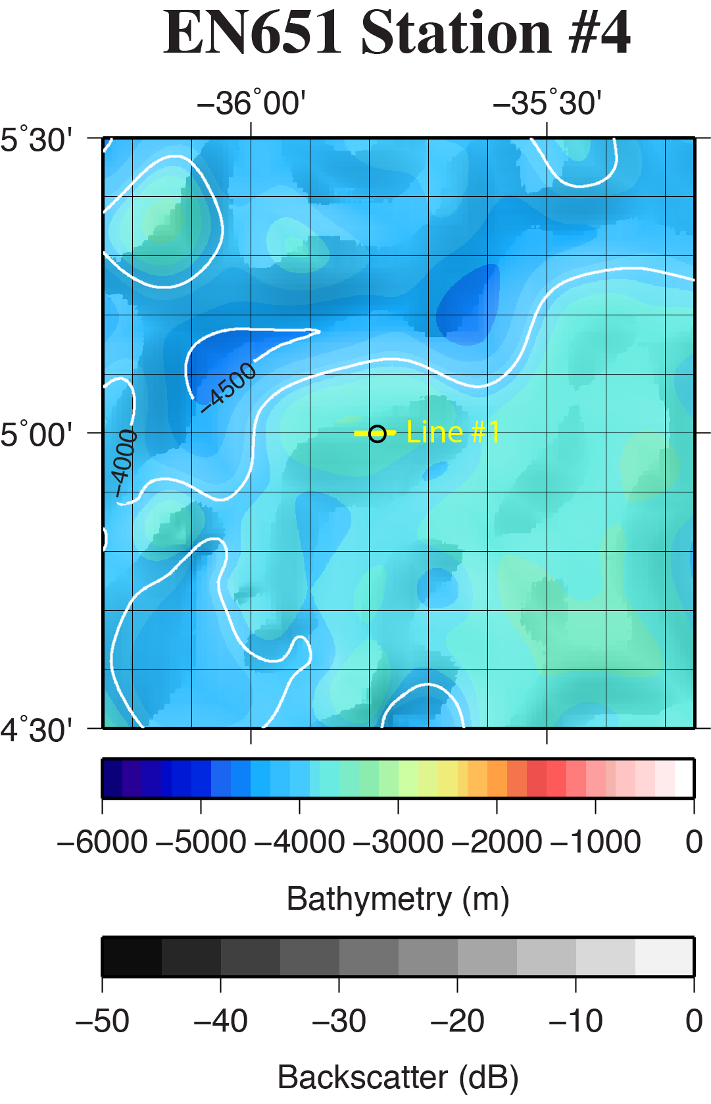

**Figure SR04-1.** Regional location of coring site EN651-04 (black circle) overlain on the GMRT database (Ryan et al., 2009) and available multibeam data. Bathymetry color-change interval is 100 meters with contours labeled every 500 meters. Backscatter intensity grayscale is darker for more reflective regions. Yellow line is the location of CHIRP surveys shown in Fig. SR04-2.

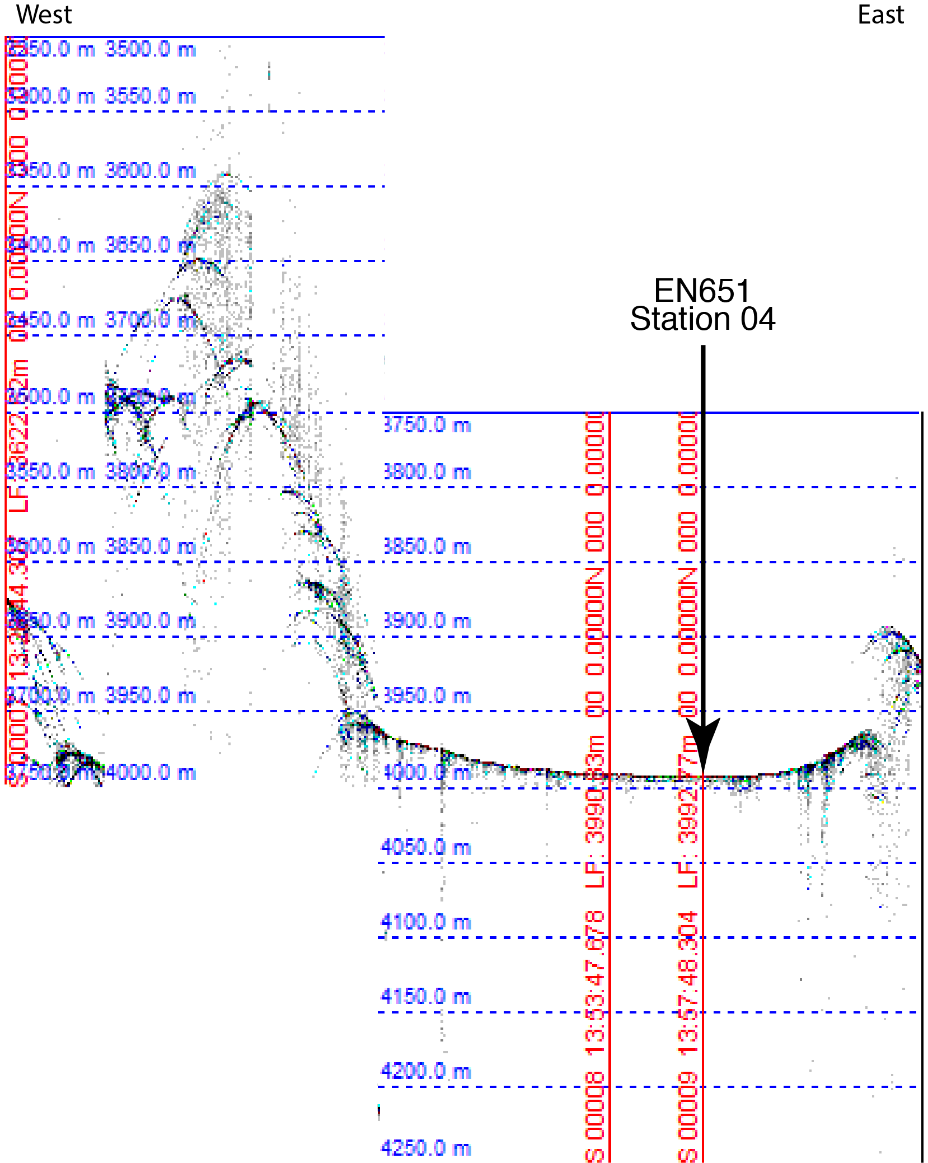

**Figure SR04-2:** A portion of CHIRP seismic data surveyed at 10 kts across core site EN651-04. Oceanic crust is not imaged but at least 10 m of sediment are visible in the record.

**Site EN651-05 (Mid-Atlantic Ridge, South American Plate)**

**Site Objectives**

The principal objectives of this site are to,

* Obtain sediment and core material to characterize sediment type and measure black carbon content in upper 20 cm.
* Deep water CTD and water samples (e.g., > 1000 m)

**General Description**

Coring site is located on a flat sedimented region between two 100 m to 200 m abyssal hills.

Location: 5˚ 00.19’ N 33˚ 36.60’ W

Water depth: 3730 m (12 kHz Knudsen), 3830 m (GMRT)

Crustal age: 6 Ma (based upon Müller et al., 2008)

Estimated total sediment thickness:106 m (Divins, 2009).

A minimum of 10 m of sediment was imaged by CHIRP 3.5 kHz seismic system.

Thickness cored: ~35 cm cored in 6 of 8 tubes.

**Operations**

* Site survey with CHIRP 3.5 kHz

- Line #1 - 3/7/20 10:27z to 3/7/20 11:26z

* Deep-water CTD to 3700 m, 12 Niskin Bottle water samples

- CTD01 - 3/7/20 11:35z to 3/7/20 14:18z

* Multicore deployment with 8 tubes (6 normal, one open top, one closed top)

- MC01 - 3/7/20 14:47z to 3/7/20 15:40z (aborted, false pre-trip indicator)

- MC02 - 3/7/20 15:57z to 3/7/20 17:10z (aborted, false pre-trip indicator)

- MC03 - 3/7/20 17:40z to 3/7/20 21:15z

**Lithologic Description**

Foraminiferal marls dark yellowish red. Nearly identical to Station 4 lithology.

Total Core – 35 cm

- 0 - 12 cm 5YR 7/8

- 12 - 27 cm 2.5 YR 8/4

- 27 - 35 cm 5 YR 7/4

**EN651-05 Survey**

The EN651-05 site was surveyed on March 07, 2020 with Knudsen 320B seismic system. Survey Line #1 began at 10:27z on March 7 and was completed at 11:26z on March 7.

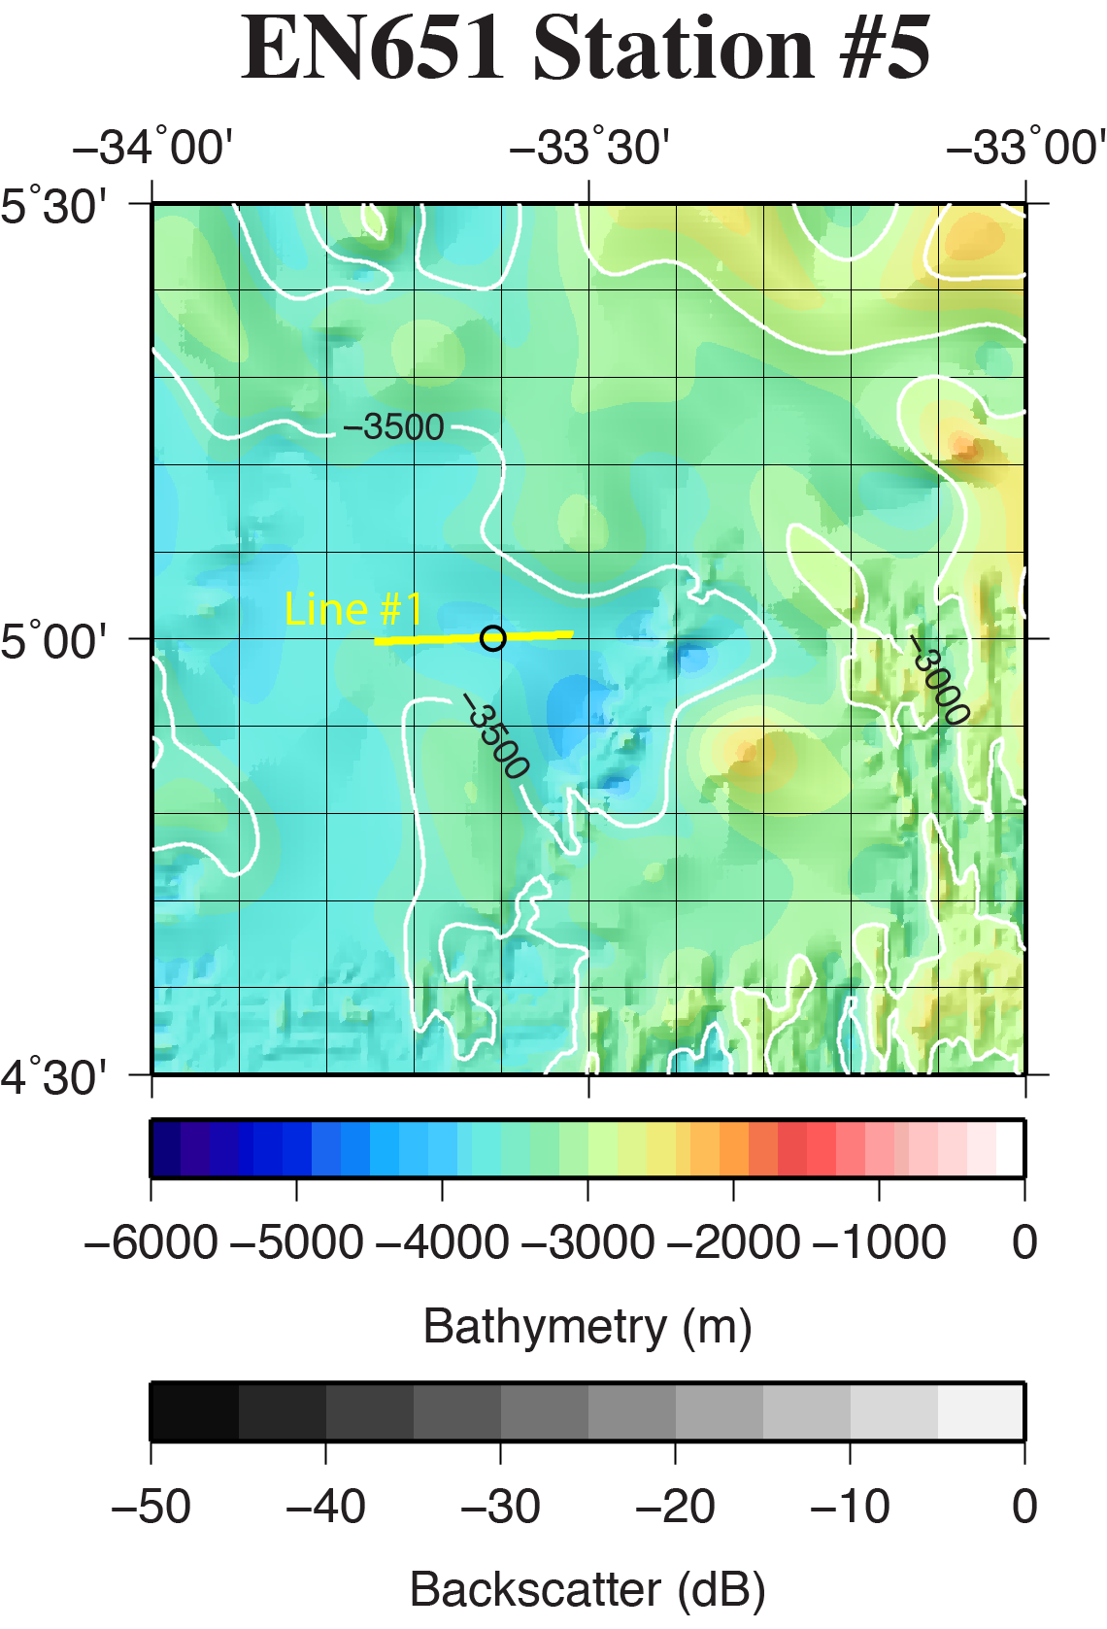

**Figure SR05-1.** Regional location of coring site EN651-05 (black circle) overlain on the GMRT database (Ryan et al., 2009) and available multibeam data. Bathymetry color-change interval is 100 meters with contours labeled every 500 meters. Backscatter intensity grayscale is darker for more reflective regions. Yellow line is the location of CHIRP surveys shown in Fig. SR05-2.

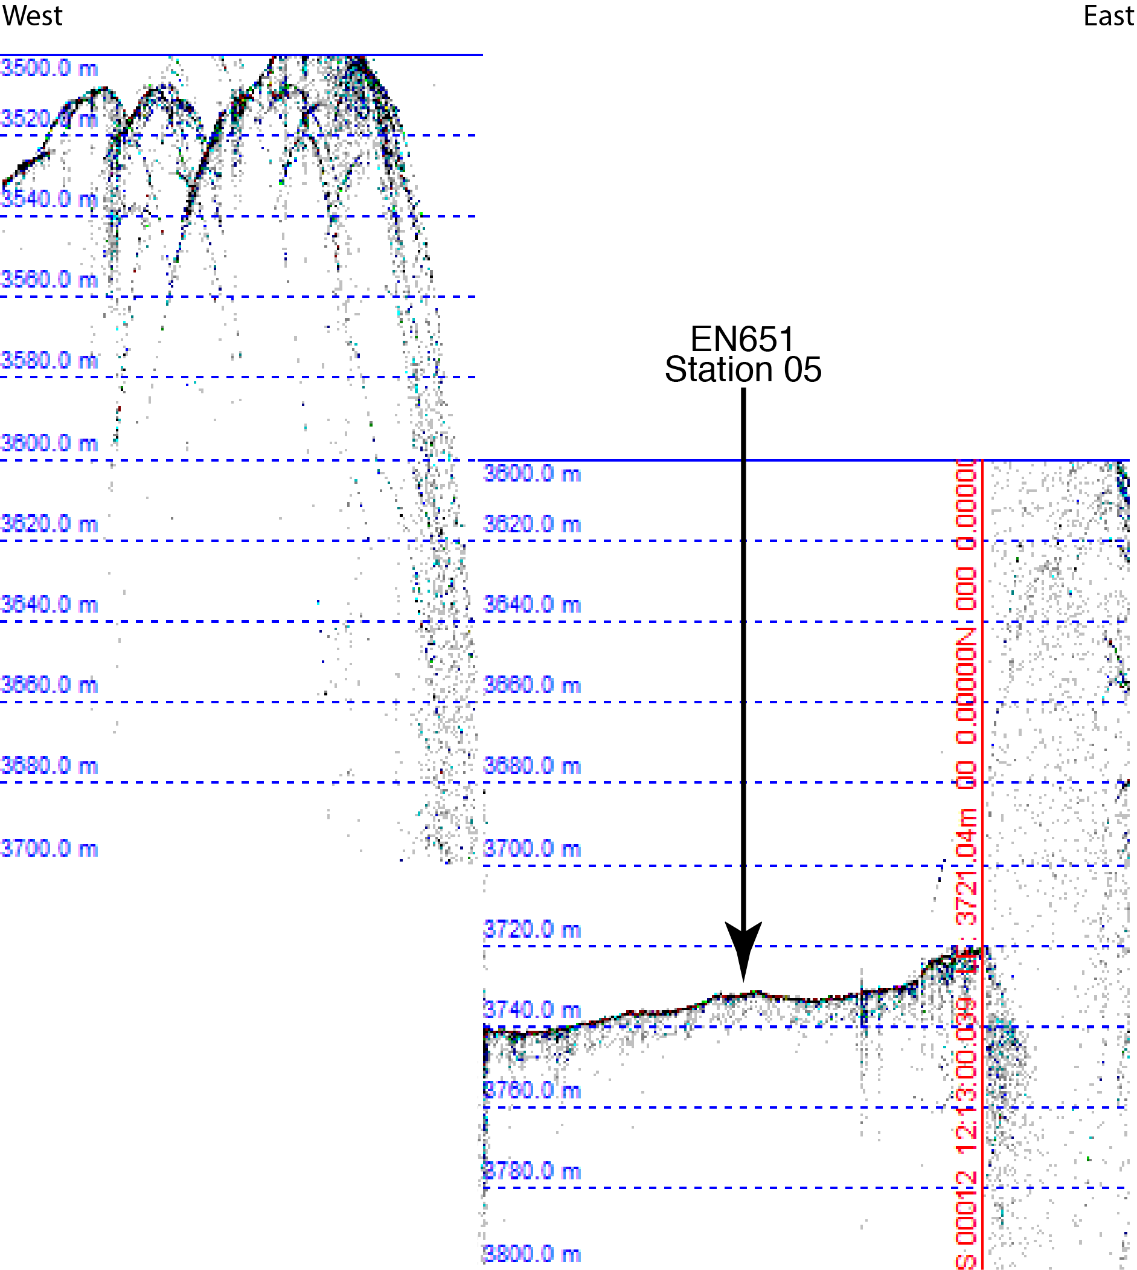

**Figure SR05-2:** A portion of CHIRP seismic data surveyed at 10 kts across core site EN651-05. Oceanic crust is not imaged but at least 10 m of sediment are visible in the record.

**Site EN651-06 (Mid-Atlantic Ridge, African Plate)**

**Site Objectives**

The principal objectives of this site are to,

* Obtain sediment and core material to characterize sediment type and measure black carbon content in upper 20 cm.
* Deep water CTD and water samples (e.g., > 1000 m)

**General Description**

Coring site is located on a flat sedimented region between two 100 m abyssal hills.

Location: 4˚ 59.80’ N 30˚ 4.40’ W

Water depth: 3605 m (12 kHz Knudsen), 3630 m (GMRT)

Crustal age: 18 Ma (based upon Müller et al., 2008)

Estimated total sediment thickness:100 m (Divins, 2009).

Sub-bottom sediment reflectors were not imaged by CHIRP 3.5 kHz seismic system.

Thickness cored: ~35 cm cored in 6 of 8 tubes.

**Operations**

* Site survey with CHIRP 3.5 kHz

- Line #1 - 3/8/20 18:30z to 3/8/20 19:15z

* Deep-water CTD to 3575 m, 12 Niskin Bottle water samples

- CTD01 - 3/8/20 19:46z to 3/8/20 22:07z

* Multicore deployment with 8 tubes (6 normal, one open top, one closed top)

- MC01 - 3/8/20 22:31z to 3/7/20 02:01z (6 tubes)

**Lithologic Description**

Foraminiferal marls dark yellowish red.

Total Core – 35 cm

- 0 - 13 cm 5YR 7/2

- 13 - 25 cm 5YR 8/2

- 25 - 35 cm 5 YR 7/6. (darker bands)

**EN651-06 Survey**

The EN651-06 site was surveyed on March 08, 2020 with Knudsen 320B seismic system. Survey Line #1 began at 18:30z on March 8 and was completed at 19:15z on March 8.

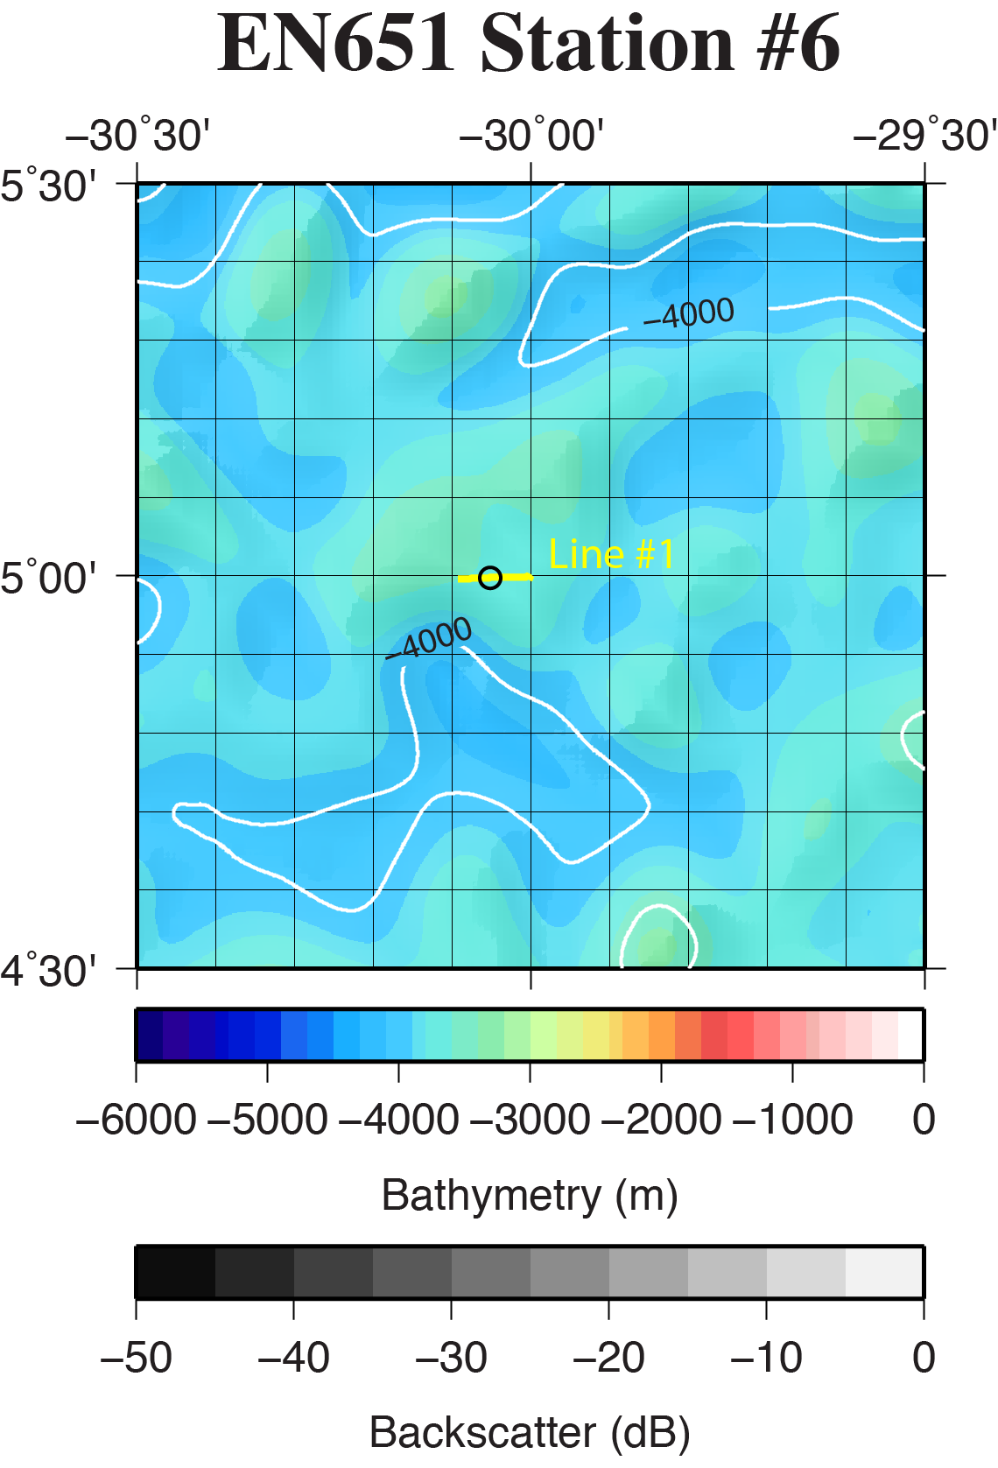

**Figure SR06-1.** Regional location of coring site EN651-06 (black circle) overlain on the GMRT database (Ryan et al., 2009) and available multibeam data. Bathymetry color-change interval is 100 meters with contours labeled every 500 meters. Backscatter intensity grayscale is darker for more reflective regions. Yellow line is the location of CHIRP surveys shown in Fig. SR06-2.

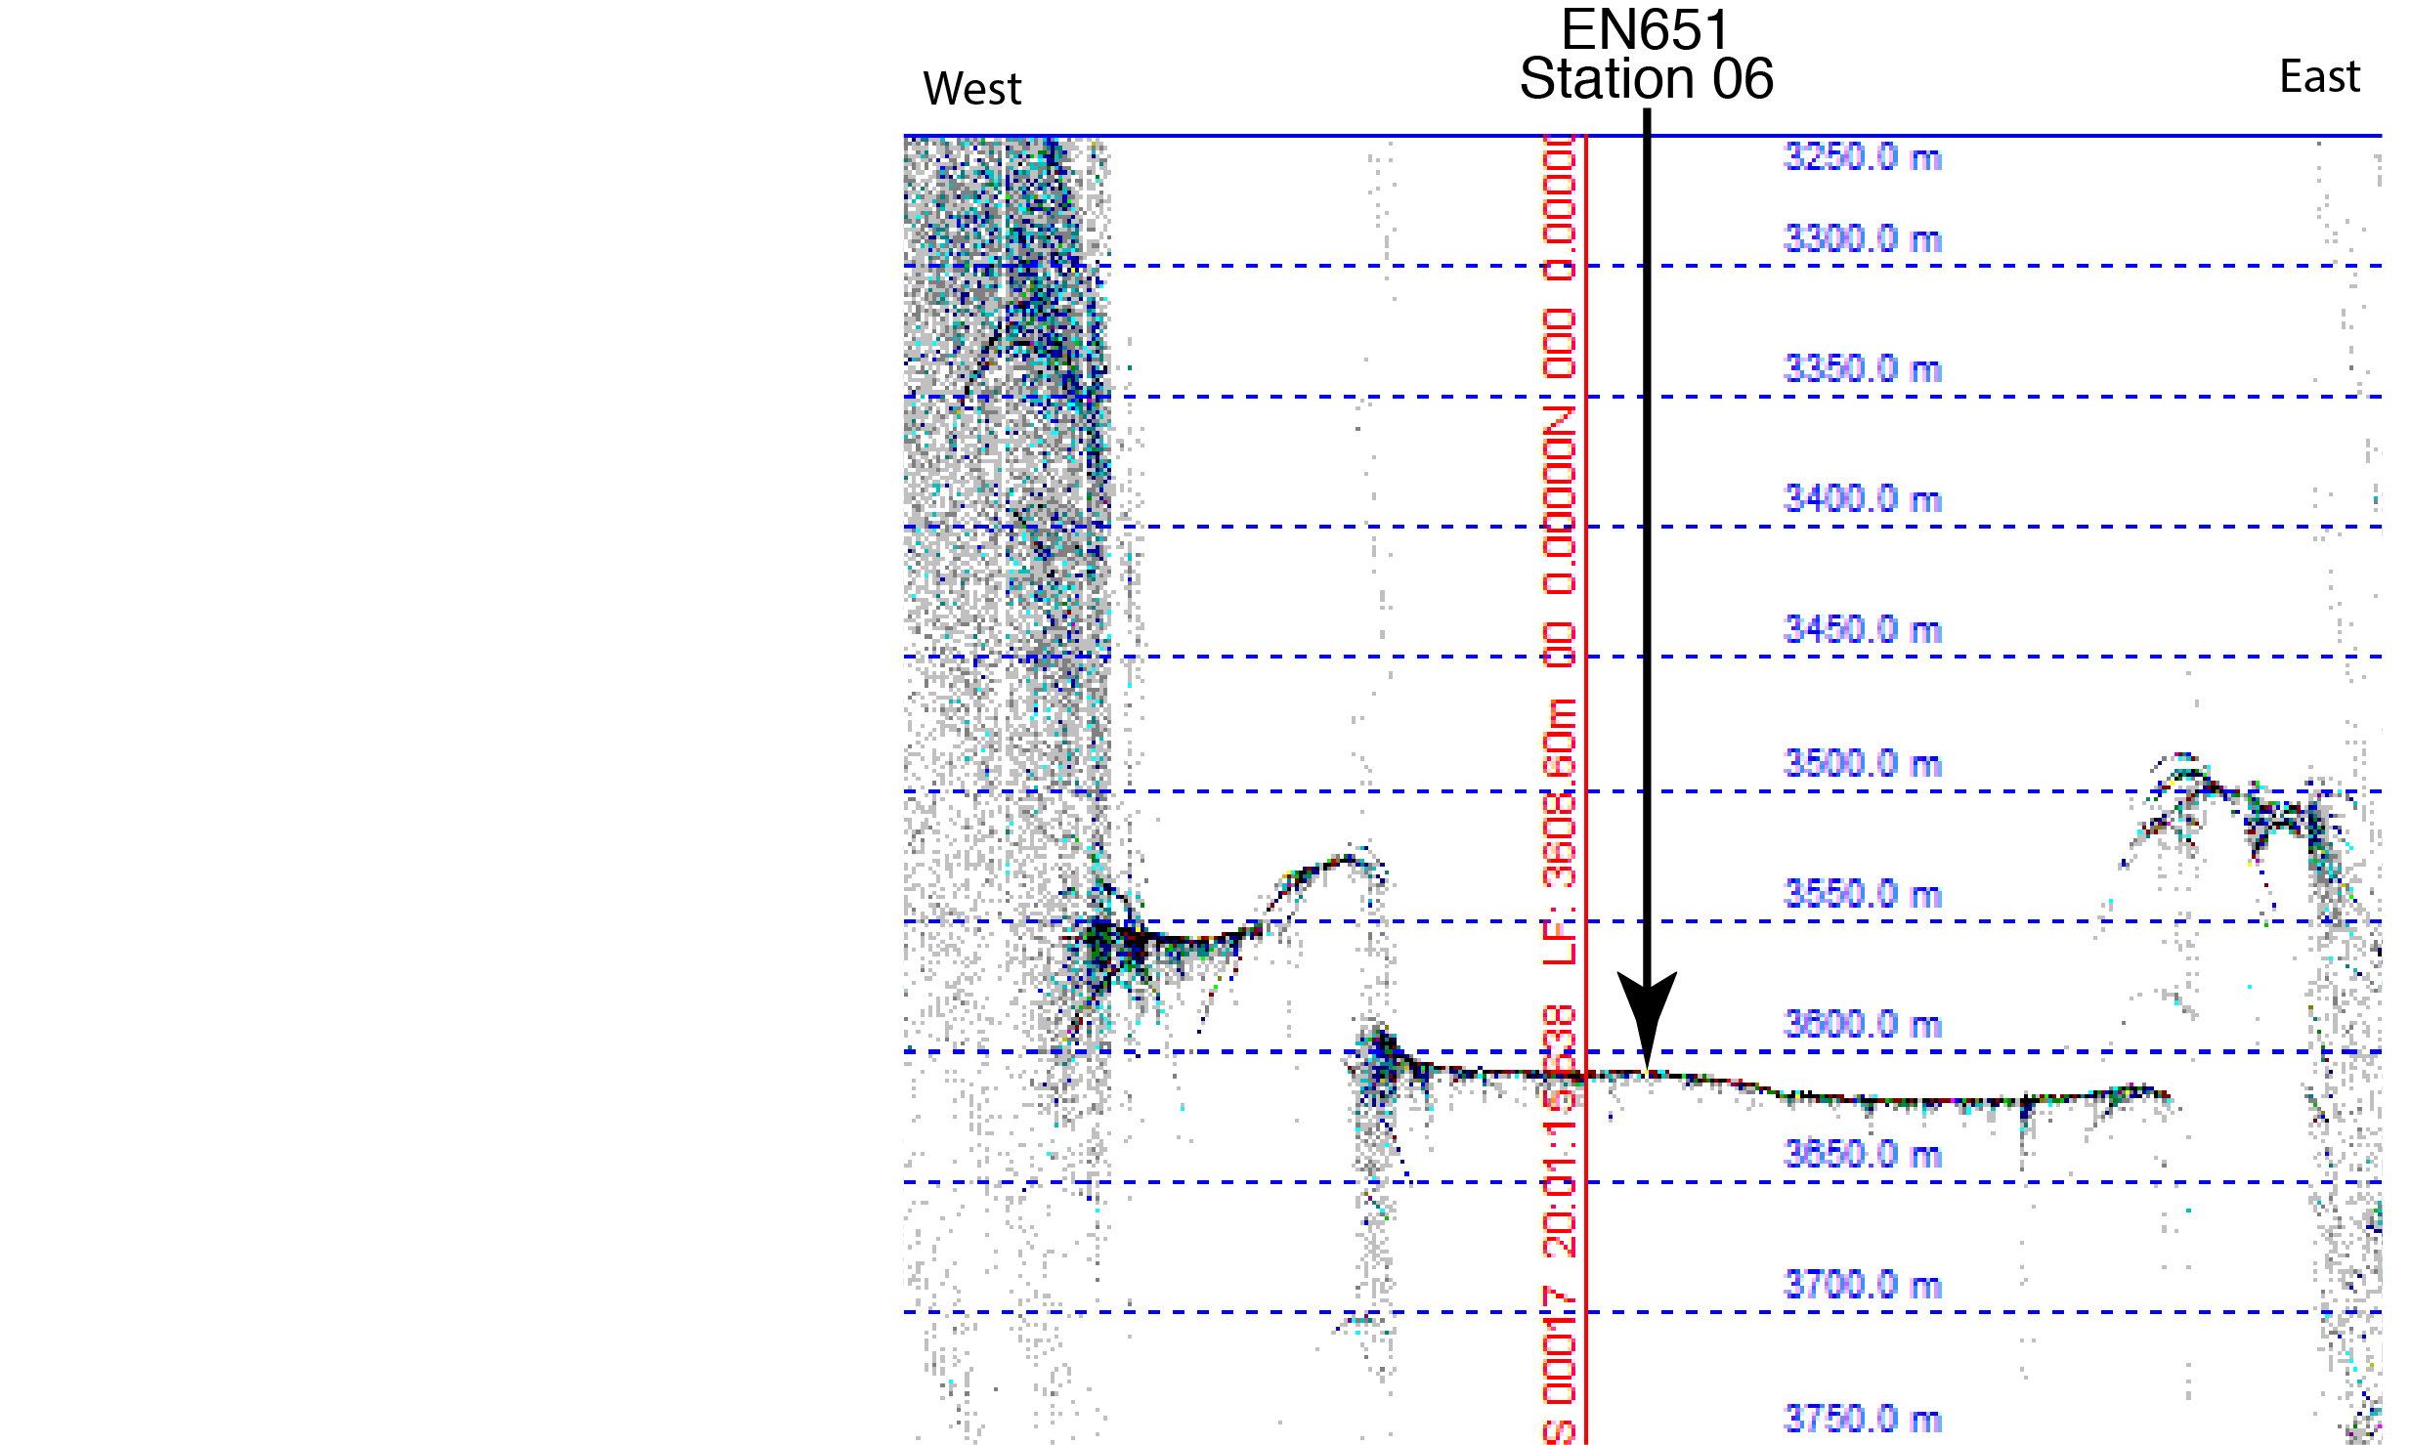

**Figure SR06-2:** A portion of CHIRP seismic data surveyed at 10 kts across core site EN651-06. Oceanic crust is not imaged and definitive sediment layers are not visible in the record.

**Site EN651-07 (Abyssal Plain, African Plate)**

**Site Objectives**

The principal objectives of this site are to,

* Obtain sediment and core material to characterize sediment type and measure black carbon content in upper 20 cm.
* CTD to 1000 m and water samples

**General Description**

Coring site is located on a very flat sedimented region between two small 20 m high abyssal hills.

Location: 5˚ 09.90’ N 27˚ 00.00’ W

Water depth: 4276 m (12 kHz Knudsen), 4375 m (GMRT)

Crustal age: 37 Ma (based upon Müller et al., 2008)

Estimated total sediment thickness:470 m (Divins, 2009).

Sub-bottom sediment reflectors were imaged to at least 20 m by CHIRP 3.5 kHz seismic system.

Thickness cored: ~40 cm cored in 7 of 8 tubes.

**Operations**

* Site survey with CHIRP 3.5 kHz

- Line #1 - 3/9/20 18:48z to 3/9/20 19:45z

- Line #2 - 3/10/20 01:09z to 3/9/20 02:05z

* CTD to 1000 m, 12 Niskin Bottle water samples

- CTD01 - 3/9/20 19:52z to 3/9/20 23:07z

* Multicore deployment with 8 tubes (6 normal, one open top, one closed top)

- MC01 - 3/9/20 21:03z to 3/10/20 01:09z (7tubes)

**Lithologic Description**

Foraminiferal marls dark yellowish red.

Total Core – 40 cm

- 0 - 15 cm 5YR 7/2

- 15 - 25 cm 5YR 8/3

- 25 - 40 cm 5 YR 7/3. (darker bands)

**EN651-07 Survey**

The EN651-07 site was surveyed on March 09, 2020 with Knudsen 3260 seismic system. Survey Line #1 began at 18:48z on March 9 and was completed at 19:45z on March 9. Survey Line #2 began at 01:09z on March 10 and was completed at 02:05z on March 10

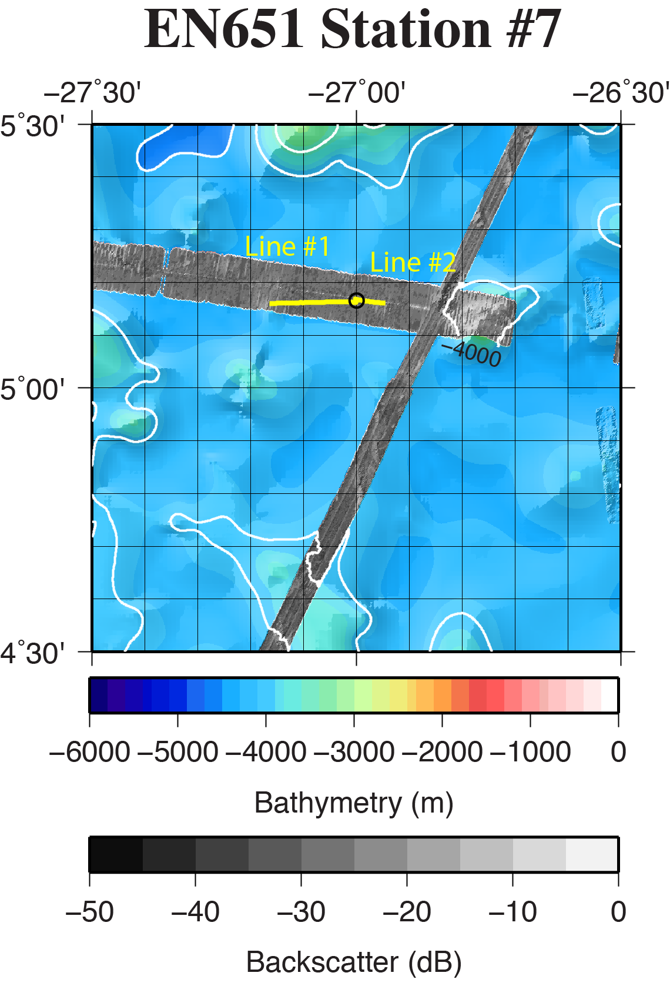

**Figure SR07-1.** Regional location of coring site EN651-07 (black circle) overlain on the GMRT database (Ryan et al., 2009) and available multibeam data. Bathymetry color-change interval is 100 meters with contours labeled every 500 meters. Backscatter intensity grayscale is darker for more reflective regions. Yellow line is the location of CHIRP surveys shown in Fig. SR07-2.

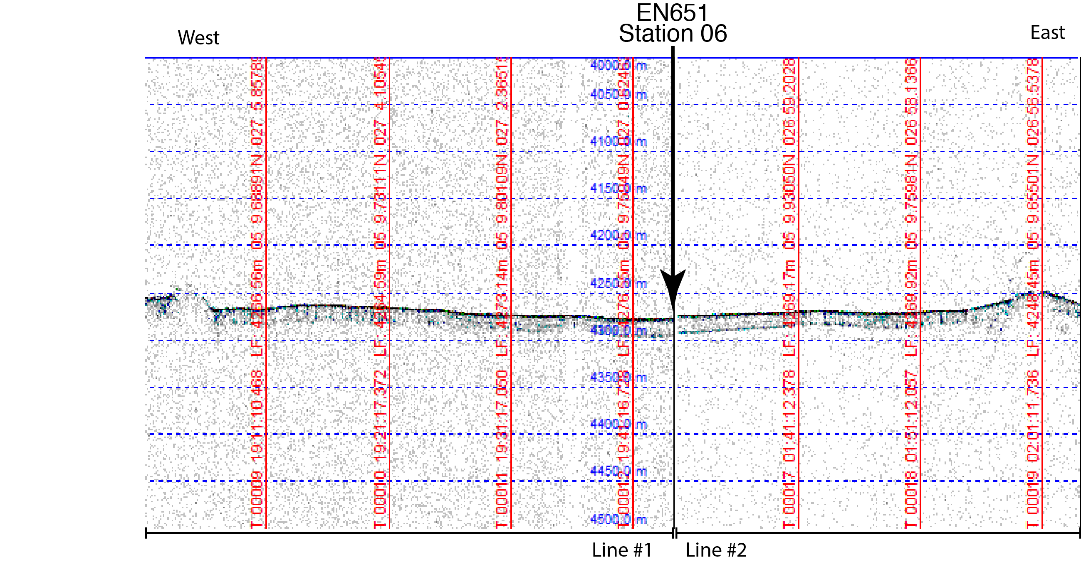

**Figure SR07-2:** A portion of CHIRP seismic data surveyed at 10 kts across core site EN651-07. Oceanic crust is not imaged but at least 20 m of sediment are visible in the record.

**Site EN651-08 (Abyssal Plain, African Plate)**

**Site Objectives**

The principal objectives of this site are to,

* Obtain sediment and core material to characterize sediment type and measure black carbon content in upper 20 cm.
* CTD to 1000 m and water samples

**General Description**

Coring site is located in a sedimented valley region between a 100 m and 200 m abyssal hill.

Location: 5˚ 00.00’ N 23˚ 26.50’ W

Water depth: 4310 m (12 kHz Knudsen), 4100 m (GMRT)

Crustal age: 57 Ma (based upon Müller et al., 2008)

Estimated total sediment thickness:750 m (Divins, 2009).

Sub-bottom sediment reflectors were imaged to at least 20 m by CHIRP 3.5 kHz seismic system.

Thickness cored: ~40 cm cored in 8 of 8 tubes.

**Operations**

* Site survey with CHIRP 3.5 kHz

- Line #1 - 3/10/20 21:41z to 3/10/20 22:24z

- Line #2 - 3/11/20 04:25z to 3/9/20 04:58z

* CTD to 1000 m, 12 Niskin Bottle water samples

- CTD01 - 3/10/20 22:47z to 3/10/20 23:35z

* Multicore deployment with 8 tubes (6 normal, one open top, one closed top)

- MC01 - 3/11/20 00:03z to 3/11/20 04:16z (8 tubes)

**Lithologic Description**

Foraminiferal marls dark yellowish red.

Total Core – 40 cm

- 0 - 15 cm 5YR 7/2

- 15 - 25 cm 5YR 8/2

- 25 - 40 cm 7.25 YR 7/4. (darker bands)

**EN651-08Survey**

The EN651-08 site was surveyed on March 10, 2020 with Knudsen 3260 seismic system. Survey Line #1 began at 21:41z on March 10 and was completed at 22:24z on March 10. Survey Line #2 began at 04:25z on March 11 and was completed at 04:58z on March 11

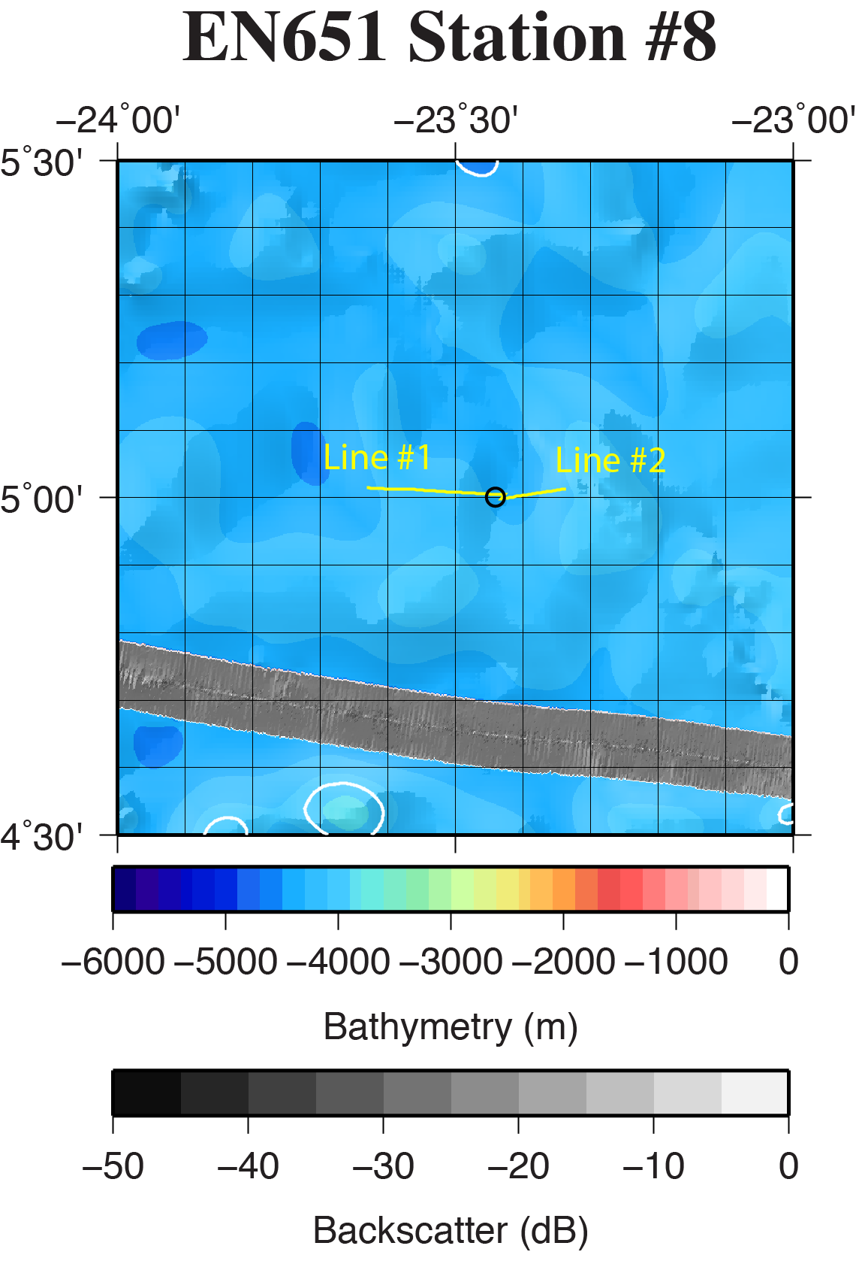

**Figure SR08-1.** Regional location of coring site EN651-08 (black circle) overlain on the GMRT database (Ryan et al., 2009) and available multibeam data. Bathymetry color-change interval is 100 meters with contours labeled every 500 meters. Backscatter intensity grayscale is darker for more reflective regions. Yellow line is the location of CHIRP surveys shown in Fig. SR08-2.

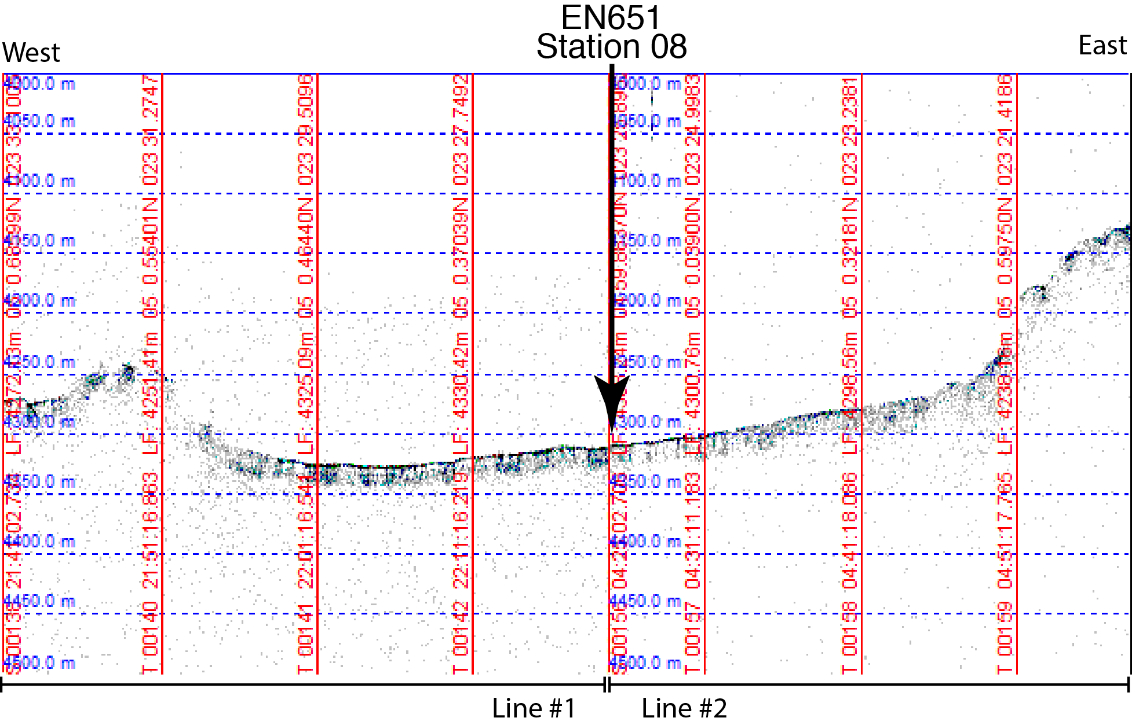

**Figure SR08-2:** A portion of CHIRP seismic data surveyed at 10 kts across core site EN651-08. Oceanic crust is not imaged but at least 20 m of sediment are visible in the record.

**Site EN651-09 (Sierra Leone Rise)**

**Site Objectives**

The principal objectives of this site are to,

* Obtain sediment and core material to characterize sediment type and measure black carbon content in upper 20 cm.
* CTD to 1000 m and water samples

**General Description**

Coring site is located in top of an elevated region on the southern portion of the Sierra Leone Rise. The local topography is somewhat uneven and rolling.

Location: 5˚ 30.10’ N 20˚ 00.00’ W

Water depth: 2840 m (12 kHz Knudsen), 2950 m (GMRT)

Crustal age: 77 Ma (based upon Müller et al., 2008)

Estimated total sediment thickness:1950 m (Divins, 2009).

Poor penetration of sub-bottom sediment. No obvious deeper reflectors imaged by CHIRP 3.5 kHz seismic system.

Thickness cored: ~40 cm cored in 8 of 8 tubes, some tubes less. May have entered at an angle.

**Operations**

* Site survey with CHIRP 3.5 kHz

- Line #1 - 3/11/20 22:25z to 3/12/20 00:08z

- Line #2 - 3/12/20 04:28z to 3/12/20 05:00z

* CTD to 1000 m, 12 Niskin Bottle water samples

- CTD01 - 3/12/20 00:21z to 3/12/20 01:10z

* Multicore deployment with 8 tubes (7 normal, one closed top)

- MC01 - 3/12/20 01:35z to 3/12/20 04:19z (8 tubes)

**Lithologic Description**

Foraminiferal marls dark yellowish red.

Total Core – 40 cm

- 0 - 15 cm 7.5YR 7/2

- 15 - 25 cm 5YR 8/2

- 25 - 40 cm 7.5 YR 7/4

**EN651-09Survey**

The EN651-09 site was surveyed on March 11-12, 2020 with Knudsen 3260 seismic system. Survey Line #1 began at 22:25z on March 11 and was completed at 00:08z on March 12. Survey Line #2 began at 04:28z on March 11 and was completed at 05:00z on March 12

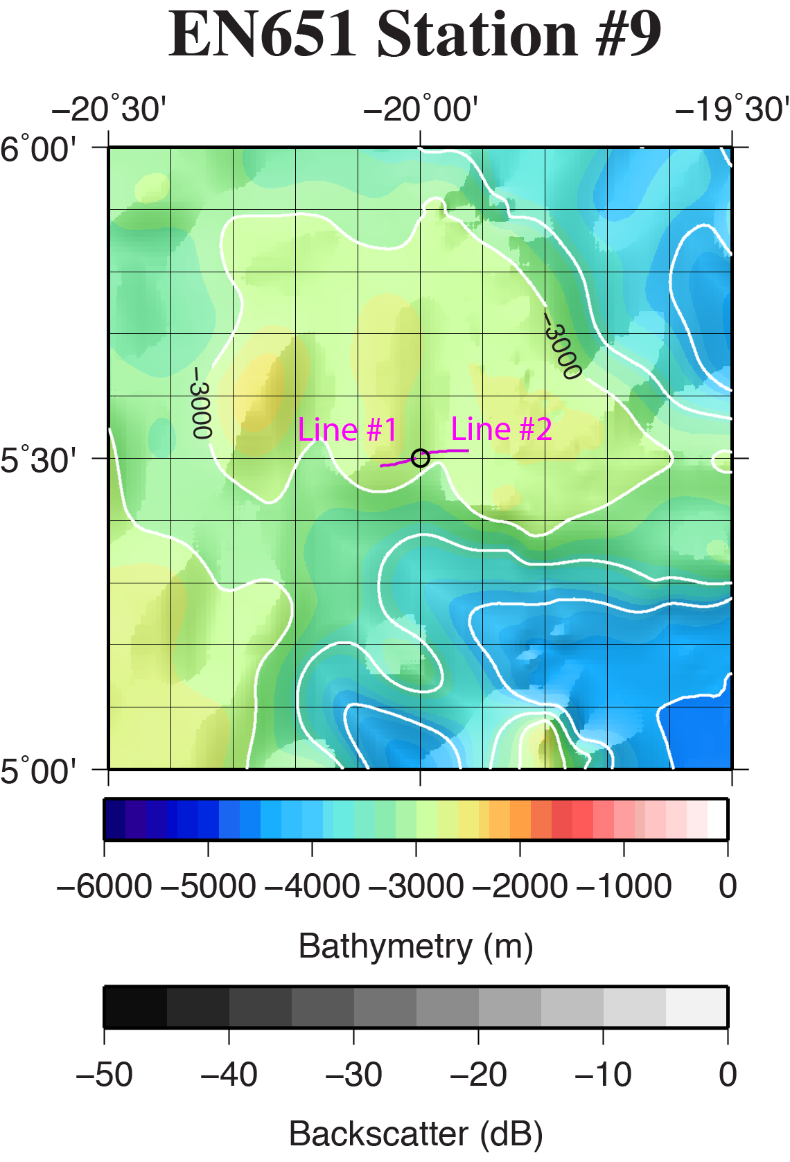

**Figure SR09-1.** Regional location of coring site EN651-09 (black circle) overlain on the GMRT database (Ryan et al., 2009) and available multibeam data. Bathymetry color-change interval is 100 meters with contours labeled every 500 meters. Backscatter intensity grayscale is darker for more reflective regions. Magenta lines indicate the location of CHIRP surveys shown in Fig. SR09-2.

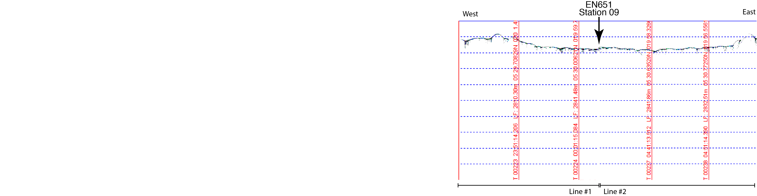

**Figure SR09-2:** A portion of CHIRP seismic data surveyed at 10 kts across core site EN651-09.

**Site EN651-10 (Sierra Leone Basin)**

**Site Objectives**

The principal objectives of this site are to,

* Obtain sediment and core material to characterize sediment type and measure black carbon content in upper 20 cm.
* CTD to 1000 m and water samples

**General Description**

Coring site is located in a broad sedimented basin between the Sierra Leone Rise to the west and Africa to the east.

Location: 5˚ 30.00’ N 17˚ 30.00’ W

Water depth: 4965 m (12 kHz Knudsen), 5000 m (GMRT)

Crustal age: 89 Ma (based upon Müller et al., 2008)

Estimated total sediment thickness:2000 m (Divins, 2009).

Very good characterization of the upper 40 m of sub-bottom sediment with the CHIRP 3.5 kHz seismic system.

Thickness cored: ~45 cm cored in 8 of 8 tubes.

**Operations**

* Site survey with CHIRP 3.5 kHz

- Line #1 - 3/12/20 17:33z to 3/12/20 18:17z

- Line #2 - 3/13/20 00:32z to 3/13/20 01:01z

* CTD to 1000 m, 12 Niskin Bottle water samples

- CTD01 - 3/12/20 18:24z to 3/12/20 19:12z

* Multicore deployment with 8 tubes (7 normal, one closed top)

- MC01 - 3/12/20 01:34z to 3/13/20 00:17z (8 tubes)

**Lithologic Description**

Foraminiferal marls dark yellowish red.

Total Core – 45 cm

- 0 - 15 cm 7.5YR 6/4 (need to update back onshore)

- 15 - 25 cm 7.5YR 7/4

- 25 - 40 cm 7.5YR 4/1

- 5YR 5/3

**EN651-10Survey**

The EN651-10 site was surveyed on March 12-13, 2020 with Knudsen 3260 seismic system. Survey Line #1 began at 17:33z on March 12 and was completed at 18:17z on March 12. Survey Line #2 began at 00:32z on March 13 and was completed at 01:01z on March 13.

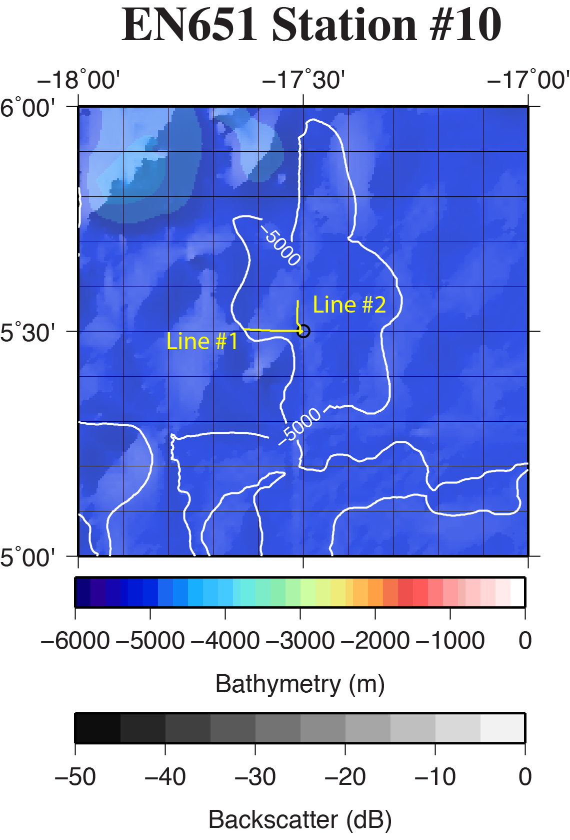

**Figure SR10-1.** Regional location of coring site EN651-10 (black circle) overlain on the GMRT database (Ryan et al., 2009) and available multibeam data. Bathymetry color-change interval is 100 meters with contours labeled every 500 meters. Backscatter intensity grayscale is darker for more reflective regions. Yellow line is the location of CHIRP surveys shown in Fig. SR10-2.

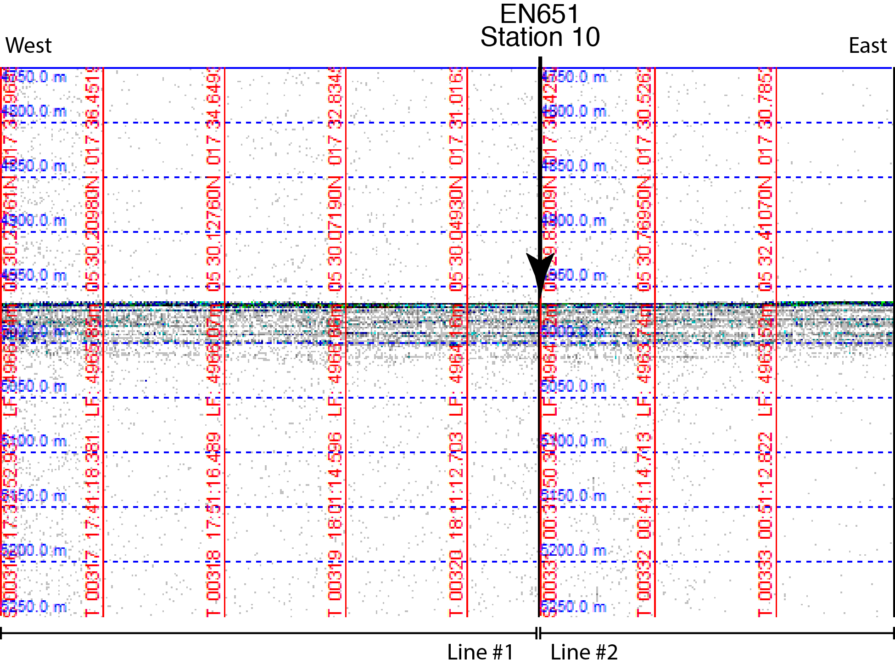

**Figure SR10-2:** A portion of CHIRP seismic data surveyed at 10 kts across core site EN651-10. Nearly 50 m of sediment are imaged.

**Site EN651-11 (Sierra Leone Basin)**

**Site Objectives**

The principal objectives of this site are to,

* Obtain sediment and core material to characterize sediment type and measure black carbon content in upper 20 cm.
* CTD to 1000 m and water samples

**General Description**

Coring site is located in a broad sedimented basin between the Sierra Leone Rise to the west and Africa to the east. Most of the region is fairly flat lying, but there are some dome-like or fault-like structures in the sediment imaged.

Location: 7˚ 30.00’ N 17˚ 30.00’ W

Water depth: 4805 m (12 kHz Knudsen), 4830m (GMRT)

Crustal age: 95 Ma (based upon Müller et al., 2008)

Estimated total sediment thickness:1500 m (Divins, 2009).

Very good characterization of the upper 40 m of sub-bottom sediment with the CHIRP 3.5 kHz seismic system.

Thickness cored: ~50 cm cored in 8 of 8 tubes.

**Operations**

* Site survey with CHIRP 3.5 kHz

- Line #1 - 3/13/20 11:02z to 3/13/20 11:51z

- Line #2 - 3/13/20 18:09z to 3/13/20 18:41z

* CTD to 1000 m, 12 Niskin Bottle water samples

- CTD01 - 3/13/20 11:58z to 3/13/20 12:47z

* Multicore deployment with 8 tubes (7 normal, one closed top)

- MC01 - 3/13/20 13:05z to 3/13/20 17:50z (8 tubes)

**Lithologic Description** (need to update back onshore)

Foraminiferal marls dark yellowish red.

Total Core – 50 cm

- 0 - 15 cm 7.5YR 6/4

- 15 - 25 cm 7.5YR 7/4

- 25 - 40 cm 7.5YR 4/1

**EN651-11 Survey**

The EN651-11 site was surveyed on March 12-13, 2020 with Knudsen 3260 seismic system. Survey Line #1 began at 11:02z on March 12 and was completed at 11:51z on March 13. Survey Line #2 began at 18:09z on March 13 and was completed at 18:41z on March 13.

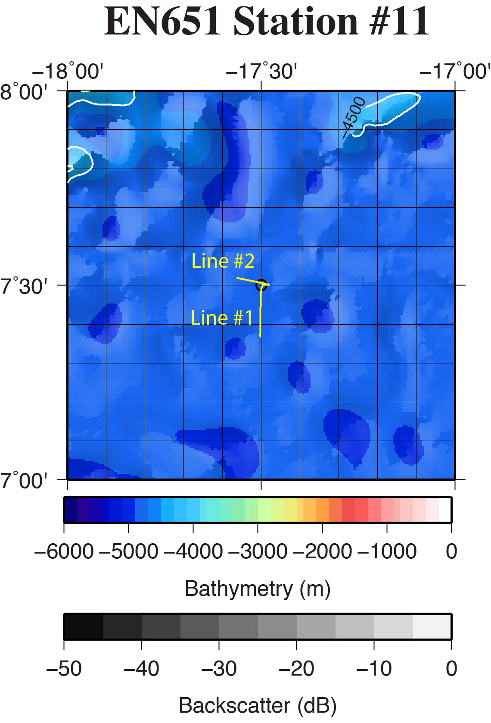

**Figure SR11-1.** Regional location of coring site EN651-11 (black circle) overlain on the GMRT database (Ryan et al., 2009) and available multibeam data. Bathymetry color-change interval is 100 meters with contours labeled every 500 meters. Backscatter intensity grayscale is darker for more reflective regions. Yellow lines are the locations of CHIRP surveys shown in Fig. SR11-2.

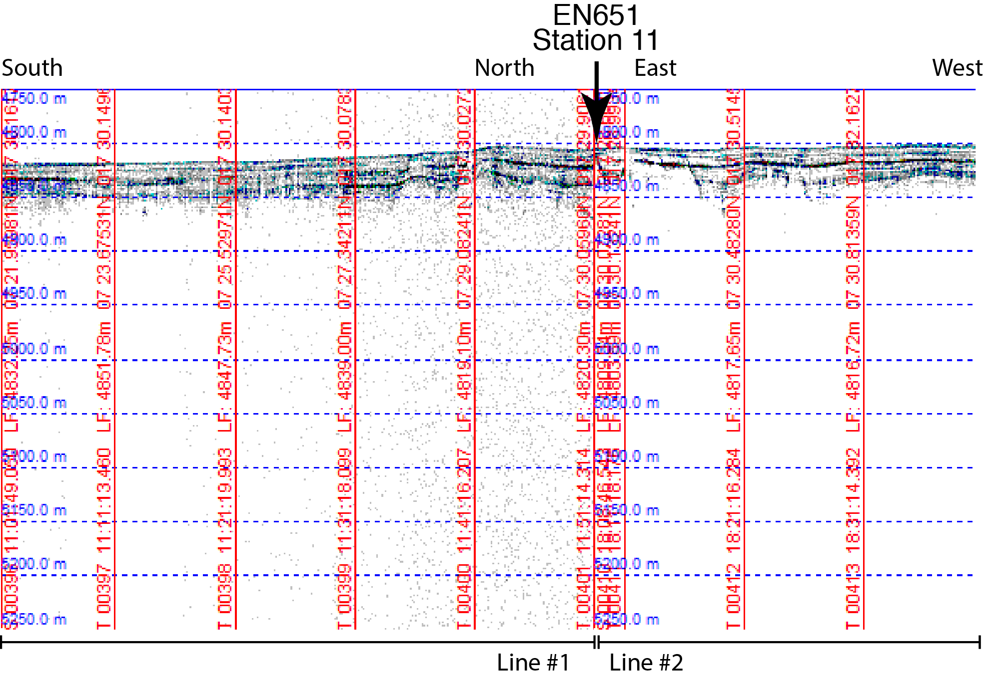

**Figure SR11-2:** A portion of CHIRP seismic data surveyed at 10 kts across core site EN651-11. No basement is visible, but sediments are imaged to about 50 mbsf. Also, the possibility faults or some other structure in sediments

**Site EN651-12 (Sierra Leone Rise)**

**Site Objectives**

The principal objectives of this site are to,

* Obtain sediment and core material to characterize sediment type and measure black carbon content in upper 20 cm.
* CTD to 4000+ m and water samples

**General Description**

Coring site is located in top of an elevated region on the northern portion of the Sierra Leone Rise. The regional topography is characterized by numerous seamount and volcanic features.

Location: 7˚ 59.20’ N 20˚ 10.80’ W

Water depth: 4180 m (12 kHz Knudsen), 4040 m (GMRT)

Crustal age: 92 Ma (based upon Müller et al., 2008)

Estimated total sediment thickness: 850 m (Divins, 2009).

Poor characterization of sub-bottom sediment with CHIRP 3.5 kHz seismic system.

Thickness cored: ~50 cm cored in 8 of 8 tubes. (need to update back onshore)

**Operations**

* Site survey with CHIRP 3.5 kHz

- Line #1 - 3/14/20 09:27z to 3/14/20 10:30z

- Line #2 - 3/14/20 19:38z to 3/14/20 20:22z

* CTD01 to 4000 m, 12 Niskin Bottle water samples

- CTD01 - 3/14/20 10:50z to 3/14/20 13:42z

* CTD02 to 4000 m, 12 Niskin Bottle water samples

- CTD01 - 3/14/20 18:36z to 3/14/20 19:27z

* Multicore deployment with 8 tubes (7 normal, one closed top)

- MC01 - 3/14/20 14:10z to 3/14/20 18:19z (8 tubes)

**Lithologic Description** (need to update back onshore)

Foraminiferal marls dark yellowish red.

Total Core – 50 cm

- 0 - 15 cm 2.5YR 7/3

- 15 - 25 cm 5YR 5/3

**EN651-12Survey**

The EN651-12 site was surveyed on March 14, 2020 with Knudsen 3260 seismic system. Survey Line #1 began at 09:27z on March 14 and was completed at 10:30z on March 14. Survey Line #2 began at 19:38z on March 14 and was completed at 20:22z on March 14.

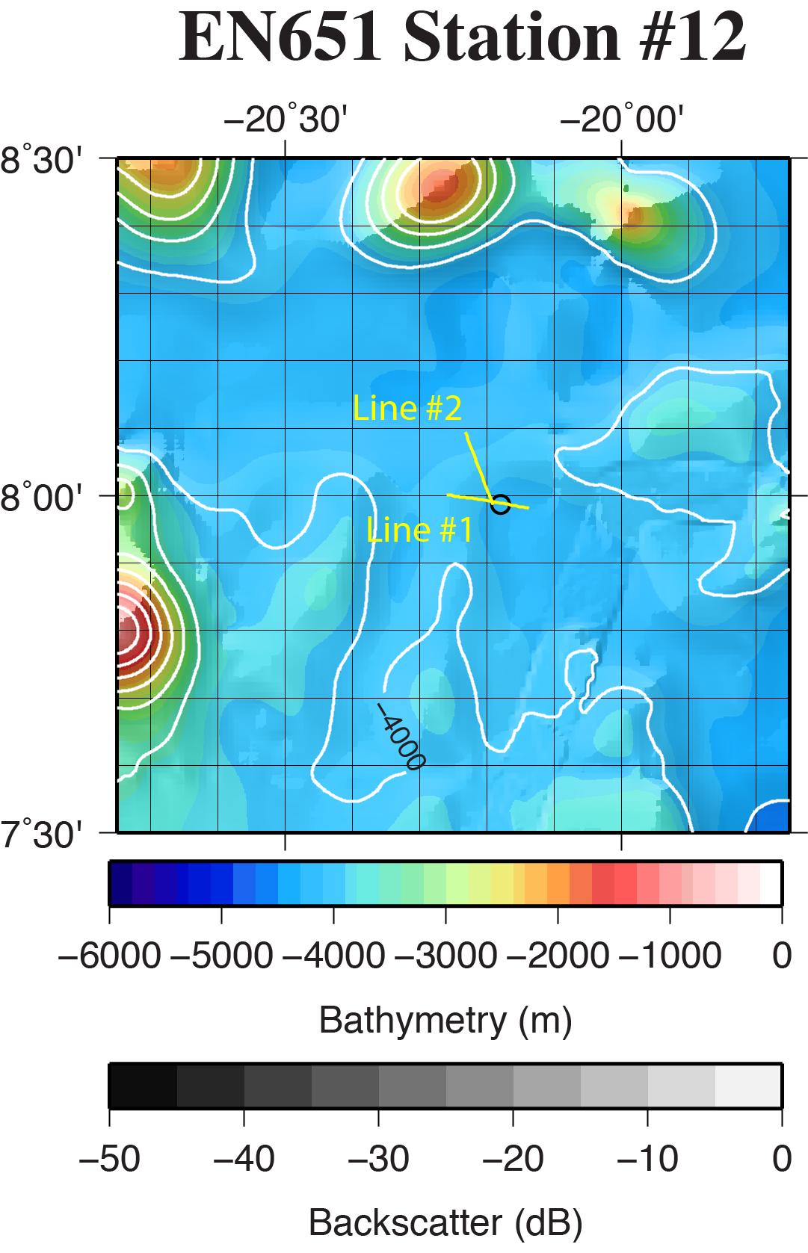

**Figure SR21-1.** Regional location of coring site EN651-12 (black circle) overlain on the GMRT database (Ryan et al., 2009) and available multibeam data. Bathymetry color-change interval is 100 meters with contours labeled every 500 meters. Backscatter intensity grayscale is darker for more reflective regions. Yellow lines indicate the location of CHIRP surveys shown in Fig. SR12-2.

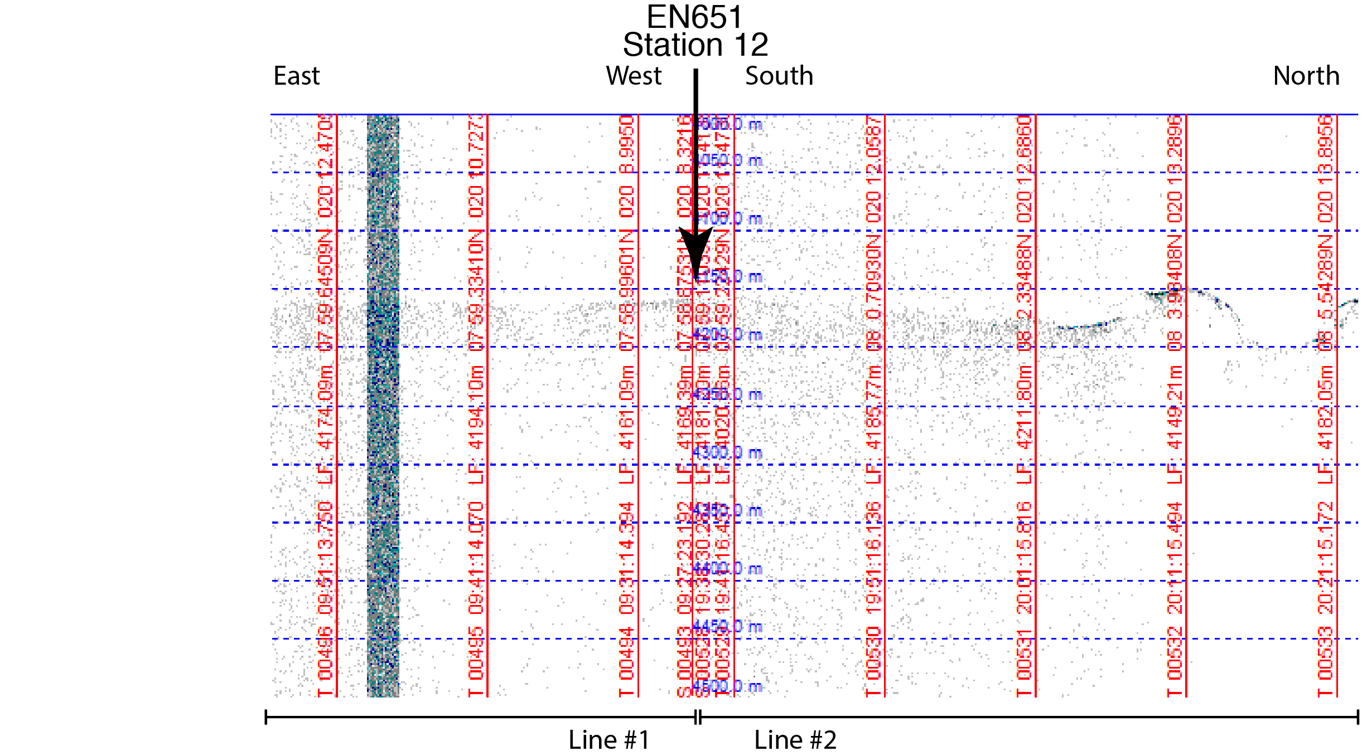

**Figure SR12-2:** A portion of CHIRP seismic data surveyed at 10 kts across core site EN651-12.

**Site EN651-13 (Gambia Abyssal Plain)**

**Site Objectives**

The principal objectives of this site are to,

* Obtain sediment and core material to characterize sediment type and measure black carbon content in upper 20 cm.
* CTD to 1000 m and water samples

**General Description**

Coring site is located in a broad, flat sedimented basin between with Sierra Leone Rise to the south and the Cape Verde Plateau to the North.

Location: 10˚ 22.50’ N 21˚ 00.00’ W

Water depth: 5130 m (12 kHz Knudsen), 5170 m (GMRT)

Crustal age: 127 Ma (based upon Müller et al., 2008)

Estimated total sediment thickness: 990 m (Divins, 2009).

Poor penetration of sub-bottom sediment. No obvious deeper reflectors imaged by CHIRP 3.5 kHz seismic system.

Thickness cored: ~80 cm cored in 8 of 8 tubes.

**Operations**

* Site survey with CHIRP 3.5 kHz

- Line #1 - 3/15/20 09:20z to 3/15/20 09:53z

* CTD01 to 1000 m, 12 Niskin Bottle water samples

- CTD01 - 3/15/20 09:59z to 3/15/20 10:56z

* Multicore deployment with 8 tubes (8 normal)

- MC01 - 3/15/20 11:26z to 3/15/20 16:31z (8 tubes)

**Lithologic Description** (need to update back onshore)

Foraminiferal marls dark yellowish red.

Total Core – 80 cm

- 0 - 16 cm 5YR 5/3

- 16 - 40 cm 7.5YR 6/2

- 40 - 45 cm 10 YR 7/1

**EN651-13 Survey**

The EN651-13 site was surveyed on March 15, 2020 with Knudsen 3260 seismic system. Survey Line #1 began at 09:20z on March 15 and was completed at 09:53z on March 15. Very poor data quality did not characterize the sediments, but did show flat seafloor.

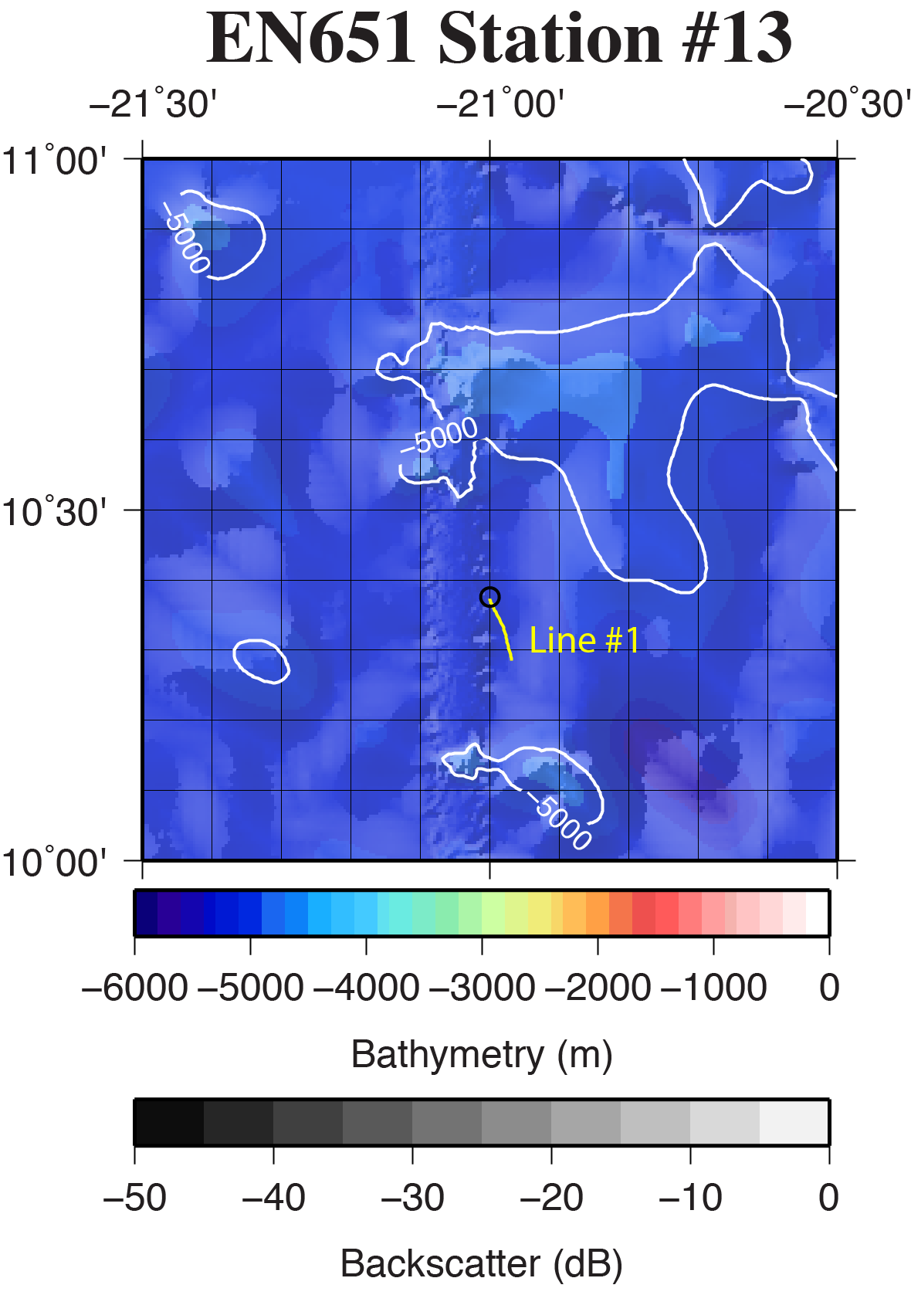

**Figure SR13-1.** Regional location of coring site EN651-13 (black circle) overlain on the GMRT database (Ryan et al., 2009) and available multibeam data. Bathymetry color-change interval is 100 meters with contours labeled every 500 meters. Backscatter intensity grayscale is darker for more reflective regions. Yellow line is the location of an attempted CHIRP survey, but data quality was poor and is not shown.

**Site EN651-14 (Gambia Abyssal Plain)**

**Site Objectives**

The principal objectives of this site are to,

* Obtain sediment and core material to characterize sediment type and measure black carbon content in upper 20 cm.
* CTD to 1000 m and water samples

**General Description**

Coring site is located in a broad, flat sedimented basin between with Sierra Leone Rise to the south and the Cape Verde Plateau to the North.

Location: 12˚ 00.00’ N 21˚ 00.00’ W

Water depth: 4890 m (12 kHz Knudsen), 4940 m (GMRT)

Crustal age: 144 Ma (based upon Müller et al., 2008)

Estimated total sediment thickness: 1460 m (Divins, 2009).

Poor penetration of sub-bottom sediment. No obvious deeper reflectors imaged by CHIRP 3.5 kHz seismic system.

Thickness cored: no sediment recovered in tubes except small chunks.

**Operations**

* Site survey with CHIRP 3.5 kHz

- Line #1 - 3/16/20 03:18z to 3/16/20 04:00z

- Line #2 - 3/16/20 10:11z to 3/16/20 10:41z

* Multicore deployment with 8 tubes (8 normal)

- MC01 - 3/16/20 04:01z to 3/14620 09:00z (8 tubes)

* CTD01 to 1000 m, 12 Niskin Bottle water samples

- CTD01 - 3/16/20 09:06z to 3/16/20 09:58z

**Lithologic Description**

No core recovered.

- scraping cm 7.5YR 7/4

**EN651-14 Survey**

The EN651-14 site was surveyed on March 16, 2020 with Knudsen 3260 seismic system. Survey Line #1 began at 03:18z on March 16 and was completed at 04:00z on March 16. Survey Line #2 began at 10:11z on March 16 and was completed at 10:41z on March 16.

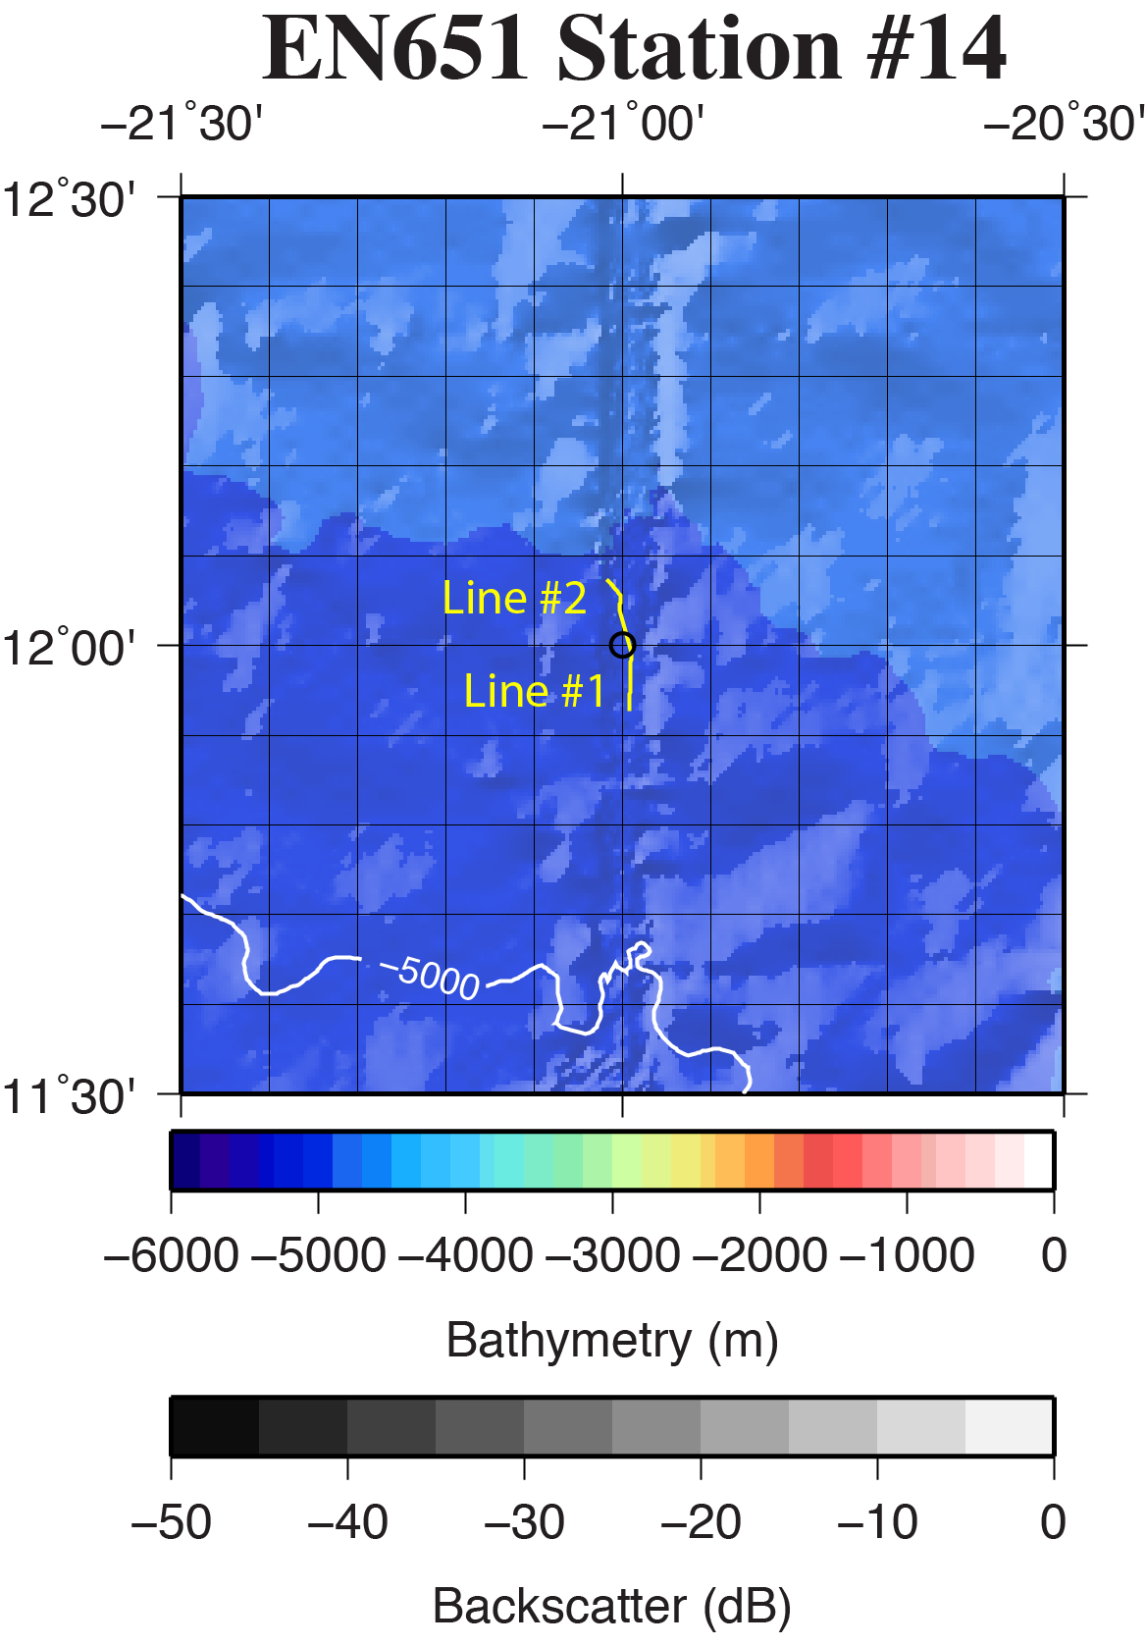

**Figure SR14-1.** Regional location of coring site EN651-14 (black circle) overlain on the GMRT database (Ryan et al., 2009) and available multibeam data. Bathymetry color-change interval is 100 meters with contours labeled every 500 meters. Backscatter intensity grayscale is darker for more reflective regions. Yellow line is the location of CHIRP surveys shown in Fig. SR14-2.

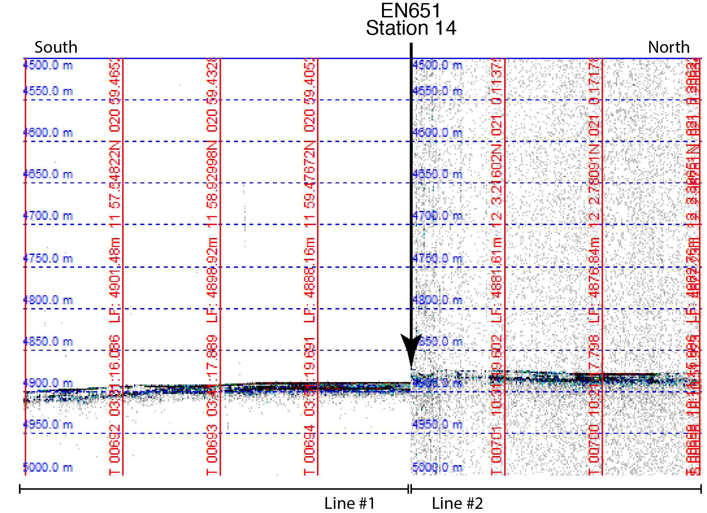

**Figure SR14-2:** A portion of CHIRP seismic data surveyed at 10 kts across core site EN651-14. Sediment layer at surface resembles sheet of turbidites.

**References**

Divins, D.L., NGDC Total Sediment Thickness of the World's Oceans & Marginal Seas, June 20, 2009, <http://www.ngdc.noaa.gov/mgg/sedthick/sedthick.html>.

Muller, R.D., M. Sdrolias, C. Gaina, and W.R. Roest, 2008. Age, spreading rates and spreading symmetry of the world's ocean crust, Geochem. Geophys. Geosyst., 9, Q04006, doi:10.1029/2007GC001743.

Ryan, W.B.F., Carbotte, S.M., Coplan, J.O., O’Hara, S., Melkonian, A., Arko, R., Weissel, R.A., Ferrini, V., Goodwillie, A., Nitsche, F., Bonczkowski, J., and Zemsky, R, 2009, Global multi-resolution topography synthesis, Geochemical Geophysical and Geosystems, v. 10, Q03014.

Smith, W.H.F, and Sandwell, D.T., 1997, Global sea floor topography from satellite altimetry and ship depth soundings, *Science*, 277, 1956-1962.