Appendix D. CTD / Rosette Operations

The following profiles have been generated following processing protocols described in [XX], with minimal adjustments made in Plot_CTD.ipynb. Briefly, temperature and salinity values represent the average of the two sensors, which differed by >1% for each parameter. Dissolved oxygen values from the two sensors differed slightly (~1%), with differences being most pronounced near the surface. As a result, reported dissolved oxygen values are taken from sensor DO1 (Sbox0Mm/Kg), which was calibrated most recently (Dec. 2019). Apparent oxygen utilization (AOU) is the difference between calculated dissolved oxygen saturation and the measured content of the water parcel. Original data in .hex and .bl data formats are provided, and users are encouraged to follow their own processing protocols. Contact Ben Geyman (bgeyman@fas.harvard.edu) for more information.

1 Mar 2020
Station 01 Cast 01 (fn: stn-01.hex/stn-01.bl)

Rosette In: Time 1314 (GMT) Lat. 7.425 ° N Lon. 48.143 ° W
Rosette Out: Time 1347 (GMT) Lat. 7.435 ° N Lon. 48.147 ° W
Bottom Depth: 4250 m

Rosette deployed at 30 m min⁻¹ until 100 m then increased to 60 m min⁻¹. Bottle firing error necessitated second cast to 100m (St-01-1a).

Bottle | Depth (m) | Potential Temp. (°C) | Salinity (PSU) | Potential Density (kg/m³) | Dissolved Oxygen (μM/kg) | Apparent Oxygen Utilization (μM/kg) | Fluorescence (mg/m³) | Comment
1 | 1000 | 5.0 | 34.7 | 27.5 | 147.1 | 160.6 | 0.06 | Std. depth
2 | 1000 | 5.0 | 34.7 | 27.5 | 147.3 | 160.4 | 0.05 | Std. depth
3 | 749 | 5.8 | 34.6 | 27.3 | 121.4 | 180.8 | 0.05 | Std. depth
4 | 499 | 7.5 | 34.7 | 27.1 | 122.8 | 168.4 | 0.06 | Std. depth
5 | 499 | 7.5 | 34.7 | 27.1 | 122.5 | 168.7 | 0.06 | Std. depth
6 | 250 | 9.6 | 34.9 | 26.9 | 113.7 | 163.5 | 0.05 | Std. depth
7 | - | - | - | - | - | - | - | Not fired
8 | - | - | - | - | - | - | - | Not fired
9 | - | - | - | - | - | - | - | Not fired
10 | - | - | - | - | - | - | - | Not fired
11 | - | - | - | - | - | - | - | Not fired
12 | - | - | - | - | - | - | - | Not fired

1 Mar 2020
Station 01 Cast 02 (fn: stn-01a.hex/stn-01a.bl)

Rosette In: Time 1417 (GMT) Lat. 7.435 ° N Lon. 48.147 ° W
Rosette Out: Time 1427 (GMT) Lat. 7.437 ° N Lon. 48.148 ° W
Bottom Depth: 4250 m

Bottle | Depth (m) | Potential Temp. (°C) | Salinity (PSU) | Potential Density (kg/m³) | Dissolved Oxygen (μM/kg) | Apparent Oxygen Utilization (μM/kg) | Fluorescence (mg/m³) | Comment
1 | - | - | - | - | - | - | - | Not fired
2 | - | - | - | - | - | - | - | Not fired
3 | - | - | - | - | - | - | - | Not fired
4 | - | - | - | - | - | - | - | Not fired
5 | - | - | - | - | - | - | - | Not fired
6 | - | - | - | - | - | - | - | Not fired
7 | 100 | 14.7 | 35.6 | 26.5 | 104.0 | 143.8 | 0.21 | Sub-thermocline
8 | 55 | 21.0 | 36.1 | 25.4 | 151.2 | 68.0 | 1.03 | Chl a max
9 | 54 | 21.5 | 36.2 | 25.2 | 156.2 | 61.0 | 1.22 | Chl a max
10 | 5 | 26.5 | 36.4 | 23.9 | 202.2 | -2.8 | 0.05 | Surface
11 | - | - | - | - | - | - | - | Not fired
12 | - | - | - | - | - | - | - | Not fired

3 Mar 2020
Station 02 Cast 01 (fn: stn-02.hex/stn-02.bl)

Rosette In: Time 229 (GMT) Lat. 5.482 ° N Lon. 44.451 ° W
Rosette Out: Time 321 (GMT) Lat. 5.485 ° N Lon. 44.456 ° W
Bottom Depth: 4250 m
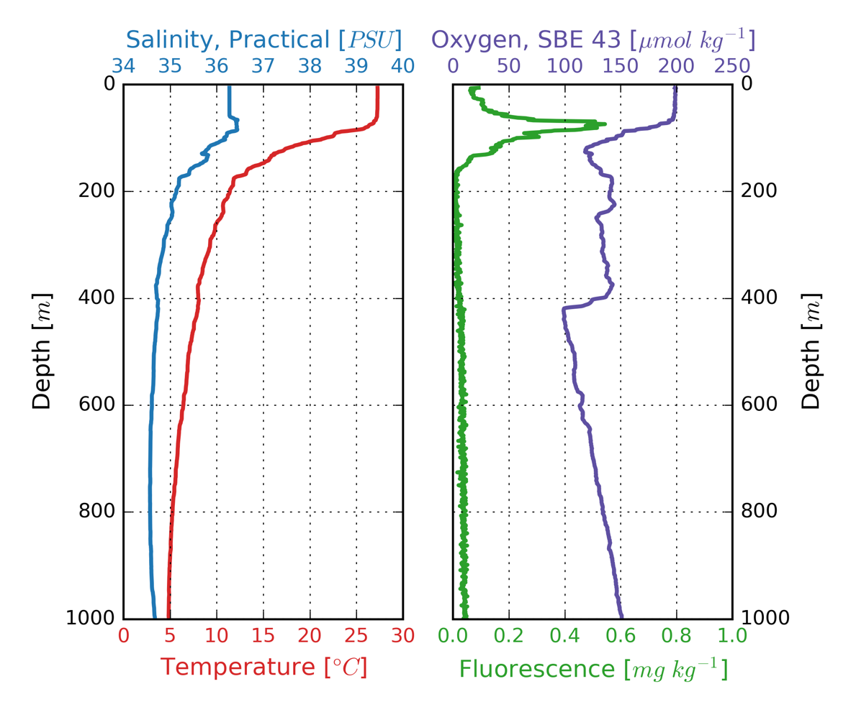
Bottle | Depth (m) | Potential Temp. (°C) | Salinity (PSU) | Potential Density (kg/m³) | Dissolved Oxygen (μM/kg) | Apparent Oxygen Utilization (μM/kg) | Fluorescence (mg/m³) | Comment
1 | 1000 | 4.8 | 34.7 | 27.4 | 151.0 | 159.0 | 0.04 | Std. depth
2 | 1000 | 4.8 | 34.7 | 27.4 | 150.9 | 159.0 | 0.04 | Std. depth
3 | 1000 | 4.8 | 34.7 | 27.4 | 150.9 | 159.0 | 0.04 | Std. depth
4 | 1000 | 4.8 | 34.7 | 27.4 | 150.9 | 159.0 | 0.05 | Std. depth
5 | 500 | 6.9 | 34.6 | 27.1 | 109.0 | 186.1 | 0.05 | Std. depth
6 | 250 | 9.9 | 35.0 | 26.9 | 131.2 | 144.0 | 0.04 | Std. depth
7 | 135 | 17.2 | 35.8 | 26.1 | 119.0 | 116.7 | 0.24 | Sub-thermocline
8 | 134 | 17.2 | 35.8 | 26.1 | 119.1 | 116.6 | 0.24 | Sub-thermocline
9 | 134 | 17.2 | 35.8 | 26.1 | 119.2 | 116.5 | 0.22 | Sub-thermocline
10 | 134 | 17.2 | 35.8 | 26.1 | 119.2 | 116.5 | 0.22 | Sub-thermocline
11 | 77 | 27.1 | 36.3 | 23.7 | 197.2 | 0.2 | 0.33 | Chl a max
12 | 5 | 27.3 | 36.3 | 23.6 | 198.8 | -1.6 | 0.10 | Surface
4 Mar 2020
Station 03 Cast 01 (fn: stn-03.hex/stn-03.bl)

Rosette In: Time 1748 (GMT) Lat. 5.043° N Lon. 40.354 ° W
Rosette Out: Time 1842 (GMT) Lat. 5.050° N Lon. 40.361 ° W
Bottom Depth: 4646 m
Bottle | Depth (m) | Potential Temp. (°C) | Salinity (PSU) | Potential Density (kg/m³) | Dissolved Oxygen (μM/kg) | Apparent Oxygen Utilization (μM/kg) | Fluorescence (mg/m³) | Comment
1 | 999 | 4.9 | 34.8 | 27.5 | 156.1 | 152.2 | 0.04 | Std. depth
2 | 999 | 4.9 | 34.8 | 27.5 | 156.1 | 152.3 | 0.04 | Std. depth
3 | 999 | 4.9 | 34.8 | 27.5 | 155.6 | 152.8 | 0.05 | Std. depth
4 | 999 | 4.9 | 34.8 | 27.5 | 155.1 | 153.3 | 0.04 | Std. depth
5 | 501 | 7.0 | 34.7 | 27.1 | 105.2 | 189.3 | 0.06 | Std. depth
6 | 250 | 9.8 | 34.9 | 26.9 | 113.3 | 162.5 | 0.04 | Std. depth
7 | 182 | 11.3 | 35.1 | 26.8 | 119.3 | 147.3 | 0.04 | Sub-thermocline
8 | 181 | 11.3 | 35.1 | 26.8 | 119.6 | 147.0 | 0.05 | Sub-thermocline
9 | 181 | 11.3 | 35.1 | 26.8 | 119.6 | 147.0 | 0.05 | Sub-thermocline
10 | 181 | 11.3 | 35.1 | 26.8 | 119.5 | 147.1 | 0.04 | Sub-thermocline
11 | 90 | 27.8 | 36.1 | 23.3 | 192.9 | 2.8 | 0.57 | Chl a max
12 | 5 | 28.0 | 35.9 | 23.0 | 197.8 | -2.5 | 0.05 | Surface
6 Mar 2020
Station 04 Cast 01 (fn: stn-04.hex/stn-04.bl)

Rosette In: Time 1327 (GMT) Lat. 4.999° N Lon. 35.788 ° W
Rosette Out: Time 1609 (GMT) Lat. 5.019° N Lon. 35.793 ° W
Bottom Depth: 3995 m
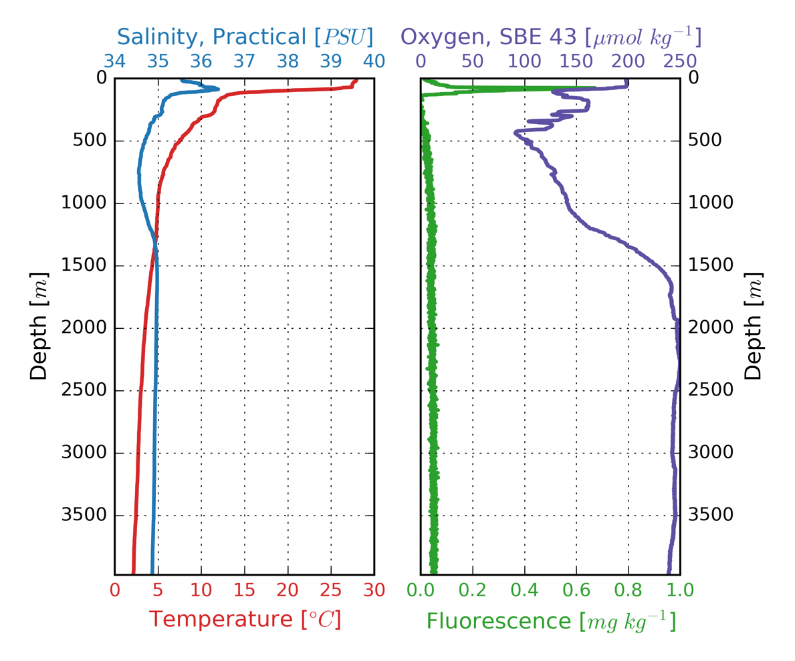
Bottle | Depth (m) | Potential Temp. (°C) | Salinity (PSU) | Potential Density (kg/m³) | Dissolved Oxygen (μM/kg) | Apparent Oxygen Utilization (μM/kg) | Fluorescence (mg/m³) | Comment
1 | 3975 | 1.8 | 34.9 | 27.9 | 239.1 | 91.9 | 0.05 | 20m off bottom
2 | 3975 | 1.8 | 34.9 | 27.9 | 238.1 | 92.8 | 0.06 | 20m off bottom
3 | 3975 | 1.8 | 34.9 | 27.9 | 238.6 | 92.3 | 0.05 | 20m off bottom
4 | 2999 | 2.5 | 34.9 | 27.8 | 242.1 | 83.7 | 0.05 | Std. depth
5 | 2001 | 3.4 | 35.0 | 27.8 | 245.4 | 73.8 | 0.05 | Std. depth
6 | 999 | 4.9 | 34.6 | 27.4 | 140.5 | 168.4 | 0.06 | Std. depth
7 | 999 | 4.9 | 34.6 | 27.4 | 140.6 | 168.3 | 0.05 | Std. depth
8 | 999 | 4.9 | 34.6 | 27.4 | 140.8 | 168.0 | 0.06 | Std. depth
9 | 123 | 13.5 | 35.4 | 26.6 | 133.9 | 120.3 | 0.11 | Sub-thermocline
10 | 123 | 13.5 | 35.4 | 26.6 | 134.9 | 119.5 | 0.10 | Sub-thermocline
11 | 124 | 13.4 | 35.4 | 26.6 | 134.8 | 119.9 | 0.09 | Sub-thermocline
12 | 81 | 23.1 | 36.4 | 24.9 | 158.3 | 52.7 | 0.57 | Chl a max
7 Mar 2020
Station 05 Cast 01 (fn: stn-05.hex/stn-05.bl)

Rosette In: Time 1135 (GMT) Lat. 5.006° N Lon. 33.613 ° W
Rosette Out: Time 1418 (GMT) Lat. 5.034° N Lon. 33.621 ° W
Bottom Depth: 3730 m
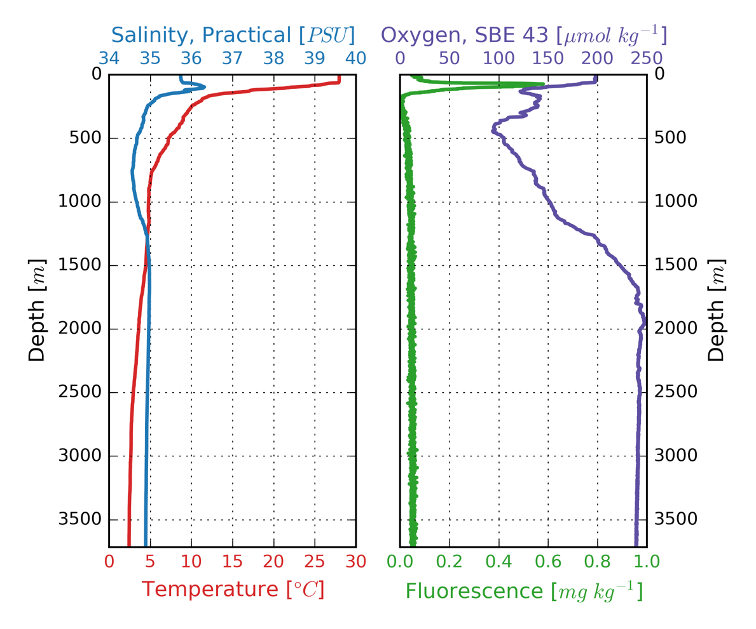
Bottle | Depth (m) | Potential Temp. (°C) | Salinity (PSU) | Potential Density (kg/m³) | Dissolved Oxygen (μM/kg) | Apparent Oxygen Utilization (μM/kg) | Fluorescence (mg/m³) | Comment
1 | 3715 | 2.1 | 34.9 | 27.8 | 239.4 | 89.1 | 0.05 | 15 m off bottom
2 | 3714 | 2.1 | 34.9 | 27.8 | 239.2 | 89.3 | 0.06 | 15 m off bottom
3 | 3714 | 2.1 | 34.9 | 27.8 | 239.4 | 89.1 | 0.05 | 15 m off bottom
4 | 3715 | 2.1 | 34.9 | 27.8 | 239.7 | 88.8 | 0.05 | 15 m off bottom
5 | 3001 | 2.4 | 34.9 | 27.8 | 240.5 | 86.1 | 0.05 | Std. depth
6 | 2001 | 3.4 | 35.0 | 27.8 | 242.5 | 76.7 | 0.04 | Std. depth
7 | 1002 | 4.7 | 34.7 | 27.4 | 151.0 | 159.3 | 0.05 | Std. depth
8 | 1004 | 4.7 | 34.7 | 27.4 | 151.0 | 159.4 | 0.05 | Std. depth
9 | 1004 | 4.7 | 34.7 | 27.4 | 151.3 | 159.1 | 0.06 | Std. depth
10 | 150 | 13.8 | 35.5 | 26.6 | 128.3 | 124.4 | 0.08 | Sub-thermocline
11 | 151 | 13.8 | 35.5 | 26.6 | 128.3 | 124.4 | 0.08 | Sub-thermocline
12 | 81 | 25.8 | 36.1 | 23.9 | 179.9 | 22.0 | 0.65 | Chl a max
8 Mar 2020
Station 06 Cast 01 (fn: stn-06.hex/stn-06.bl)

Rosette In: Time 1946 (GMT) Lat. 4.996 ° N Lon. 30.057 ° W
Rosette Out: Time 2207 (GMT) Lat. 5.003 ° N Lon. 30.059 ° W
Bottom Depth: 3607 m
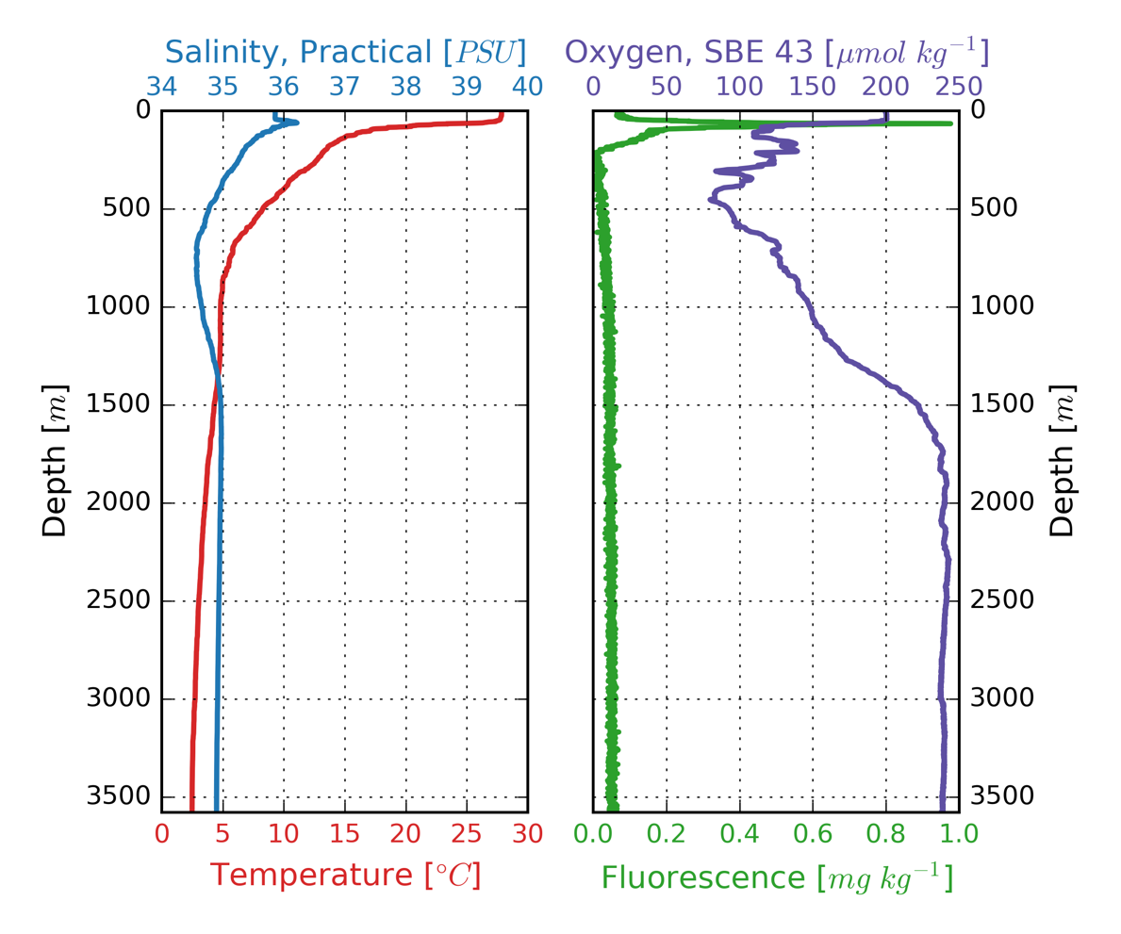
Bottle | Depth (m) | Potential Temp. (°C) | Salinity (PSU) | Potential Density (kg/m³) | Dissolved Oxygen (μM/kg) | Apparent Oxygen Utilization (μM/kg) | Fluorescence (mg/m³) | Comment
1 | 3577 | 2.2 | 34.9 | 27.8 | 238.2 | 89.8 | 0.05 | 30 m off bottom
2 | 3576 | 2.2 | 34.9 | 27.8 | 238.5 | 89.5 | 0.05 | 30 m off bottom
3 | 3577 | 2.2 | 34.9 | 27.8 | 238.6 | 89.4 | 0.05 | 30 m off bottom
4 | 3576 | 2.2 | 34.9 | 27.8 | 238.8 | 89.2 | 0.06 | 30 m off bottom
5 | 2001 | 3.4 | 35.0 | 27.8 | 239.3 | 79.8 | 0.05 | Std. depth
6 | 999 | 4.7 | 34.7 | 27.4 | 148.9 | 161.4 | 0.06 | Std. depth
7 | 1000 | 4.7 | 34.7 | 27.4 | 148.8 | 161.5 | 0.05 | Std. depth
8 | 999 | 4.7 | 34.7 | 27.4 | 148.8 | 161.5 | 0.05 | Std. depth
9 | 500 | 8.2 | 34.8 | 27.1 | 93.3 | 192.9 | 0.06 | Std. depth
10 | 125 | 15.7 | 35.6 | 26.3 | 111.8 | 131.1 | 0.21 | Sub-thermocline
11 | 125 | 15.7 | 35.6 | 26.3 | 112.2 | 130.8 | 0.18 | Sub-thermocline
12 | 65 | 21.9 | 36.0 | 25.0 | 143.8 | 72.3 | 0.59 | Chl a max
9 Mar 2020
Station 07 Cast 01 (fn: stn-07.hex/stn-07.bl)

Rosette In: Time 1952 (GMT) Lat. 5.166 ° N Lon. 27.000 ° W
Rosette Out: Time 2043 (GMT) Lat. 5.172 ° N Lon. 27.002 ° W
Bottom Depth: 4276 m
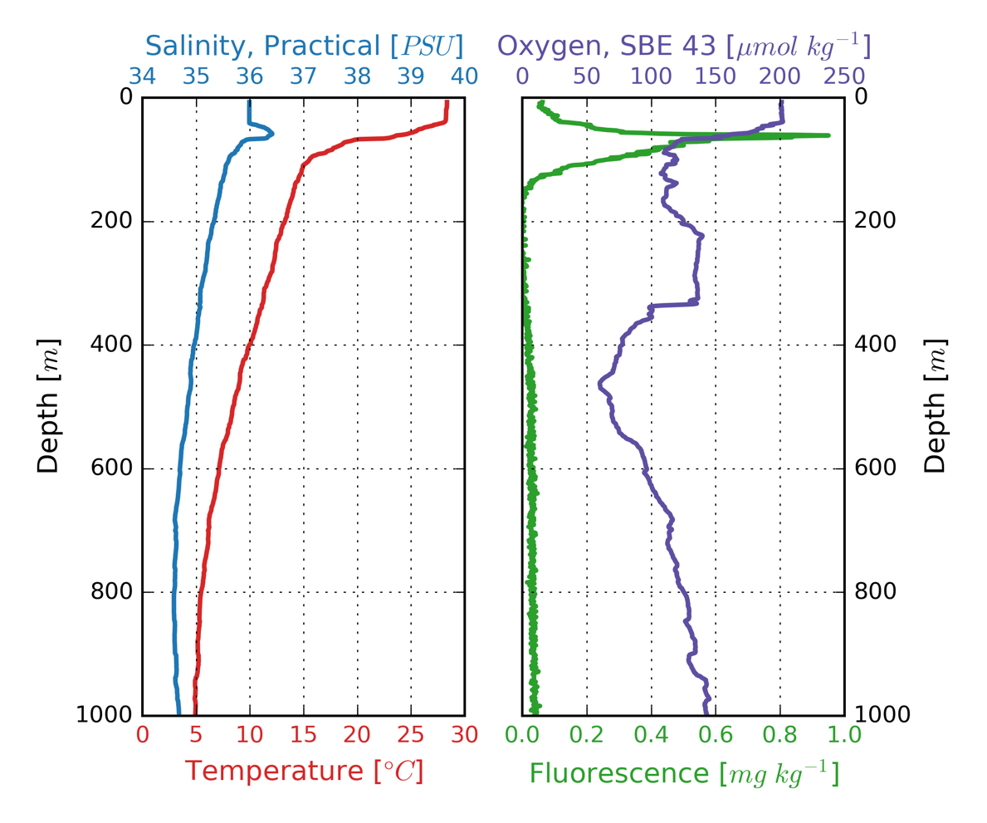
Bottle | Depth (m) | Potential Temp. (°C) | Salinity (PSU) | Potential Density (kg/m³) | Dissolved Oxygen (μM/kg) | Apparent Oxygen Utilization (μM/kg) | Fluorescence (mg/m³) | Comment
1 | 1000 | 4.8 | 34.7 | 27.4 | 143.2 | 166.2 | 0.04 | Std. depth
2 | 999 | 4.8 | 34.7 | 27.4 | 143.3 | 166.1 | 0.04 | Std. depth
3 | 1000 | 4.8 | 34.7 | 27.4 | 143.4 | 165.9 | 0.04 | Std. depth
4 | 1000 | 4.8 | 34.7 | 27.4 | 143.5 | 165.9 | 0.04 | Std. depth
5 | 999 | 4.8 | 34.7 | 27.4 | 143.4 | 166.0 | 0.05 | Std. depth
6 | 500 | 8.4 | 34.8 | 27.1 | 69.2 | 215.8 | 0.05 | Std. depth
7 | 251 | 12.3 | 35.2 | 26.7 | 136.2 | 124.6 | 0.03 | Std. depth
8 | 100 | 15.5 | 35.6 | 26.3 | 118.2 | 126.2 | 0.32 | Sub-thermocline
9 | 100 | 15.5 | 35.6 | 26.3 | 117.6 | 126.3 | 0.35 | Sub-thermocline
10 | 100 | 15.5 | 35.6 | 26.3 | 117.5 | 126.5 | 0.33 | Sub-thermocline
11 | 62 | 24.5 | 36.4 | 24.5 | 174.7 | 31.2 | 0.66 | Chl a max
12 | 6 | 28.3 | 36.0 | 23.0 | 200.8 | -6.7 | 0.07 | Surface
10 Mar 2020
Station 08 Cast 01 (fn: stn-08.hex/stn-08.bl)

Rosette In: Time 2247 (GMT) Lat. 5.002 ° N Lon. 23.440 ° W
Rosette Out: Time 2335 (GMT) Lat. 5.008 ° N Lon. 23.430 ° W
Bottom Depth: 4310 m
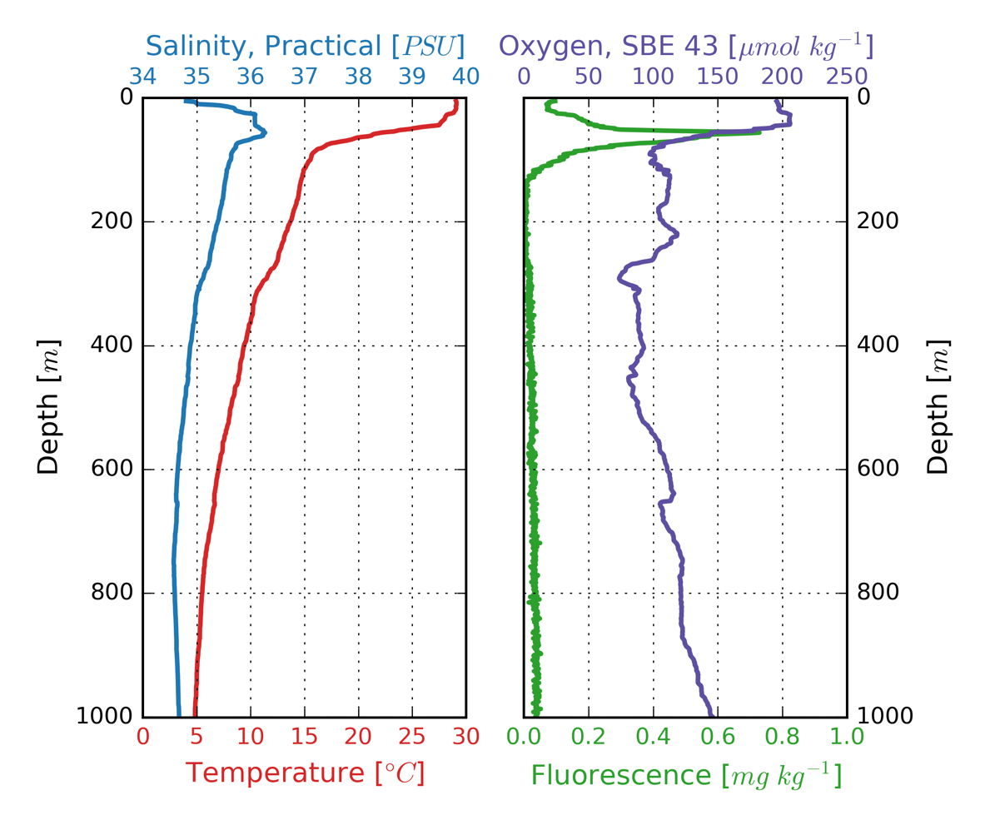
Bottle | Depth (m) | Potential Temp. (°C) | Salinity (PSU) | Potential Density (kg/m³) | Dissolved Oxygen (μM/kg) | Apparent Oxygen Utilization (μM/kg) | Fluorescence (mg/m³) | Comment
1 | 998 | 4.7 | 34.7 | 27.4 | 146.1 | 164.1 | 0.05 | Std. depth
2 | 999 | 4.7 | 34.7 | 27.4 | 145.8 | 164.4 | 0.05 | Std. depth
3 | 999 | 4.7 | 34.7 | 27.4 | 145.9 | 164.3 | 0.04 | Std. depth
4 | 998 | 4.7 | 34.7 | 27.4 | 145.0 | 165.1 | 0.04 | Std. depth
5 | 998 | 4.7 | 34.7 | 27.4 | 145.5 | 164.6 | 0.05 | Std. depth
6 | 252 | 12.7 | 35.3 | 26.6 | 106.6 | 152.0 | 0.04 | Std. depth
7 | 91 | 15.6 | 35.6 | 26.3 | 97.1 | 146.3 | 0.19 | Sub-thermocline
8 | 91 | 15.6 | 35.6 | 26.3 | 96.7 | 146.7 | 0.15 | Sub-thermocline
9 | 91 | 15.6 | 35.6 | 26.3 | 96.8 | 146.6 | 0.18 | Sub-thermocline
10 | 92 | 15.6 | 35.6 | 26.3 | 96.9 | 146.5 | 0.15 | Sub-thermocline
11 | 57 | 21.2 | 36.2 | 25.4 | 143.9 | 74.6 | 0.76 | Chl a max
12 | 4 | 29.1 | 34.8 | 21.9 | 195.8 | -2.6 | 0.08 | Surface
12 Mar 2020
Station 09 Cast 01 (fn: stn-09.hex/stn-09.bl)

Rosette In: Time 0021 (GMT) Lat. 5.500 ° N Lon. 20.001 ° W
Rosette Out: Time 0109 (GMT) Lat. 5.502 ° N Lon. 20.002 ° W
Bottom Depth: 2835 m
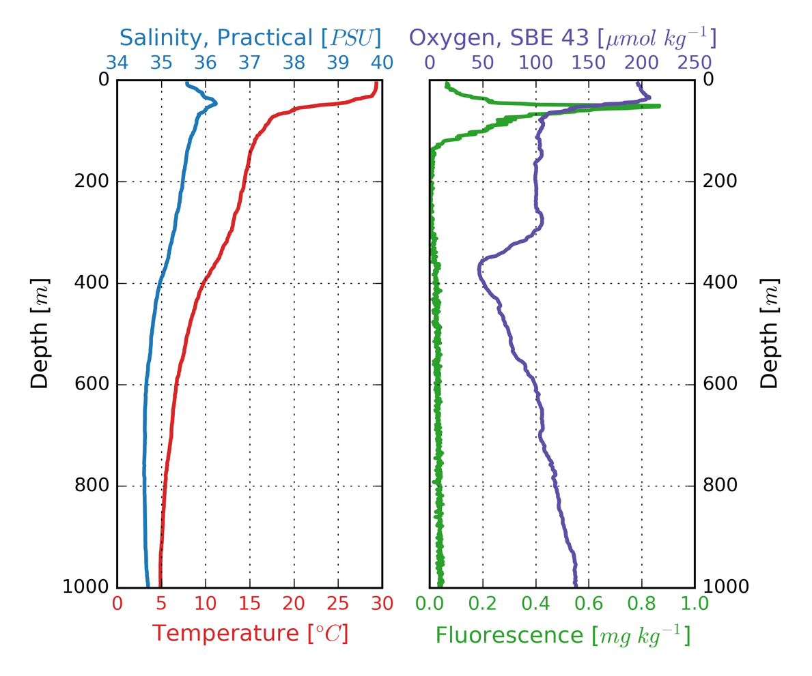
Bottle | Depth (m) | Potential Temp. (°C) | Salinity (PSU) | Potential Density (kg/m³) | Dissolved Oxygen (μM/kg) | Apparent Oxygen Utilization (μM/kg) | Fluorescence (mg/m³) | Comment
1 | 1000 | 4.8 | 34.7 | 27.4 | 138.2 | 171.4 | 0.04 | Std. depth
2 | 1001 | 4.8 | 34.7 | 27.4 | 138.3 | 171.3 | 0.05 | Std. depth
3 | 1000 | 4.8 | 34.7 | 27.4 | 138.3 | 171.3 | 0.04 | Std. depth
4 | 1000 | 4.8 | 34.7 | 27.4 | 138.4 | 171.2 | 0.05 | Std. depth
5 | 1001 | 4.8 | 34.7 | 27.4 | 138.2 | 171.3 | 0.04 | Std. depth
6 | 500 | 7.9 | 34.8 | 27.1 | 75.6 | 212.5 | 0.06 | Std. depth
7 | 249 | 13.6 | 35.4 | 26.6 | 101.5 | 152.3 | 0.04 | Std. depth
8 | 130 | 15.3 | 35.6 | 26.4 | 104.0 | 140.8 | 0.05 | Sub-thermocline
9 | 130 | 15.3 | 35.6 | 26.4 | 104.0 | 140.8 | 0.06 | Sub-thermocline
10 | 130 | 15.3 | 35.6 | 26.4 | 104.2 | 140.7 | 0.06 | Sub-thermocline
11 | 56 | 20.1 | 36.0 | 25.5 | 133.2 | 90.2 | 0.71 | Chl a max
12 | 5 | 29.3 | 35.6 | 22.4 | 196.3 | -4.8 | 0.08 | Surface
12 Mar 2020
Station 10 Cast 01 (fn: stn-10.hex/stn-10.bl)

Rosette In: Time 1824 (GMT) Lat. 5.501 ° N Lon. 17.498 ° W
Rosette Out: Time 1912 (GMT) Lat. 5.500 ° N Lon. 17.496 ° W
Bottom Depth: 4988 m
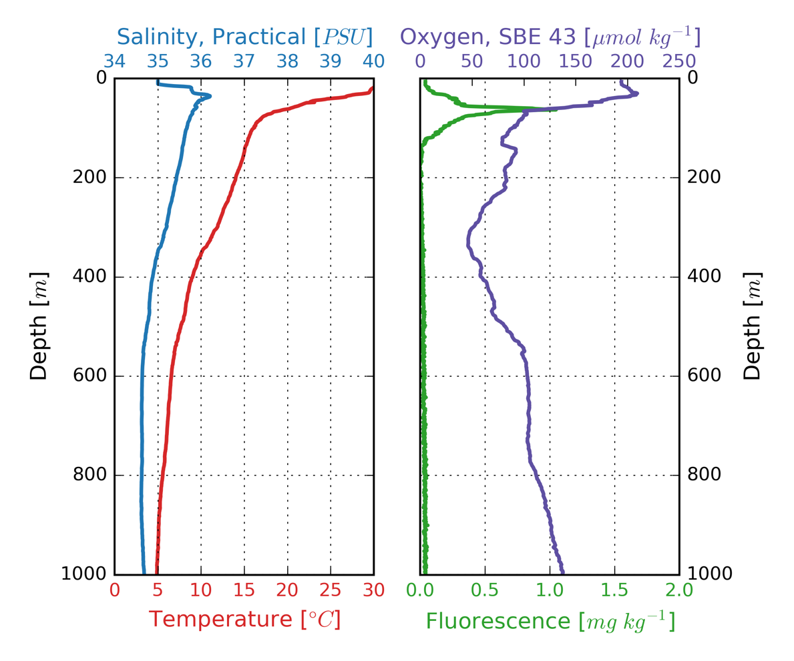
Bottle | Depth (m) | Potential Temp. (°C) | Salinity (PSU) | Potential Density (kg/m³) | Dissolved Oxygen (μM/kg) | Apparent Oxygen Utilization (μM/kg) | Fluorescence (mg/m³) | Comment
1 | 1000 | 4.8 | 34.7 | 27.4 | 137.1 | 172.5 | 0.04 | Std. depth
2 | 1000 | 4.8 | 34.7 | 27.4 | 137.2 | 172.4 | 0.04 | Std. depth
3 | 1000 | 4.8 | 34.7 | 27.4 | 136.9 | 172.7 | 0.04 | Std. depth
4 | 1000 | 4.8 | 34.7 | 27.4 | 137.3 | 172.3 | 0.04 | Std. depth
5 | 1000 | 4.8 | 34.7 | 27.4 | 137.3 | 172.3 | 0.05 | Std. depth
6 | 320 | 10.9 | 35.1 | 26.9 | 46.7 | 222.3 | 0.05 | O₂ minimum
7 | 100 | 15.7 | 35.6 | 26.3 | 85.0 | 158.0 | 0.17 | Sub-thermocline
8 | 99 | 15.7 | 35.6 | 26.3 | 85.1 | 157.9 | 0.20 | Sub-thermocline
9 | 100 | 15.7 | 35.6 | 26.3 | 85.0 | 157.9 | 0.22 | Sub-thermocline
10 | 100 | 15.7 | 35.6 | 26.3 | 84.9 | 158.1 | 0.18 | Sub-thermocline
11 | 60 | 19.1 | 35.8 | 25.6 | 111.9 | 115.6 | 0.76 | Chl a max
12 | 5 | 30.5 | 35.0 | 21.5 | 194.3 | -5.6 | 0.07 | Surface
13 Mar 2020
Station 11 Cast 01 (fn: stn-11.hex/stn-11.bl)

Rosette In: Time 1158 (GMT) Lat. 7.500 ° N Lon. 17.499 ° W
Rosette Out: Time 1246 (GMT) Lat. 7.497 ° N Lon. 17.500 ° W
Bottom Depth: 4820 m
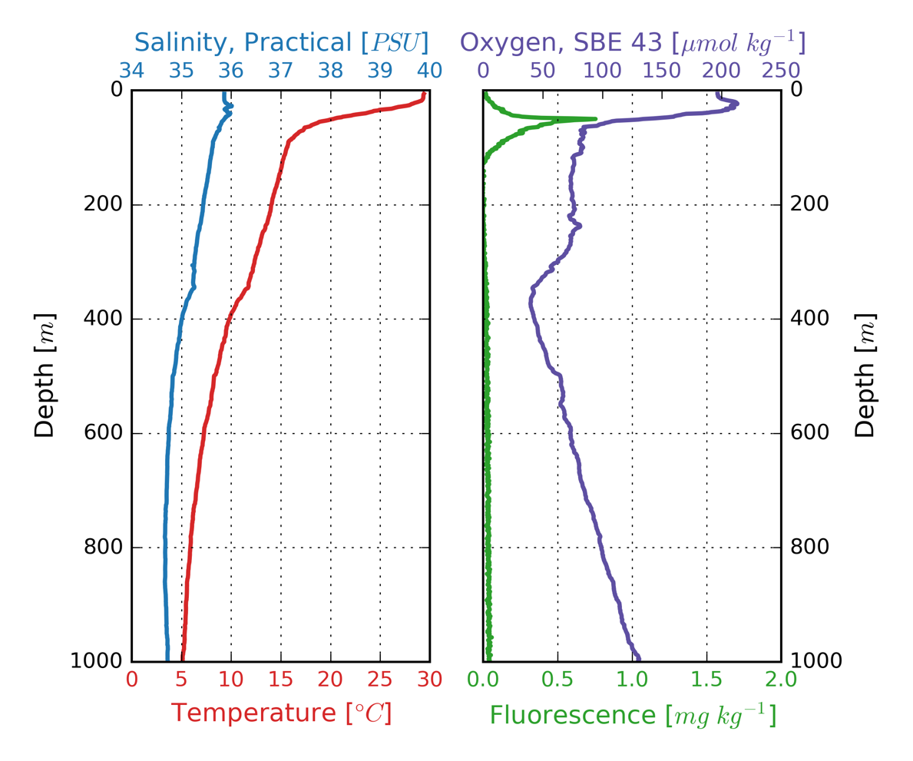
Bottle | Depth (m) | Potential Temp. (°C) | Salinity (PSU) | Potential Density (kg/m³) | Dissolved Oxygen (μM/kg) | Apparent Oxygen Utilization (μM/kg) | Fluorescence (mg/m³) | Comment
1 | 999 | 5.0 | 34.7 | 27.4 | 130.8 | 177.0 | 0.04 | Std. depth
2 | 999 | 5.0 | 34.7 | 27.4 | 130.5 | 177.3 | 0.04 | Std. depth
3 | 999 | 5.0 | 34.7 | 27.4 | 130.4 | 177.3 | 0.04 | Std. depth
4 | 999 | 5.0 | 34.7 | 27.4 | 130.5 | 177.3 | 0.05 | Std. depth
5 | 999 | 5.0 | 34.7 | 27.4 | 131.0 | 176.8 | 0.04 | Std. depth
6 | 120 | 15.2 | 35.6 | 26.4 | 74.7 | 170.6 | 0.06 | Sub-thermocline
7 | 121 | 15.2 | 35.6 | 26.4 | 74.6 | 170.7 | 0.07 | Sub-thermocline
8 | 119 | 15.2 | 35.6 | 26.4 | 74.7 | 170.5 | 0.07 | Sub-thermocline
9 | 120 | 15.2 | 35.6 | 26.4 | 74.5 | 170.8 | 0.06 | Sub-thermocline
10 | 120 | 15.2 | 35.6 | 26.4 | 74.7 | 170.6 | 0.07 | Sub-thermocline
11 | 5 | 29.4 | 35.9 | 22.6 | 196.8 | -5.7 | 0.05 | Surface
12 | 5 | 29.4 | 35.9 | 22.6 | 197.2 | -6.1 | 0.04 | Surface
14 Mar 2020
Station 12 Cast 01 (fn: stn-12.hex/stn-12.bl)

Rosette In: Time 1050 (GMT) Lat. 7.988 ° N Lon. 20.179 ° W
Rosette Out: Time 1342 (GMT) Lat. 7.956 ° N Lon. 20.182 ° W
Bottom Depth: 4179 m
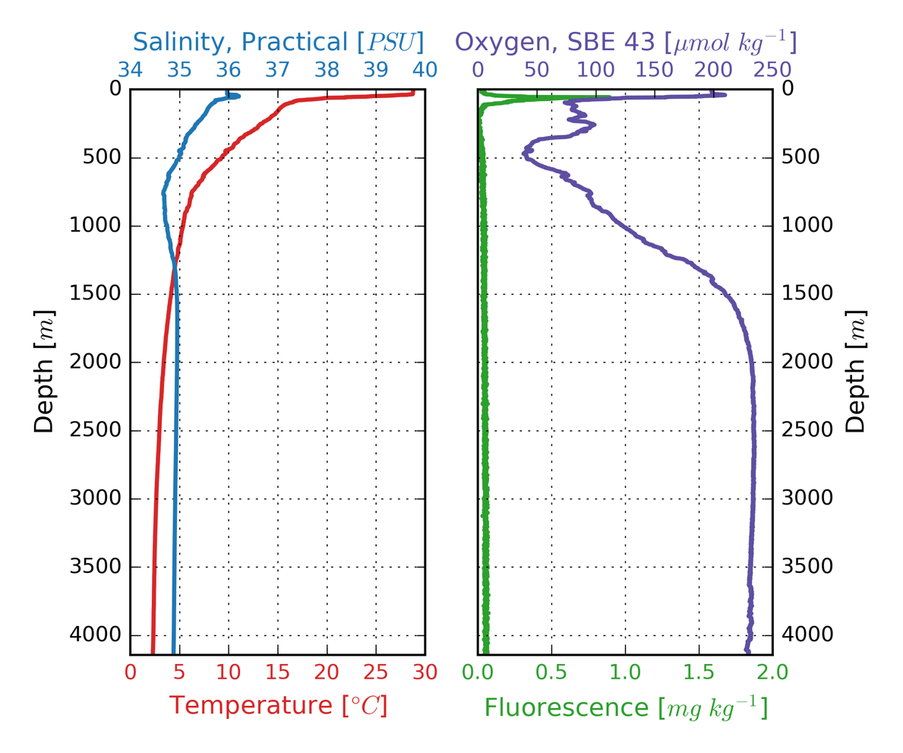
Bottle | Depth (m) | Potential Temp. (°C) | Salinity (PSU) | Potential Density (kg/m³) | Dissolved Oxygen (μM/kg) | Apparent Oxygen Utilization (μM/kg) | Fluorescence (mg/m³) | Comment
1 | 4143 | 1.9 | 34.9 | 27.9 | 229.7 | 99.9 | 0.05 | 35 m off bottom
2 | 4143 | 1.9 | 34.9 | 27.9 | 229.4 | 100.1 | 0.07 | 35 m off bottom
3 | 4142 | 1.9 | 34.9 | 27.9 | 228.5 | 101.1 | 0.06 | 35 m off bottom
4 | 4142 | 1.9 | 34.9 | 27.9 | 229.4 | 100.2 | 0.06 | 35 m off bottom
5 | 1002 | 5.3 | 34.7 | 27.4 | 123.4 | 182.7 | 0.06 | Std. depth
6 | 1001 | 5.3 | 34.7 | 27.4 | 123.0 | 183.0 | 0.06 | Std. depth
7 | 1001 | 5.3 | 34.7 | 27.4 | 123.4 | 182.7 | 0.06 | Std. depth
8 | 456 | 9.6 | 35.0 | 27.0 | 46.5 | 230.5 | 0.07 | O₂ minimum
9 | 457 | 9.6 | 35.0 | 27.0 | 46.4 | 230.6 | 0.06 | O₂ minimum
10 | 457 | 9.6 | 35.0 | 27.0 | 46.5 | 230.6 | 0.07 | O₂ minimum
11 | 100 | 15.8 | 35.6 | 26.3 | 83.2 | 159.2 | 0.11 | Sub-thermocline
12 | 100 | 15.8 | 35.6 | 26.3 | 83.7 | 158.8 | 0.13 | Sub-thermocline
14 Mar 2020
Station 12 Cast 02 (fn: stn-12.hex/stn-12.bl)

Rosette In: Time 1835 (GMT) Lat. 7.987 ° N Lon. 20.180 ° W
Rosette Out: Time 1927 (GMT) Lat. 7.985 ° N Lon. 20.188 ° W
Bottom Depth: 4166 m
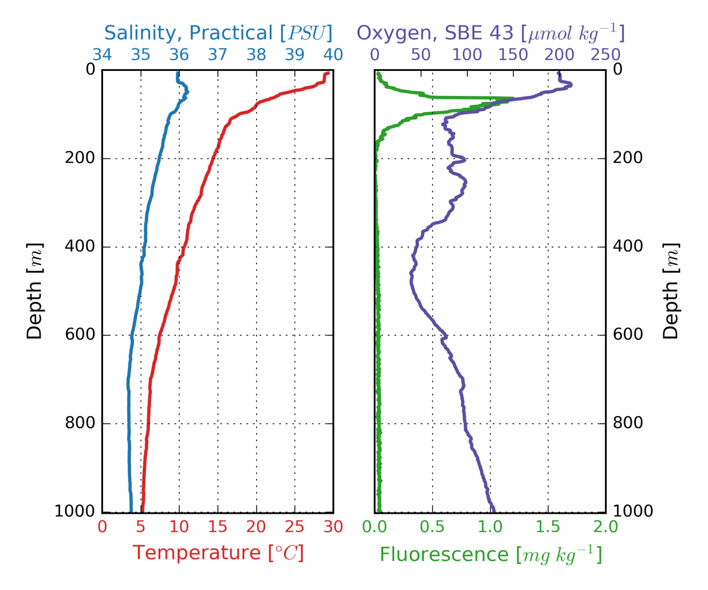
Bottle | Depth (m) | Potential Temp. (°C) | Salinity (PSU) | Potential Density (kg/m³) | Dissolved Oxygen (μM/kg) | Apparent Oxygen Utilization (μM/kg) | Fluorescence (mg/m³) | Comment
1 | 1001 | 5.1 | 34.8 | 27.5 | 129.4 | 177.5 | 0.04 | Std. depth
2 | 1001 | 5.1 | 34.8 | 27.5 | 129.2 | 177.7 | 0.05 | Std. depth
3 | 1001 | 5.1 | 34.8 | 27.5 | 129.8 | 177.1 | 0.04 | Std. depth
4 | 1001 | 5.1 | 34.8 | 27.5 | 129.6 | 177.3 | 0.05 | Std. depth
5 | 1002 | 5.1 | 34.8 | 27.5 | 129.7 | 177.2 | 0.04 | Std. depth
6 | 1001 | 5.1 | 34.8 | 27.5 | 129.7 | 177.2 | 0.04 | Std. depth
7 | 115 | 15.8 | 35.7 | 26.3 | 76.6 | 165.7 | 0.14 | Sub-thermocline
8 | 115 | 15.8 | 35.7 | 26.3 | 76.9 | 165.5 | 0.13 | Sub-thermocline
9 | 115 | 15.8 | 35.7 | 26.3 | 76.6 | 165.8 | 0.13 | Sub-thermocline
10 | 115 | 15.8 | 35.7 | 26.3 | 77.3 | 165.1 | 0.15 | Sub-thermocline
11 | 115 | 15.8 | 35.7 | 26.3 | 77.8 | 164.7 | 0.13 | Sub-thermocline
12 | 115 | 15.8 | 35.6 | 26.3 | 77.8 | 164.7 | 0.12 | Sub-thermocline
15 Mar 2020
Station 13 Cast 01 (fn: stn-13.hex/stn-13.bl)

Rosette In: Time 0959 (GMT) Lat. 10.374 ° N Lon. 21.000 ° W
Rosette Out: Time 1056 (GMT) Lat. 10.386 ° N Lon. 21.006 ° W
Bottom Depth: 5130 m
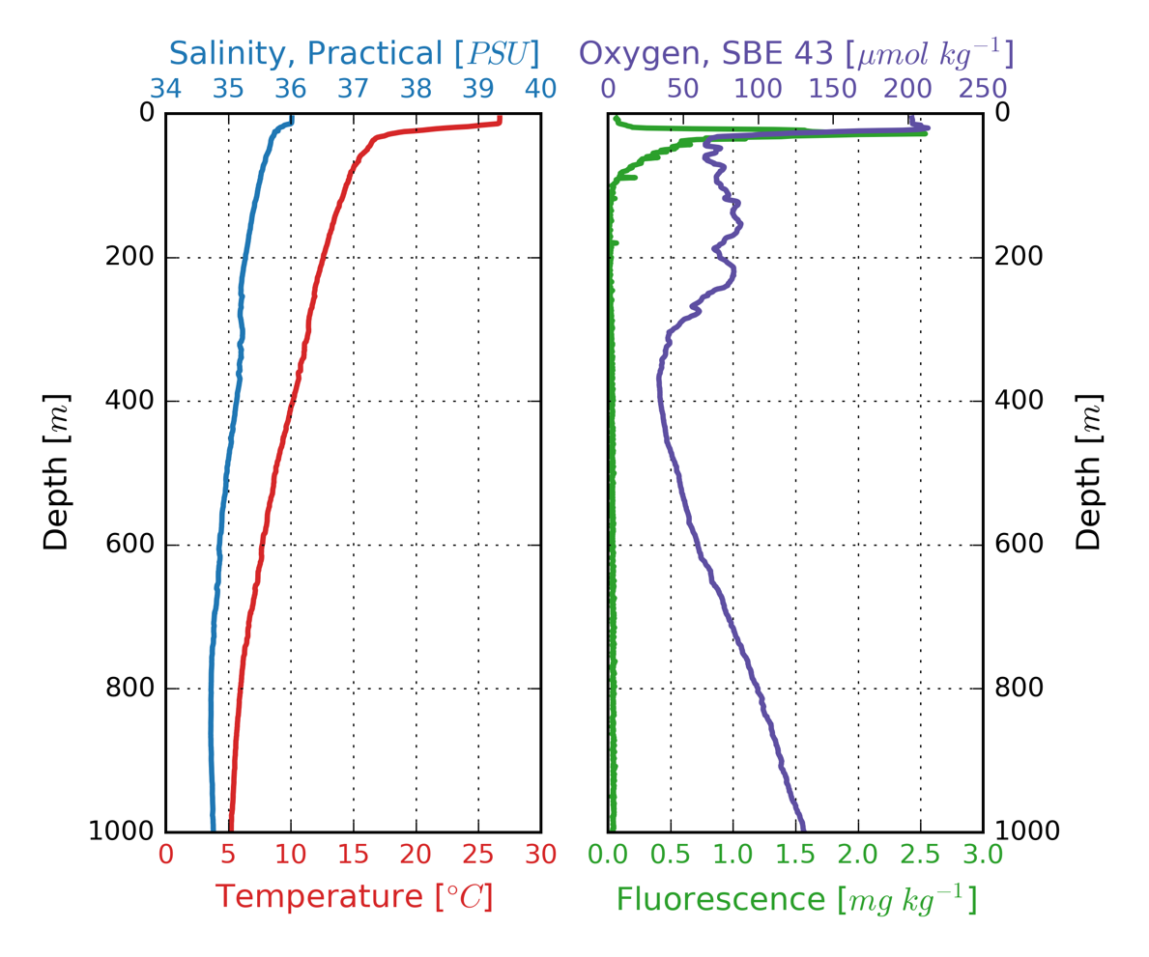
Bottle | Depth (m) | Potential Temp. (°C) | Salinity (PSU) | Potential Density (kg/m³) | Dissolved Oxygen (μM/kg) | Apparent Oxygen Utilization (μM/kg) | Fluorescence (mg/m³) | Comment
1 | 997 | 5.1 | 34.8 | 27.5 | 130.7 | 176.3 | 0.05 | Std. depth
2 | 996 | 5.1 | 34.8 | 27.5 | 130.7 | 176.3 | 0.05 | Std. depth
3 | 996 | 5.1 | 34.8 | 27.5 | 130.7 | 176.3 | 0.04 | Std. depth
4 | 996 | 5.1 | 34.8 | 27.5 | 130.6 | 176.4 | 0.04 | Std. depth
5 | 371 | 10.5 | 35.2 | 27.0 | 34.0 | 237.3 | 0.06 | O₂ minimum
6 | 371 | 10.5 | 35.2 | 27.0 | 34.0 | 237.3 | 0.06 | O₂ minimum
7 | 371 | 10.5 | 35.2 | 27.0 | 33.9 | 237.3 | 0.06 | O₂ minimum
8 | 101 | 14.4 | 35.5 | 26.5 | 73.9 | 175.6 | 0.08 | Sub-thermocline
9 | 100 | 14.4 | 35.5 | 26.5 | 73.5 | 176.0 | 0.07 | Sub-thermocline
10 | 99 | 14.5 | 35.5 | 26.5 | 73.5 | 175.9 | 0.08 | Sub-thermocline
11 | 5 | 26.7 | 36.0 | 23.6 | 202.6 | -3.3 | 0.05 | Surface
12 | 5 | 26.7 | 36.0 | 23.6 | 201.9 | -2.7 | 0.06 | Surface
16 Mar 2020
Station 14 Cast 01 (fn: stn-14.hex/stn-14.bl)

Rosette In: Time 0906 (GMT) Lat. 12.022 ° N Lon. 21.000 ° W
Rosette Out: Time 0958 (GMT) Lat. 12.035 ° N Lon. 21.003 ° W
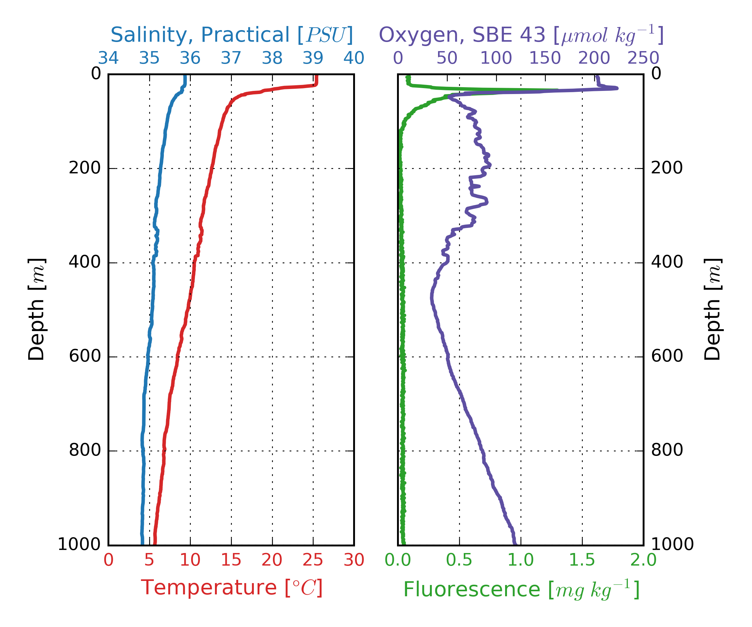
Bottle | Depth (m) | Potential Temp. (°C) | Salinity (PSU) | Potential Density (kg/m³) | Dissolved Oxygen (μM/kg) | Apparent Oxygen Utilization (μM/kg) | Fluorescence (mg/m³) | Comment
1 | 998 | 5.7 | 34.8 | 27.4 | 119.0 | 183.9 | 0.04 | Std. depth
2 | 999 | 5.7 | 34.8 | 27.4 | 118.9 | 183.9 | 0.05 | Std. depth
3 | 1000 | 5.7 | 34.8 | 27.4 | 119.0 | 183.8 | 0.05 | Std. depth
4 | 999 | 5.7 | 34.8 | 27.4 | 119.1 | 183.8 | 0.05 | Std. depth
5 | 998 | 5.7 | 34.8 | 27.4 | 119.1 | 183.8 | 0.05 | Std. depth
6 | 472 | 10.1 | 35.1 | 27.0 | 35.0 | 238.9 | 0.05 | O₂ minimum
7 | 472 | 10.1 | 35.1 | 27.0 | 35.1 | 238.8 | 0.07 | O₂ minimum
8 | 472 | 10.1 | 35.1 | 27.0 | 35.1 | 238.8 | 0.05 | O₂ minimum
9 | 471 | 10.1 | 35.1 | 27.0 | 35.1 | 238.8 | 0.06 | O₂ minimum
10 | 76 | 14.7 | 35.5 | 26.4 | 64.6 | 183.3 | 0.23 | Sub-thermocline
11 | 76 | 14.7 | 35.5 | 26.4 | 64.1 | 183.8 | 0.21 | Sub-thermocline
12 | 76 | 14.7 | 35.5 | 26.4 | 64.1 | 183.8 | 0.23 | Sub-thermocline

