Impact of Global Change on New England’s Coastal Environment (GCH-103)
Spring Semester, 2016
Class Meets: T-Th 11:00-12:15
Location: Davis Hall Room 009
Field Trip(s): TBD
Office Hours: Th 12:30-1:30 with location TBD

Instructors:
John King 874-6182 jwking@uri.edu South Lab, GSO
Rob Pockalny 874-6926 rpockalny@uri.edu 207 Horn Lab, GSO
David Robinson 874-6182 dsrobinson@uri.edu South Lab, GSO

Required Text: None, reading and video material will be provided and accessible on-line.

Course Description
The relationship between science and society will be explored with a range of environmental change topics related to climate change (e.g., sea level rise, major storm frequency) and societal change (e.g., population trends, globalization). These topics will be presented in the context of past, recent and future environmental change with both local and global perspectives. A field trip to coastal regions will expose students to the dynamic character of the coastal environment and provide real-world examples of environmental change. Students will synthesize their course experience with a final group presentation that identifies a local/regional example of environmental change. The project will then consider opposing viewpoints on the appropriate response to the environmental change.

General Course Goals
1) To explore the relationship between science and society.
2) To use critical thinking for the analysis scientific and societal events.
3) To recognize the factors and processes driving global environmental change.
4) To understand the dynamic nature of environmental processes that impact coastal regions.

General Education Areas
Knowledge. A1 STEM
Responsibilities. C2. Global Responsibilities
Grand Challenge

Specific Student Learning Outcomes
Students will be able to describe the difference between weather and climate, and identify the primary factors that cause global climate to vary.
Students will be able to recognize various greenhouse gases and how they impact climate. They will also recognize data sources used to constrain past climate and the concepts used to predict future climate.
Students will be able to conduct in-class activities that demonstrate the impact of atmospheric CO₂, albedo and feedback mechanisms on climate.
Students will be able to use climate data and atmospheric CO₂ measurements to identify seasonal, decadal and millennial patterns and potential causes.
Students will be able to analyze different representations and interpretations of climate data to evaluate arguments for and against climate change.
Student will use Social Institutions (e.g., gov’t, family, education, religion, economy) as a method to become self-aware of their own and fellow students identity, as well as other cultures.
Students will be exposed to oral history of the Narragansett Indian Tribe for perspective on how a culture has adapted to sea level change since the last glacial maximum.
Students will combine knowledge of climate change and social institutions to discuss implications and potential interventions that will address issues of global environmental change.
Course Administration
Exams – 2 online exams (specifics TBD).
If missed due to illness, emergency, or pre-approved circumstance, a make-up exam will be provided.
Accommodations will be made for documented conditions (please inform instructors in advance)
Assignments – a range of on-line questionnaires, readings, and in-class activity reports.
Late assignments will have their maximum point value decreased by 10% per day
Class Participation – respectful and timely discussion or group work.
Use of electronic devices subject to instructors permission.
Attendance – expected, unless provided with an acceptable excuse.
Field Trip(s) – Preference for a trip during an extneded class period. If schedules do not permit, an extended class-time field trip will be scheduled for a Saturday.
For those unable to attend field trip with valid excuse, classes will meet to cover material missed.
Grading
Exams (20%)
Assignments (20%)
Class Participation (20%)
Attendance (20%)
Final Group Presentation (20%)

Tentative Calendar of Course Topics & Events

Date | Topics
Jan. 26 | Introduction | Past
Jan. 28 | Narragansett Oral History | Past
Feb. 2 | Archaeology (Evidence Found) | Past
Feb. 4 | Archaeology (Make Meaning) | Past
*Feb. 9 | Earth History (Recent Sea Level History, causes) | Past
Feb. 11 | Summarize Narragansett Case Study | Past
Feb. 16 | Weather vs Climate (Critical Thinking) | Present
*Feb. 18 | Climate History (described & causes) | Present
Feb. 23 | Climate Proxies (ice activity & review) | Present
*Feb. 25 | Climate Greenhouse Gases (box activity & review) | Present
Mar. 1 | Sea Level Change – (defined, causes) | Present
Mar. 3 | Storms - case studies | Present
Mar. 8 | Climate Summary | Present
Mar. 10 | Field Trip Prep (Field Trip on Sat. 12th) | Present
Mar. 15 | No Class (if Sat. Field Trip) | Present
Mar. 17 | No Class (if Sat. Field Trip) | Present
 | SPRING BREAK
Mar. 29 | Climate Models - (NetLogo activity & models) | Future
Mar. 31 | Climate Predictions & Implications (IPCC) | Future
Apr. 5 | Feedback Mechanisms - (Post-it activity) | Future
Apr. 7 | Societal Institutions - defined/connections | Future
Apr. 12 | The Corporation - video review | Future
Apr. 14 | Group Project - introduction | Future
Apr. 19 | Geoengineering | Future
Apr. 21 | Societal Impacts | Future
Apr. 26 | Group Projects - help session | Future
Apr. 28 | Group Projects - help session | Future
May 5* | Group Projects - final presentations (8 – 11) | Final

Example of Pre-class Questionnaire
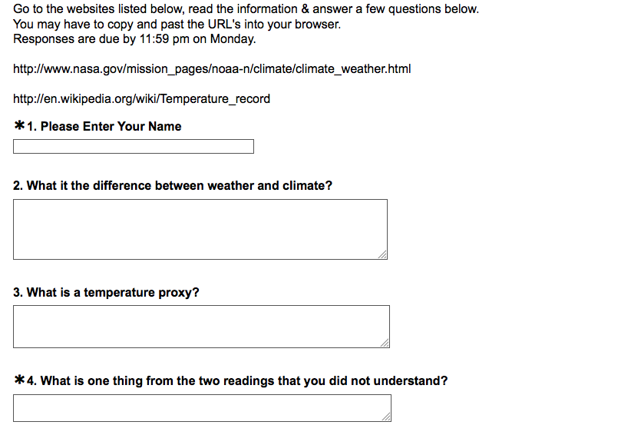

Example of On-line Exam

Directions
There are 5 short answer questions, answer them all.
There are 5 possible essay questions, answer only 2 of them.
You will have 1 hour to complete the exam once it is opened.
Exams shall be completed by 11:59 PM on Sunday November 11th, 2013.
This is not a group effort.
Do not seek answers from any other individuals.
It is OK to use your class notes or any notes we posted on Sakai.
DO NOT use GOOGLE or seek any other on-line answers.
You do not want to know what will happen if we think someone has used Google.

Short Answer Example
1) What is the difference between weather and climate?

Essay Example
1) Describe how greenhouse gases can cause global temperatures to rise.

