Multiple melt source origin of the Line Islands.

Robert Pockalny Graduate School of Oceanography, University of Rhode Island, Narragansett, Rhode Island, 02882

Ginger Barth U.S. Geological Survey, Menlo Park, California 94025

Barry Eakins National Centers for Environmental Information, Boulder, Colorado 80305

Mitchell Lyle College of Earth, Ocean, and Atmospheric Sciences, Oregon State University, Corvallis, Oregon 97331

Dan Scheirer U.S. Geological Survey, Menlo Park, California 94025

Christina Wertman Graduate School of Oceanography, University of Rhode Island, Narragansett, Rhode Island, 02882

**ABSTRACT**

The Line Islands volcanic chain in the central Pacific Ocean exhibits many of the characteristics of a hotspot-generated seamount chain; however, the lack of a predictable age progression has stymied previous models for the origin of this feature. We combine plate tectonic reconstructions with age-dated seamounts to develop a new model that involves multiple melt regions and multiple eruption styles to explain the spatial and temporal history of the Line Islands system. Our model defines a new melt source region (Larson Hotspot at 17˚S, 125˚W) that contributes to the formation of the Line Islands, as well as the Mid-Pacific Mountains and possibly the Pukapuka Ridge.

INTRODUCTION

The Line Islands are a collection of seamounts and volcanic ridges located in the central Pacific Ocean with a general NW-SE trend along its 4500 km length (Fig. 1). The volcanic chain is delimited to the north by the older Mid-Pacific Mountains (> 88 Ma) and to the south by the younger Tuamotu Islands and Pukapuka Ridge (< 50 Ma). The eruption age of the intervening Line Islands generally falls between 50 Ma and 88 Ma; however, there is no apparent age progression along the volcanic chain.

Previous attempts to explain the origin of the Line Islands with a single hotspot trace (e.g., Morgan, 1972)were unable to account for the complex age distribution, so models with multiple hotspots were proposed (e.g., Crough and Jarrard, 1981; Duncan and Clague, 1985). A more recent interpretation suggests that neither single nor multiple hotspot models can explain the origin of the Line Islands (Davis et al., 2002). Instead, melting of a heterogeneous mantle in a region of diffuse lithospheric extension is proposed for the enigmatic eruption history.

We revisit the question of the origin of the Line Islands by developing a tectonic reconstruction of the Pacific Plate from 130 Ma to present. Our model uses updated plate motion models (Seton et al., 2012) and a compilation of age-dated seamounts (Clouard and Bonneville, 2005; Earth Reference Data and Models, 2015) to constrain the spatial and temporal eruption history of the Line Islands system.

REGIONAL MORPHOLOGY

The morphology of the Line Islands volcanic chain varies dramatically along its length (Fig 1A). The northernmost region is a collection of dispersed seamounts and east-west--trending seamount chains distributed over a 1000 km x 1000 km region located immediately south of the Mid-Pacific Mountains. The central region is defined by the 1200-km-long and 200-km-wide volcanic Line Islands Ridge. The northern end of the Line Island Ridge is a circular plateau that includes Kingman Reef and Palmyra Atoll and a southern ridge that includes Fanning and Christmas islands. Continuing southward, the Boudeuse Ridge is a linear chain of closely spaced seamounts that defines the southern end of the Line Islands. The age of volcanism along the Line Islands ranges from 24 Ma to 91 Ma with most dated seamounts (23 of 27) between 55 Ma and 86 Ma (see SI); but as previously mentioned, there is no apparent age progression along the volcanic chain.

Two additional volcanic features located at either end of the Line Islands are the Mid-Pacific Mountains and the Pukapuka Ridge (Fig. 1A). The Mid-Pacific Mountains are a broad volcanic plateau extending over 2000 km with a roughly E-W trend just south of the Hawaiian Chain. The western half of the Mid-Pacific Mountains is roughly equidimensional in plan view (1200 km x 1000 km) with age dates ranging from 128 Ma to 88 Ma, while the eastern half is more elongate (1000 km x 250 km) and oriented in a NE-SW direction with age dates from 88 Ma to 74 Ma. At the easternmost end is Necker Ridge with an age date of 82 Ma. Pukapuka Ridge is a series of discrete seamounts with an E-W trend spanning the distance of 2500 km between the Tuamotu Islands and the Rano Rahi seamounts. The volcanism along Pukapuka Ridge exhibits a general age-progressive trend from ~28 Ma at the western end to ~5 Ma at the eastern end near the East Pacific Rise.

RECONSTRUCTION MODELS

We used GPlates tectonic reconstruction software (Cannon et al., 2014), hotspot locations on the Pacific Plate (Morgan and Morgan, 2007), and a compilation of dated seamounts in the central Pacific (Clouard and Bonneville, 2005; Earth Reference Data and Models, 2015) to model the volcanic evolution of the Line Islands (Figs. 1 and 2). Our initial model displays a nice temporal and spatial correlation of the Crough Hotspot track with the Boudeuse Ridge, the Tuamotu Islands, and possibly the southern end of the Line Islands (Fig. 1B). However, the northern seamount province and the northern half of the Line Islands Ridge only come within ~500 km of the Marquesas Hotspot track. This reconstruction also does not account for the mixture of seamount ages along the Line Islands Ridge and northern seamount province.

Our preferred reconstruction requires an additional melt source located at 17˚S, 125˚W, which we call the Larson Hotspot in memory of Roger Larson (Fig 1C). This new hotspot is located between the Crough and Marquesas hotspots near the Pukapuka Ridge and traces along the Line Island Ridge, through the heart of the northern seamount province, and along the Mid-Pacific Mountains.

RESULTS

The spatial and temporal history of the Larson Hotspot is coincident with much of the volcanism along the Line Islands, including the Mid-Pacific Mountains and Pukapuka Ridge (Fig. 1C). The Crough, Marquesas and Tahiti hotspots also contribute to the volcanic history, but to a much lesser extent.

In our proposed scenario (Figs. 2, 3), the Mid-Pacific Mountains were formed 110–130 Ma through a plume-ridge interaction with the Larson Hotspot. The Larson Hotspot at this time was likely a robust melt event (i.e., plume head) located within 500 km of the Pacific-Farallon ridge axis. A later stage of distributed volcanism on the Mid-Pacific Mountains may be due to the passage of the Tahiti Hotspot from 85–110 Ma.

The Necker Ridge at the eastern end of the Mid-Pacific Mountains is likely the result of an off-axis extensional eruption event that coincided with the Larson Hotspot at ~95 Ma or the Marquesas Hotspot at 75–85 Ma.

The Line Islands are likely the combined result of the Larson, Crough and Marquesas hotpots (Fig. 2, 3). The northern seamounts appear to be caused by distributed volcanism associated with the Larson Hotspot from 75–100 Ma and/or the Marquesas Hotspot from 65–75 Ma. The northern half of the Line Islands Ridge coincides with the passage of the Larson Hotspot from 65–80 Ma, while the southern half coincides with the Crough Hotspot from 85–100 Ma and/or the Larson Hotspot from 50–70 Ma. The cross-grained ridges emanating from the eastern side of the Line Island Ridge suggest an extensional environment (Davis et al., 2002), but we believe the similar trends of the hotspot tracks and the Line Islands indicate a more conventional melt conduit hotspot track. The track of the Crough Hotspot nicely coincides with the Boudeuse Ridge from 45–75 Ma and suggests a similar melt conduit eruption style.

At the southern end of the Line Islands, the Crough Hotspot coincides with the Tuamotu Islands from 20–50 Ma and parallels the series of seamounts connecting the Tuamotu Islands with the Easter Microplate (Figs. 2,3). Limited seamount age information does not provide enough information to assess the eruption style, so these features may be due to either melt conduits or lithosphere extension. The Pukapuka Ridge, however, is likely the result of lithosphere extension with the Larson Hotspot as our proposed melt source (Janney et al., 2000; Lynch, 1999 ; Sandwell et al., 1995).

DISCUSSION

Four different melt sources (e.g., Crough, Marquesas, Tahiti and Larson hotspots) are proposed to explain the formation of the Line Islands and adjacent Mid-Pacific Mountains and Pukapuka Ridge (Fig. 3). The Larson and Crough hotspots are the predominant contributors to the volcanism, but neither of these melt sources are consistently listed in catalogs of deep mantle plumes or hotspots (e.g., Courtillot et al., 2003; Montelli et al., 2006). Recent shear-wave velocity models (French and Romanowicz, 2015), however, indicate that both of these hotspots are associated with mantle plume sources (Fig. 4). The Larson and nearby Pitcairn hotspots are linked to a deep-mantle plume source in the broad South Pacific Superswell region. The Crough and possibly the Easter hotspots are associated with a mid-mantle plume source near the Easter Microplate. The Marquesas Hotspot also appears to be connected to a mid-mantle plume source, while the Tahiti Hotspot appears to have a shallow mantle source.

Several eruption styles are proposed to explain the various volcanic morphologies observed along the Line Islands system (Fig. 3). Our proposed plume-ridge origin of Mid-Pacific Mountains, the melt-conduit origin of the Boudeuse Ridge, and the lithosphere extension origin of the Pukapuka Ridge are consistent with previous explanations (Davis et al., 2002; Lynch, 1999; Winterer and Metzler, 1984). The eruption style of the Line Islands Ridge was most recently attributed to diffuse lithospheric extension and subsequent volcanism (Davis et al., 2002); however, the large erupted volumes and the orthogonal orientation of the volcanic chain to intersecting fracture zones is significantly different from other proposed extensional volcanic ridges (e.g., Pukupuka Ridge). We believe the spatial and temporal history of the Line Islands Ridge is better explained by overlapping conventional hotspot tracks of the Crough and Larson hotspots. The northern seamount province was also previously attributed to lithosphere extension to explain the cross-grain seamount chains (e.g., Keli Ridge) in the region (Natland, 1976). We believe this mechanism is still a viable origin, but we prefer a distributed volcanism origin to explain the more dispersed seamounts. In our interpretation, the melt source for the distributed volcanism and cross-grain seamounts would be small, residual mantle heterogeneities related to the passage of the Larson and/or Marquesas hotspots.

Our proposed model of multiple melt sources and multiple eruption styles for the origin of the Line Islands, Mid-Pacific Mountains and Pukapuka Ridge suggests a complex geochemical distribution and eruption history for the region. In our model, the Mid-Pacific Mountains, the northern seamount province, and Line Islands Ridge are likely the results of multiple melt sources from different mantle provinces that have erupted at different times. In contrast, the Boudeuse and Pukapuka ridges are likely the formed by separate single melt sources and eruption styles, which would suggest a more predictable geochemistry (e.g., Janney et al., 2000).

ACKNOWLEDGMENTS

Place holder to thank the reviewers. We also thank Chris Kincaid, Victoria Fulfer and Yang Shen for helpful discussions. This research was partially funded by the U.S. Geological Survey (#G13AC00351) and the National Science Foundation (OCE-1158994).

Figure Captions

Figure 1. Series of maps of the central Pacific Ocean illustrating A) the features related to the Line Islands system (in blue) and the hotspots (yellow dots) affecting the Pacific Plate. In our initial (B) and preferred (C) reconstruction models, the dated seamounts (triangles) and hotspot motion paths are color-coded according to their age of formation.

Figure 2. Series of tectonic reconstructions of the present-day Pacific Plate illustrating the melt source and timing of the various eruptive events related to the Line Islands system. Motion paths of known hotspots (dashed lines) and the proposed Larson melt source (solid line) are shown. Dated seamounts are color coded according to time since eruptions (black < 5 Ma, gray 5-10 Ma, white > 10 Ma). Light gray patches are the locations of selected upward-projected isosurfaces shown in Figure 4. See Supplemental Information for animated reconstructions.

Figure 3. (Top) Simplified diagrams of four eruptive styles proposed to contribute to the formation of the Line Islands system. (Bottom) Timelines of eruption timing and style for each of the four contributing melt sources.

Figure 4. Three-dimensional rendering of the shear-wave-velocity anomaly (Vs/Vs) (French and Romanowicz, 2015) overlain with the shaded bathymetry (Smith and Sandwell, 1997). The -0.80 and -0.75 isosurfaces are shown from 2900 km to 950 km depth with the isosurface contours (dashed lines) projected upward onto the bathymetry. The location of hotspots (cylinders) and hotspots contributing to the Line Islands system (black cylinders) are shown.

REFERENCES CITED

Cannon, J., Lau, E. and Müller, R. D. 2014, Plate tectonic raster reconstruction in GPlates: Solid Earth Discussions, v. 6, p. 793-830, doi: 10.5194/se-5-741-2014.

Clouard, V. and Bonneville, A. 2005, Ages of seamounts, islands, and plateaus on the Pacific plate: Geological Society of America Special Papers, v. 388, p. 71-90, doi: 10.1130/0-8137-2388-4.71.

Courtillot, V., Davaille, A., Besse, J. and Stock, J. 2003, Three distinct types of hotspots in the Earth’s mantle: Earth and Planetary Science Letters, v. 205, p. 295-308, doi: 10.1016/S0012-821X(02)01048-8.

Davis, A. S., Gray, L. B., Clague, D. A. and Hein, J. R. 2002, The Line Islands revisited: New 40Ar/39Ar geochronologic evidence for episodes of volcanism due to lithospheric extension: Geochemistry, Geophysics, Geosystems, v. 3, p. 1-28, doi: 10.1029/2001GC000190.

Duncan, R. A. and Clague, D. A. 1985, Pacific plate motion recorded by linear volcanic chains. In The ocean basins and margins (pp. 89-121). Springer US, doi: 10.1007/978-1-4613-2351-8_3.

Earth Reference Data and Models, 2015, Seamount Catalog: http:// http://earthref.org/SC/ (accessed September, 2015).

French, S. W. and Romanowicz, B. 2015, Broad plumes rooted at the base of the Earth's mantle beneath major hotspots: Nature, v. 525, p. 95-99, doi:10.1038/nature14876.

Janney, P. E., Macdougall, J. D., Natland, J. H. and Lynch, M. A. 2000, Geochemical evidence from the Pukapuka volcanic ridge system for a shallow enriched mantle domain beneath the South Pacific Superswell: Earth and Planetary Science Letters, v. 18, p. 47-60, doi: 10.1016/S0012-821X(00)00181-3.

Lynch, M. A. 1999, Linear ridge groups: Evidence for tensional cracking in the Pacific Plate: Journal of Geophysical Research, v. 104, p. 29321-29333, doi: 10.1029/1999JB900241.

Morgan, W. J. 1972, Deep mantle convection plumes and plate motions: AAPG Bulletin, v. 56, p. 203-213, doi: 10.1306/819A3E50-16C5-11D7-8645000102C1865D.

Morgan, W. J. and Morgan, J. P. 2007, Plate velocities in the hotspot reference frame: Geological Society of America Special Papers, v. 430, p. 65-78, doi: 10.1130/2007.2430(04).

Montelli, R., Nolet, G., Dahlen, F. A. and Masters, G. 2006, A catalogue of deep mantle plumes: New results from finite‐frequency tomography: Geochemistry, Geophysics, Geosystems, v. 7(11), doi: 10.1029/2006GC001248.

Natland, J. H. 1976, Petrology of volcanic rocks dredged from seamounts in the Line Islands: Heirtzler, J., et al., Initial reports of the Deep Sea Drilling Project, v. 33, p. 759-777.

Sandwell, D. T., Winterer, E. L., Mammerickx, J., Duncan, R. A., Lynch, M. A., Levitt, D. A. and Johnson, C. L. 1995, Evidence for diffuse extension of the Pacific plate from Pukapuka ridges and cross‐grain gravity lineations: Journal of Geophysical Research, v. 100, p. 15087-15099, doi: 10.1029/95JB00156

Seton, M., Müller, R. D., Zahirovic, S., Gaina, C., Torsvik, T., Shephard, G., Talsma, A., Gurnis, M., Turner, M., Maush, S. and Chandler, M. 2012, Global continental and ocean basin reconstructions since 200Ma: Earth-Science Reviews, V. 113, p. 212-270, doi:10.1016/j.earscirev.2012.03.002.

Smith, W. H., and Sandwell, D. T. 1997, Global sea floor topography from satellite altimetry and ship depth soundings: Science, v. 277, p. 1956-1962, doi: 10.1126/science.277.5334.1956.

Winterer, E. L. and Metzler, C. V. 1984, Origin and subsidence of Guyots in Mid‐Pacific Mountains: Journal of Geophysical Research, v. 89, p. 9969-9979, doi: 10.1029/JB089iB12p09969.

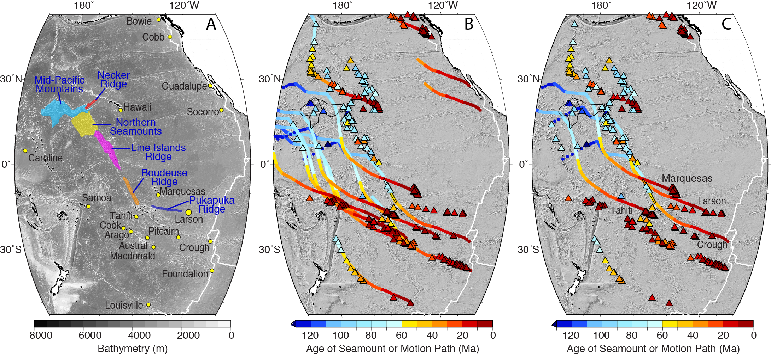

Figure 1. Series of maps of the central Pacific basin illustrating A) the features related to the Line Islands system (in blue) and the hotspots (yellow dots) affecting the Pacific Plate, B & C) the dated seamounts (triangles) and motion paths color-coded according to age for various proposed hotspot locations.

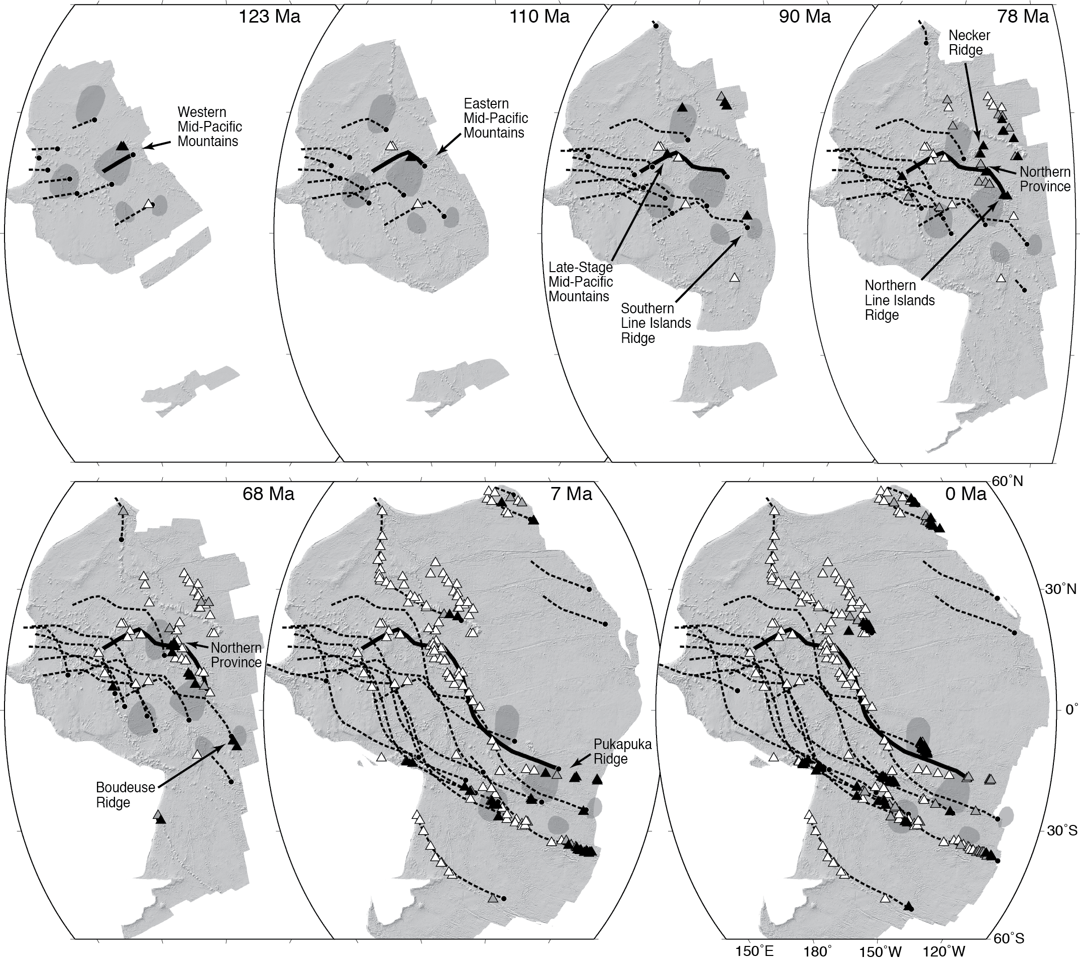

Figure 2. Series of tectonic reconstructions of the present-day Pacific plate illustrating the melt source and timing of the various eruptive events related to the Line Islands system. Motion paths of known hotspots (dashed lines) and the proposed Larson melt source (solid line) are shown. Dated seamounts are color coded according to time since eruptions (black < 5 Ma, gray 5-10 Ma, white > 10 Ma). Light gray patches are the locations of selected upward-projected isosurfaces shown in Figure 4.

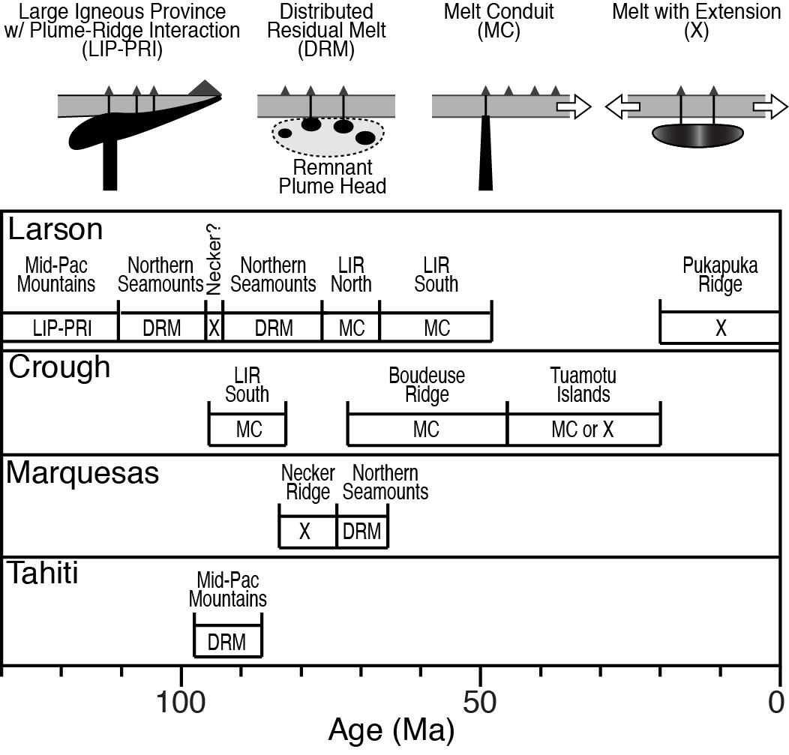

Figure 3. (Top) Simplified diagrams of four eruptive styles proposed to contribute to the formation of the Line Islands system. (Bottom) Timelines of eruption timing and style for each of the four contributing melt sources.

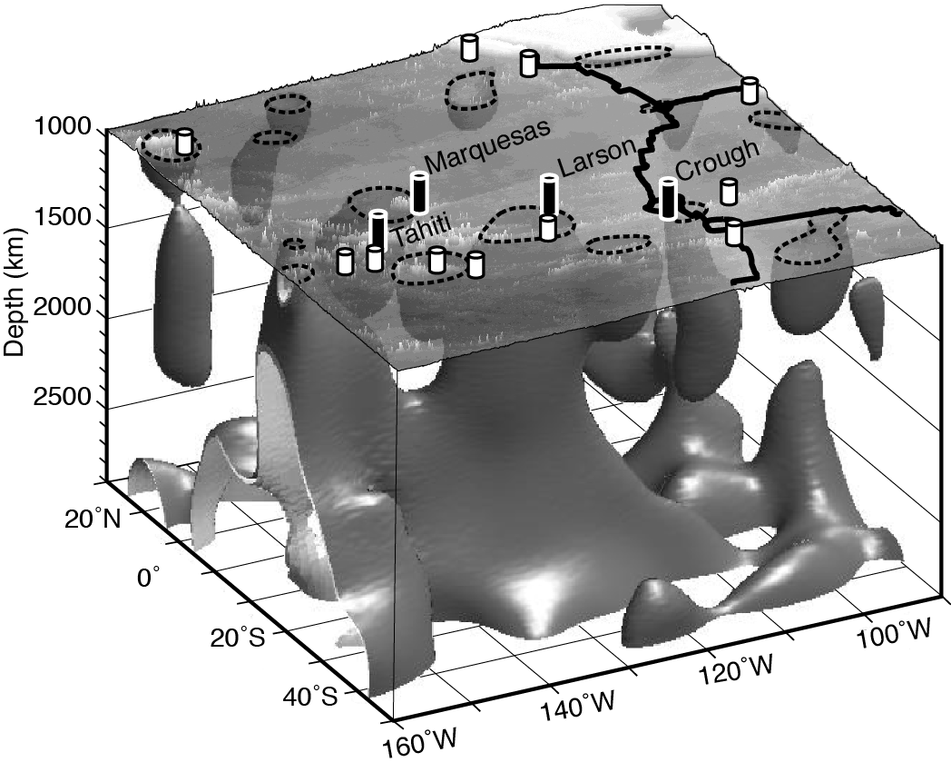

Figure 4. Three-dimensional rendering of the shear-wave-velocity anomaly (Vs/Vs) (French and Romanowicz, 2015) overlain with the shaded bathymetry (Smith and Sandwell, 1997). The -0.80 and -0.75 isosurfaces are shown from 2900 km to 950 km depth with the isosurface contours (dashed lines) projected upward onto the bathymetry. The location of hotspots (cylinders) and hotspots contributing to the Line Islands system (black cylinders) are shown.